**INDEX**

|  |  |  |  |  |
| --- | --- | --- | --- | --- |
| **Sr No.** | **Practical Name** | **Date** | **Page No** | **Sign** |
| **1** | **Installation of GNS3** |  | **4-11** |  |
| **2** | **Implement IP SLA (IP Service Level Agreement)** |  | **12-15** |  |
| **3** | **Implement IPv4 ACLs**  **1. Standard**  **2. Extended** |  | **16-23** |  |
| **4** | **Practical 3: 1. Implement a GRE Tunnel**  **2. Implement VTP**  **3. Implement NAT** |  | **23-29** |  |
| **5** | **Implement Inter-VLAN Routing** |  | **29-40** |  |
| **6** | **Observe STP Topology Changes and Implement RSTP**  **1. Implement Advanced STP Modifications and Mechanisms**  **2. Implement MST** |  | **40-58** |  |
| **7** | **1. Implement EtherChannel**  **2. Tune and Optimize EtherChannel Operations** |  | **58-76** |  |
| **8** | **OSPF Implementation**  **1. Implement Single-Area OSPFv2**  **2. Implement Multi-Area OSPFv2**  **3. OSPFv2 Route Summarization and Filtering**  **4. Implement Multiarea OSPFv3** |  | **76-98** |  |
| **9** | **Implement BGP Communities**  **1. Implement MP-BGP**  **2. Implement eBGP for IPv4**  **3. Implement BGP Path Manipulation** |  | **98-123** |  |
| **10** | **Implement IPsec Site-to-Site VPNs**  **1. Implement GRE over Ipsec Site-to-Site VPNs**  **2. Implement VRF Lite** |  | **124-134** |  |

**Practical 1**

**Aim: Installation of GNS3.**

**Step 1:** Download from the link.

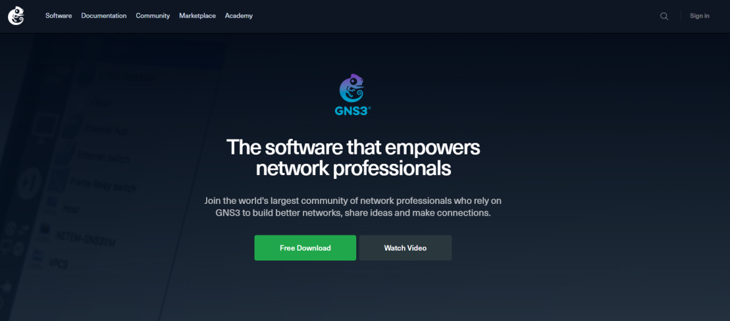

**Step 2:** Select your system.

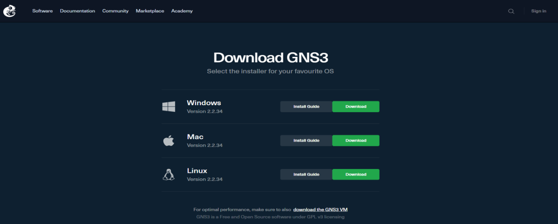

**Step 3:** Run the system.

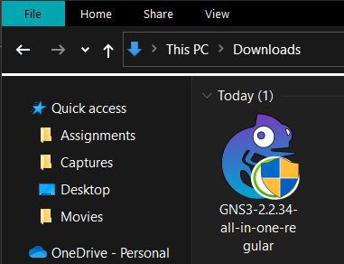

**Step 4:** Run the setup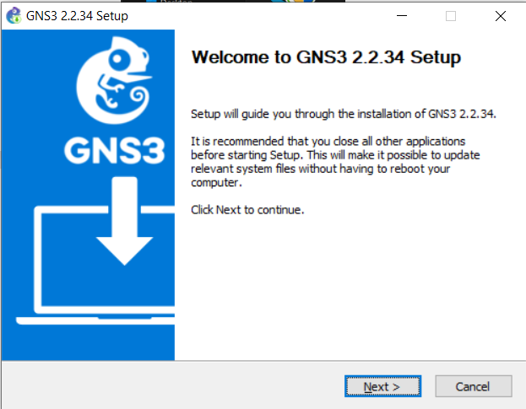

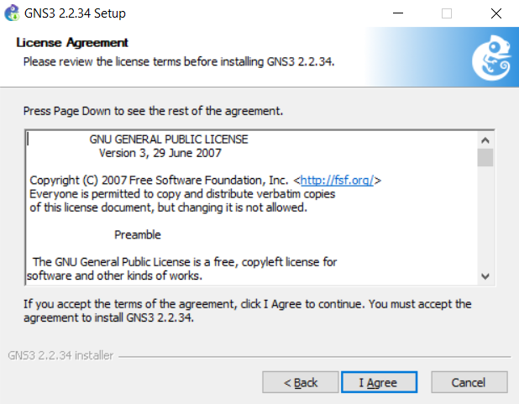

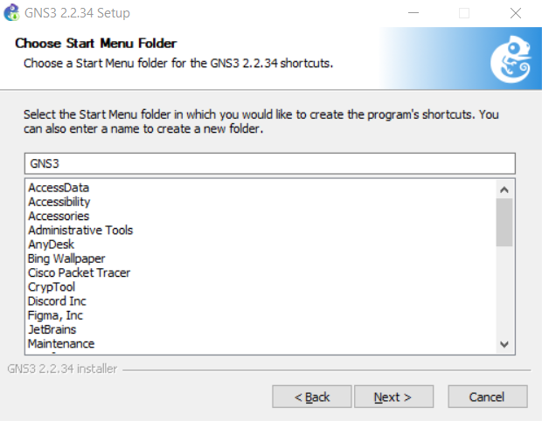

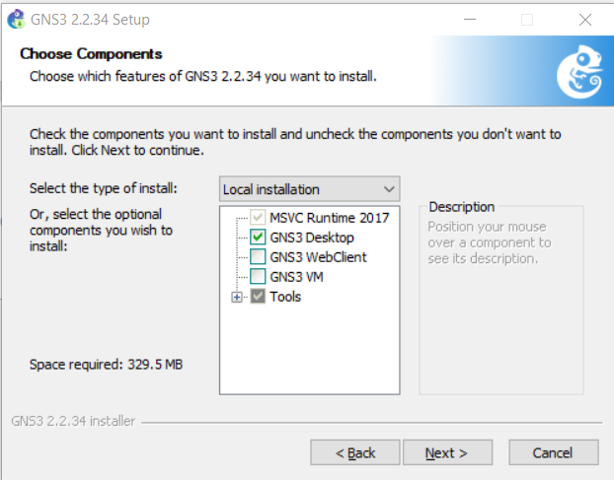

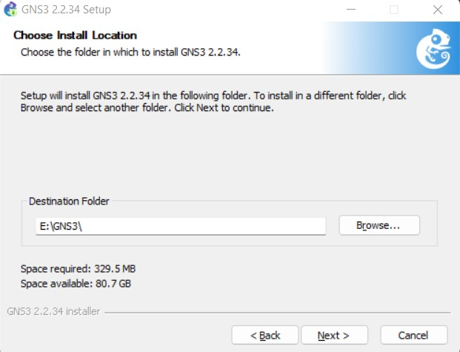

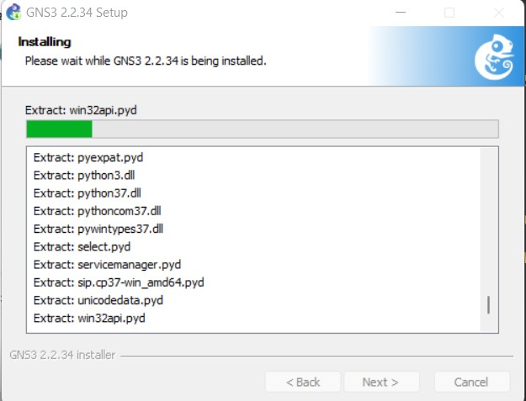

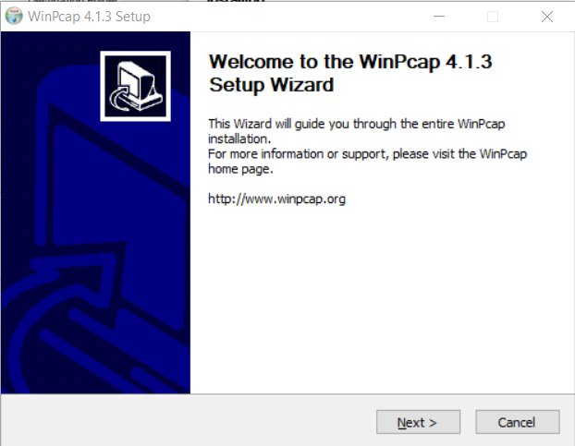

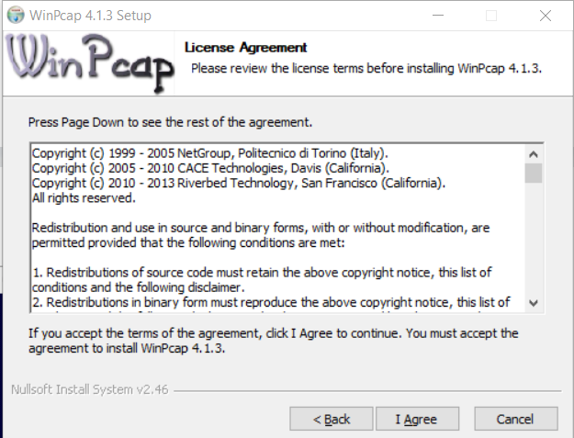

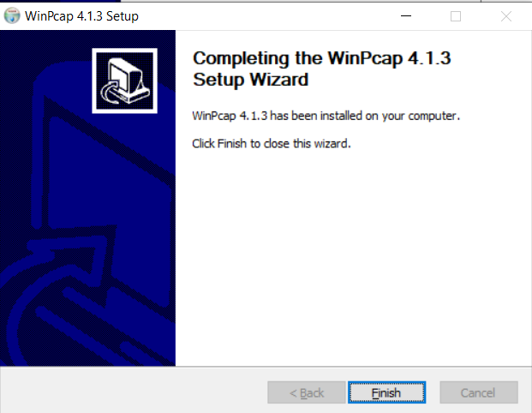

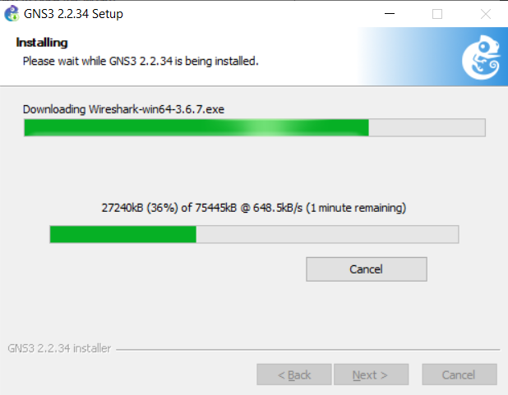

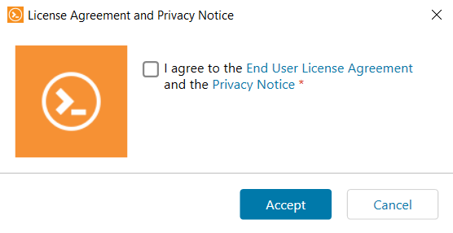

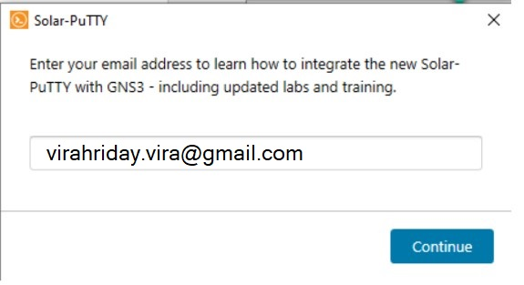

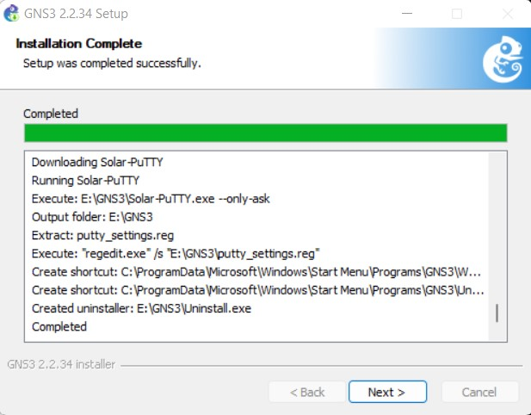

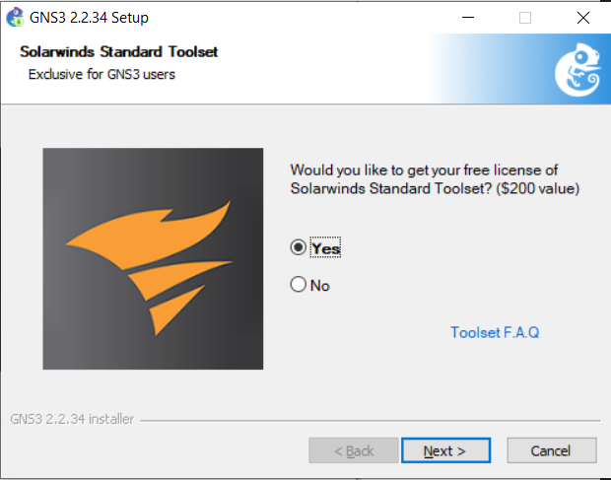

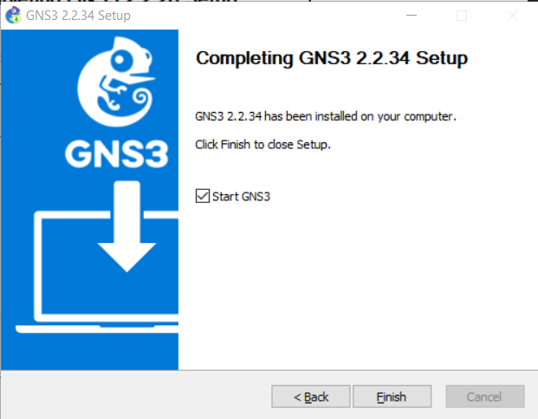

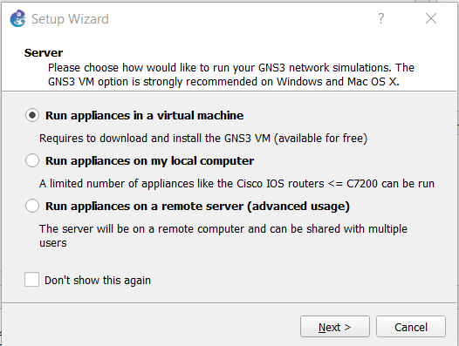

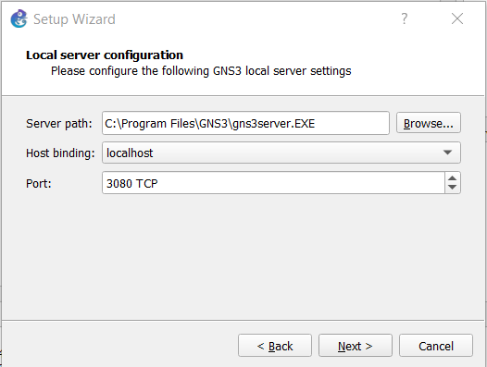

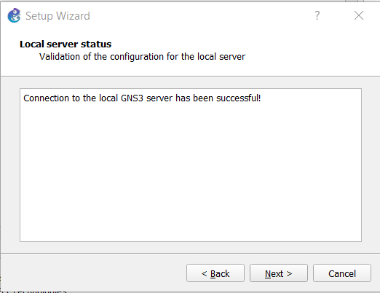

**Step 5:** Install VMWare.

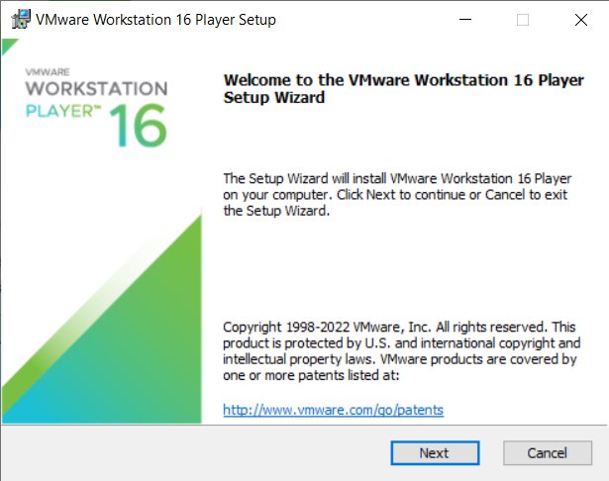

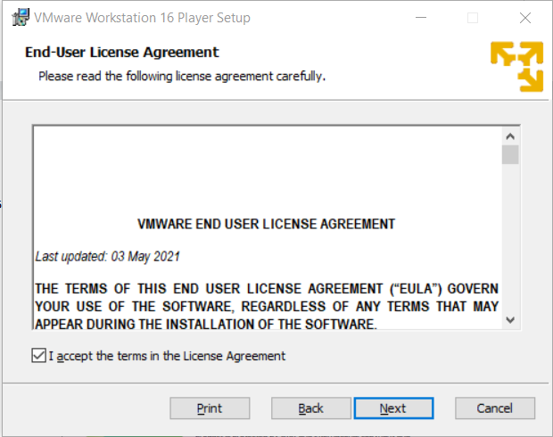

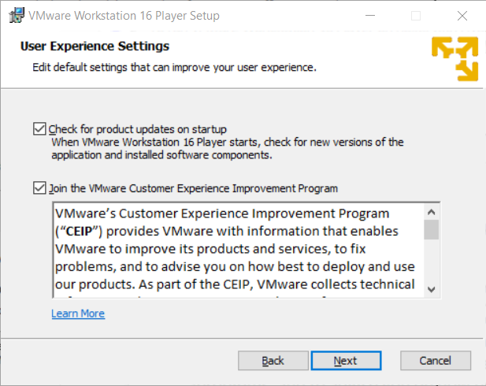

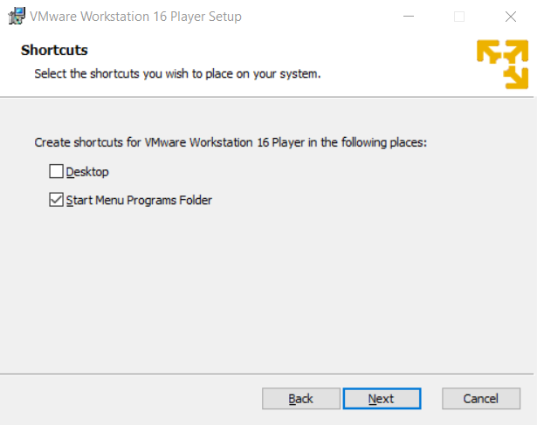

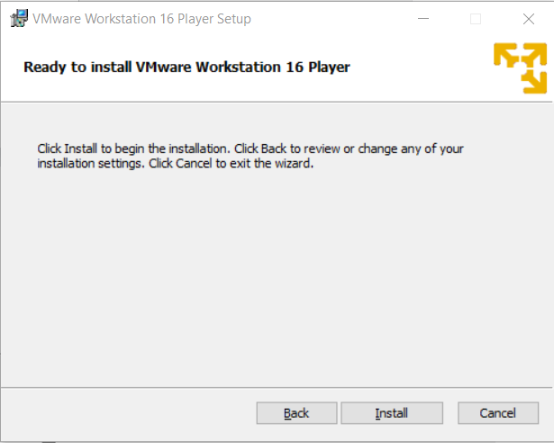

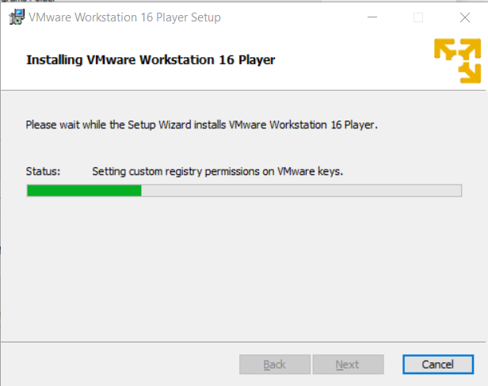

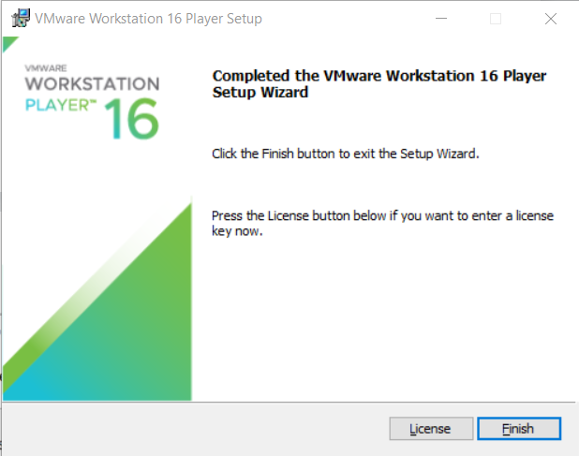

**Practical 2**

**Aim: Implement IP SLA (IP Service Level Agreement)**

**Solution:**

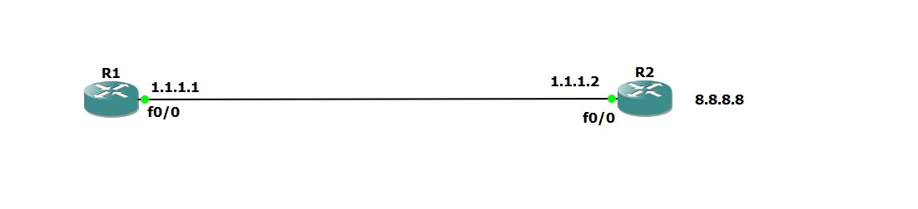**Step 1: Design the topology.**

* **What is IP SLA?**
* IP SLA is an active method of monitoring and reliably reporting on network performance. By "active," it refers to the fact that IP SLA will generate and actively monitor traffic continuously across the network.
* An IP SLA Router is capable of generating traffic and reporting on it in real time. IP SLA can be configured in such a way that it can report on statistics such as: - Jitter

- Response time

- Packet loss

- Voice Quality Scoring (MOS)

- Connectivity

- Server or website responses and downtime

- Delay

* IP SLA can be configured in two parts. There is the IP SLA router, which generates the traffic, and the IP SLA Responder.

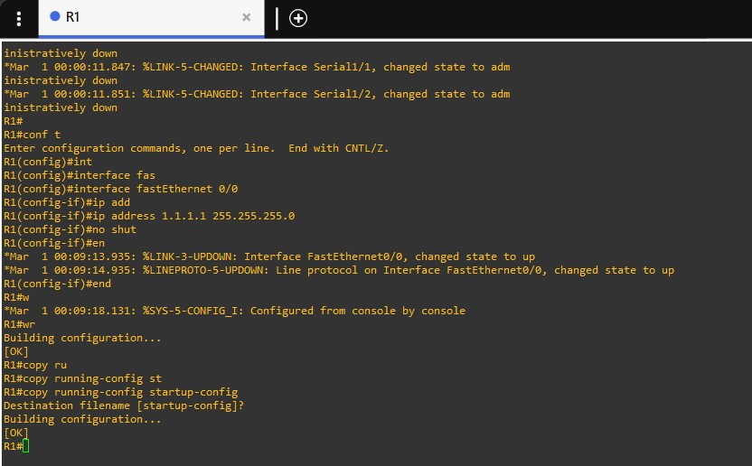

**Step 2: Configure the two routers.**

* **Router 1:**

First we configure the FastEthernet0/0 interface and set its Ip-address.

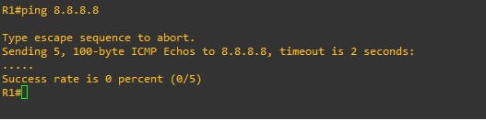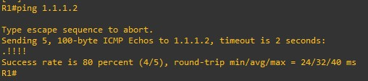Once the interface is configured, we navigate back to the global hash and then we try to ping the ISP Router (1.1.1.2).

Then we try to ping 8.8.8.8

Then we navigate to router configuration and set the ip-route. Then we ping 8.8.8.8.

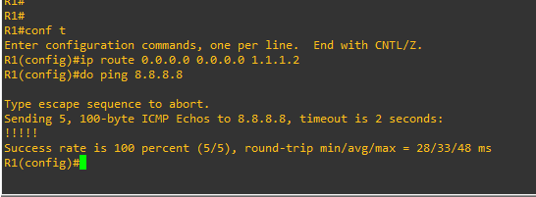

Then we configure the Ip SLA.

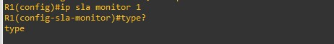

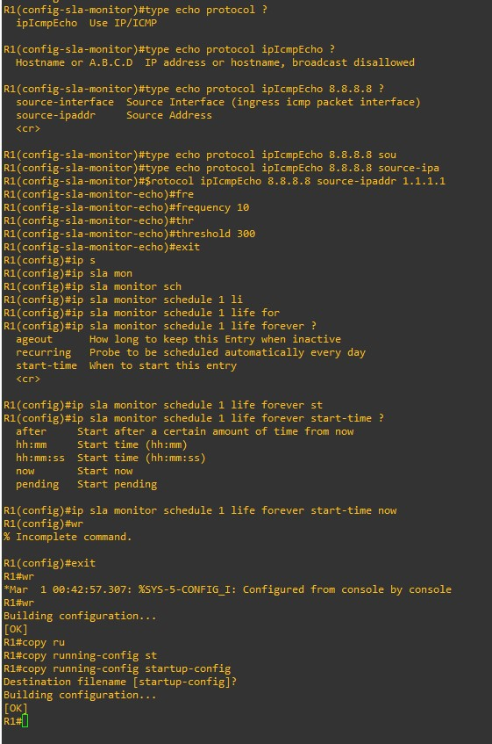

* **Router 2:**

Since Router two is on the receiving end (the responder), it will be convenient to rename it to ISP.

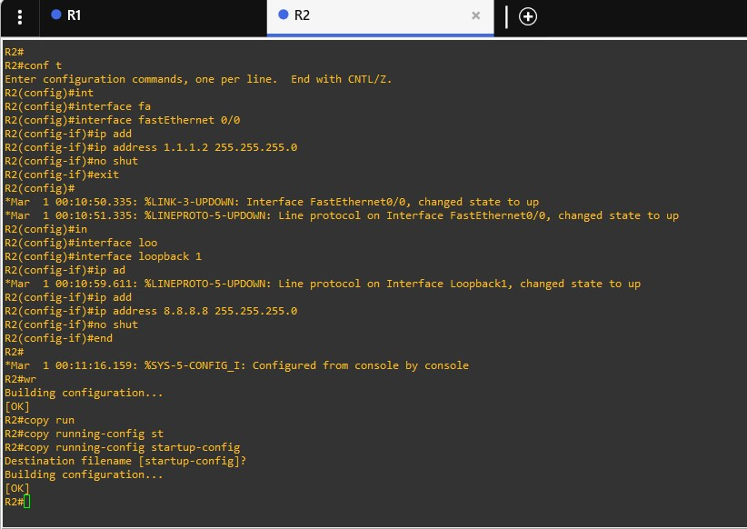So we will initially configure the second router to have its hostname as ISP. Then we set the interface to loopback 1 and then set Ip-address of the rouThen we change the interface to the FastEthernet0/0 and configure its Ip-address.

**Step 3: Output**

Here we can show the various ip sla monitoring attributes. Here we are going to use 5 separate ip sla monitoring commands.

1. **Ip sla monitor collection-statistics:**

Here it provides a collection of all the statistics of ip sla.

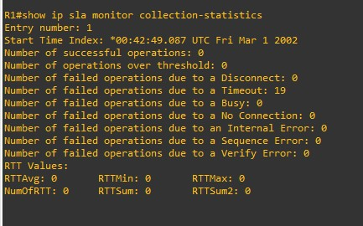

**2) ip sla monitor distribution-statistics:**

Here it provides the various distribution statistics of all the operations performed

by the ip sla.

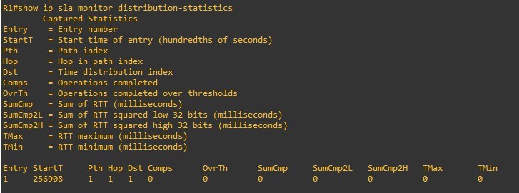

**3) ip sla monitor operational-state:**

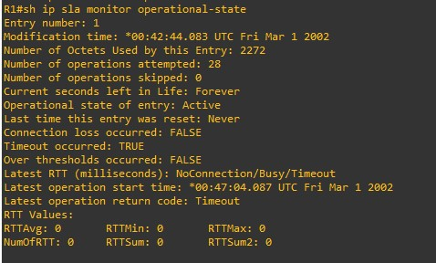Here we are provided with the overall operational state of the ip sla

**4) ip sla monitor configuration:**

Here we can see the overall configuration of the ip sla

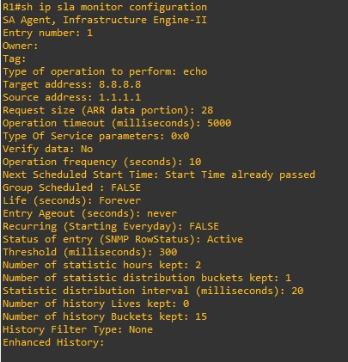

**5) ip sla monitor statistics:**

Here we can see the basic statistics of the ip sla

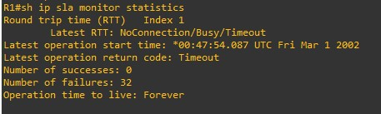

**Practical 3**

**Aim: Implement IPv4 ACLs 1. Standard 2. Extended**

**Step 1: Design the Topology**

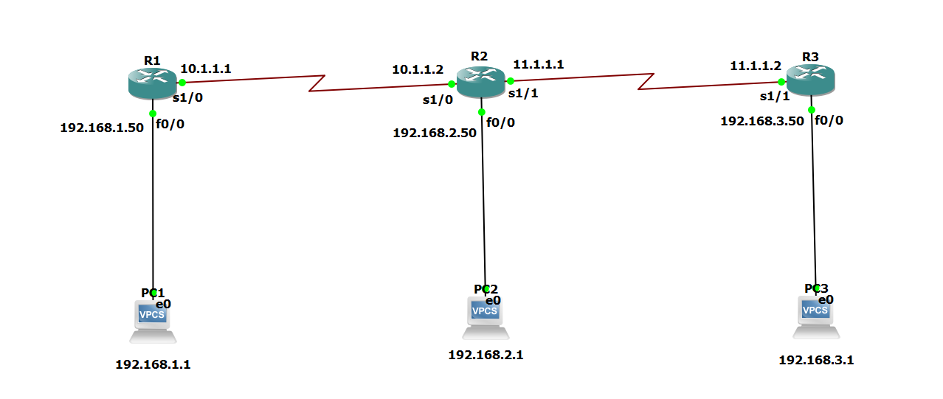

**Step 2: Explain what ACL is and how we apply it in the current system.**

* Access-list (ACL) is a set of rules defined for controlling network traffic and reducing network attacks. ACLs are used to filter traffic based on the set of rules defined for the incoming or outgoing of the network.
* Layer 3 Security – Router blocks the IP address, which means that ACL is applied.
* ACL is also called as packet filtering firewall
* There are two main types of ACL:

**1. Standard:**

**-** Standard access-list is implemented using source IP address only.

- Standard Access-list is generally applied close to destination (but not always).

**-** Standard access-list uses the range 1-99 and extended range 1300-1999.

- In a standard access list, the whole network or sub-network is denied.

**2. Extended:**

- In the Extended access list, packet filtering takes place on the basis of source

IP address, destination IP address, port numbers.

- Extended access-list is generally applied close to the source but not always.

- Extended ACL is created from 100 – 199 & extended range 2000 – 2699.

- In an extended access list, particular services will be permitted or denied.

* To enable ACL on our network we use Routing protocols.

Note: As the destination is not reachable from PC 1 to Router 2 (means via connection is not reachable) so we apply a routing protocol.

* There are many routing protocols:

1. Static

2. Dynamic:

- RIP, OSPF, EIGRP.

- Here we apply RIP. After applying RIP all the Routers and PCs are able to communicate and ping each other.

**Step 3: Configure the System.**

**Router R1:**

Here we configure Router 1 (R1).

We set the ip address for the router and its various connections.

Note: Always remember to set the ‘no shutdown’ attribute for each interface. This way the protocol state will be changed to up rather than down.

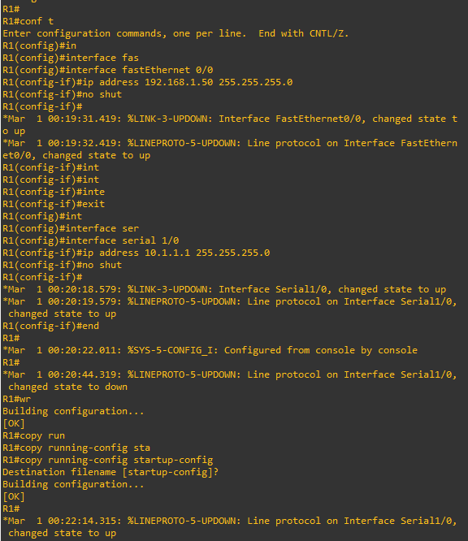

Also after setting up the configuration, it is advised to ping a nearby device to check whether the connection has been established.

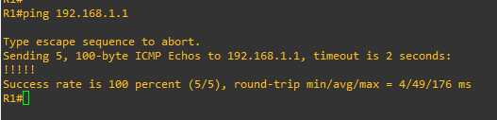

**PC 1:**

PC 1 can be used to help send data to other PCs on the network via its router. In this case PC 1 is connected to R1 via the fastEthernet 0/0 connection.

Here we set the Ip-address of the PC to ‘192.168.1.1/24’ with a gateway of ‘192.168.1.50’.

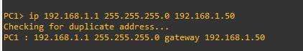

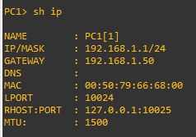

**Router 2:**

Here we configure Router 2 (R2).

R3 is connected to three devices (2 routers – R1 and R3, and one PC – PC 2).

Note: Always remember to set the ‘no shutdown’ attribute for each interface. This way the protocol state will be changed to up rather than down.

Also after setting up the configuration, it is advised to ping a nearby device to check whether the connection has been established.

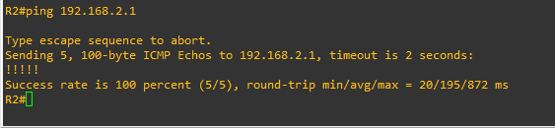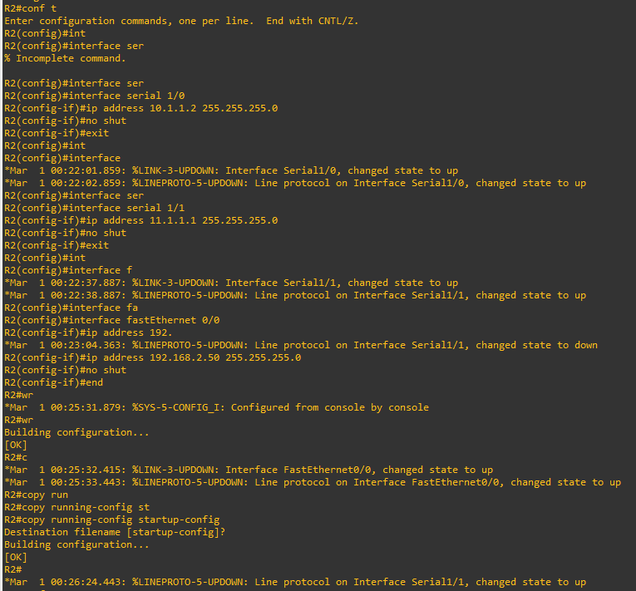

**PC 2:**

PC 2 can be used to help send data to other PCs on the network via its router. In this case PC 2 is connected to R3 via the fastEthernet 0/0 connection.

Here we set the Ip-address of the PC to ‘192.168.2.1/24’ with a gateway of ‘192.168.2.50

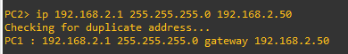

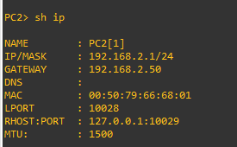

**Router 3:**

Here we configure Router 3 (R3).

R3 is connected to two devices (router – R3, and PC – PC 3).

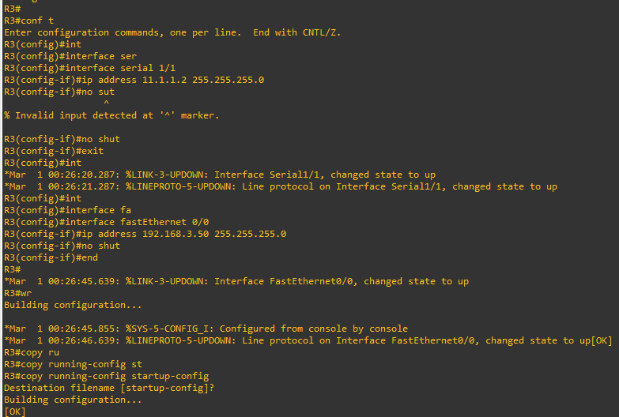Note: Always remember to set the ‘no shutdown’ attribute for each interface. This way the protocol state will be changed to up rather than down.

Also after setting up the configuration, it is advised to ping a nearby device to check whether the connection has been established.

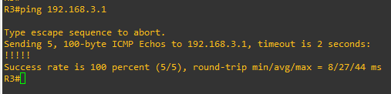

**PC 3:**

PC 3 can be used to help send data to other PCs on the network via its router. In this case PC 3 is connected to R2 via the fastEthernet 0/0 connection.

Here we set the Ip-address of the PC to ‘192.168.3.1/24’ with a gateway of ‘192.168.3.50’

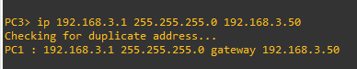

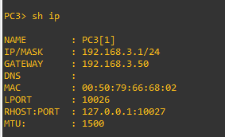

**Step 4: Configure and test the ACL on the network system.**

* To initially apply the routing protocol for the system:

To configure the network route for the Router R1, we use the RIP protocol. Using router rip – version 2 we set the network route PC 1 and Router 1

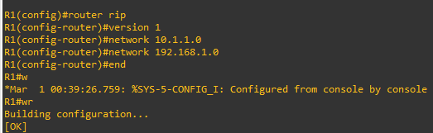

To configure the network route for the Router 2 (R2), we use the RIP protocol. Using router rip – version 2 we set the network route PC 2 and Router 2. This includes the two serial connections (serial 1/0, serial 1/1) and the fastEthernet 0/0 connection.

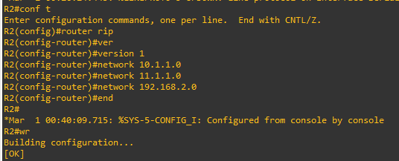

To configure the network route for the Router 3 (R3), we use the RIP protocol. Using router rip – version 2 we set the network route PC3 and Router 3. This includes the serial connection serial 1/1 and the fastEthernet 0/0 connection.

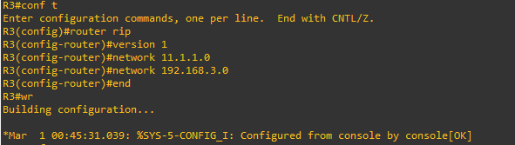

To check whether the routing has been done and the connection has been made, we use a simple ping. If it returns a successful message, we can assume that the routing of the network has been done for all the routers.

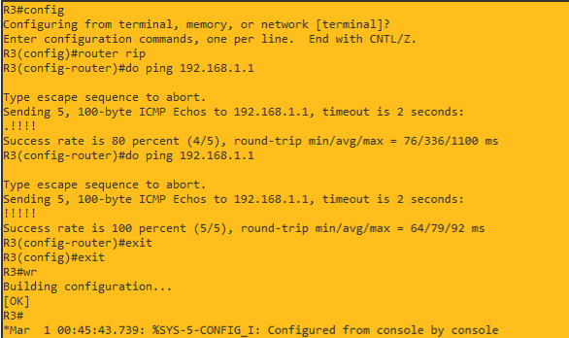

**1. To apply Standard ACL:**

Here the scenario we are going to use is that whatever data that is being sent by PC 1 should not be received by PC 3, so based on the features of a standard ASL, we know that it needs to be place near the destination.

So by checking the network topology we can say that the best place to create a standard ASL is in Router 3 (R3). We should also note that the number of the standard ASL should be in the range of 1-99, in our case we have chosen 10. So by configuring the access list to ‘deny’, we can deny all communication from PC 1 to PC 2.

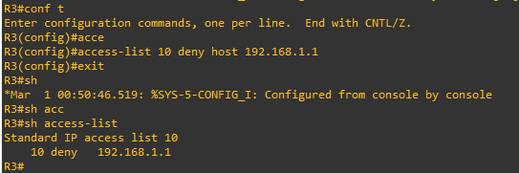

Note: The ‘deny’ keyword tends to deny access to the entire network, so we have to configure the access list for the serial interface 1/0 to allow data to be received from other devices other than PC 1. To achieve this we use the ‘permit’ keyword in the access-list configuration.

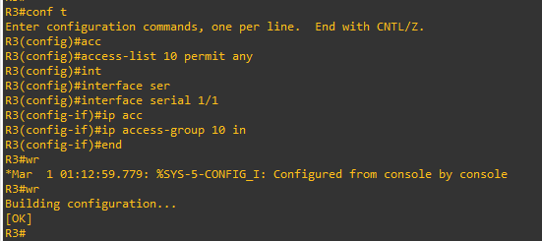

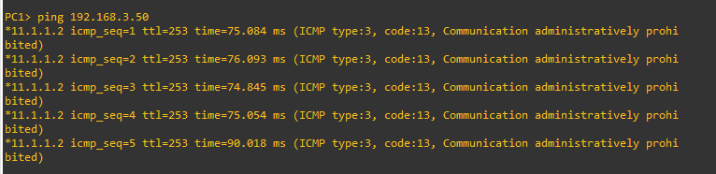Here we can observe that when PC 1 tries to send data to PC 3, its access is denied.

But when PC 1 tries to send data to PC 2, its access is not denied.

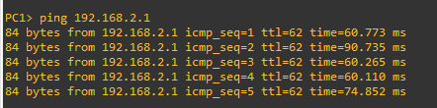

But when PC 3 tries to send data to PC 1, its access is not denied.

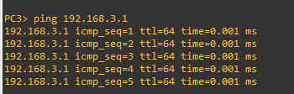

Based on this observation we can assume that we have successfully used a standard access list.

**2. To apply Extended ACL:**

Here the scenario we are going to use is that PC 2 should not be able to send data to PC 3. To achieve this we are going to use Extended ASL. The concept of extended ASL states that we need to place it close to its source. So in terms of the network topology and the position of PC 2, the closest place that is near the source would be Router 2 (R2). We should also note that the number of the extended ASL should be in the range of 100-199, in our case we have chosen 141.

So by configuring the access list to ‘deny’, we can deny all communication from PC 2 to PC 3. The difference between the standard ASL and the extended ASL in this regard is that in extended ASL we have to mention both the source and the destination, whereas in standard ASL we have to only mention the destination.

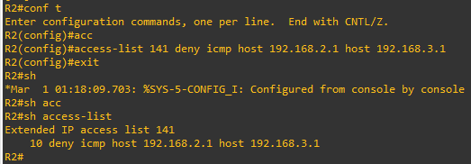

Note: The ‘deny’ keyword tends to deny access to the entire network, so here we have to initially give permission for other devices to send data to PC 2 and then group the output that is provided by PC 2 via the serial interface 1/1 in order to prevent it from sending any data to PC 3. To achieve this we use the ‘permit’ keyword in the access-list configuration.

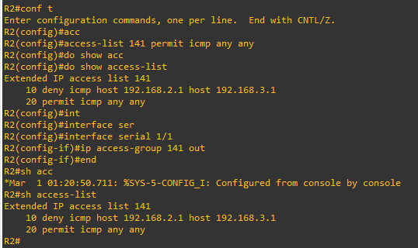

Here we can observe that when PC 2 tries to send data to PC 3, its access is denied.

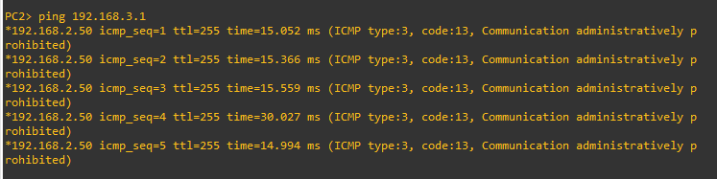

Similarly when PC 3 tries to send data to PC 2, nothing gets through since all communication has been blocked between them.

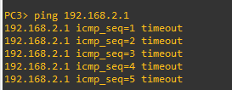

But when PC 1 tries to send data to PC 2, its access is not denied.

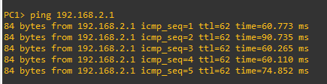

Similarly when PC 2 tries to communicate with PC 1, its access is not denied

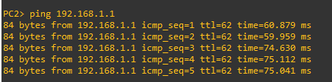

Based on this observation we can assume that we have successfully used an extended access list

**Practical 4**

**Aim:**

**1. Implement a GRE Tunnel**

**2. Implement VTP**

**3. Implement NAT**

1. **Implement a GRE Tunnel:**

**What is GRE Tunnelling?**

Generic Routing Encapsulation, or GRE, is a protocol for encapsulating data packets that use one routing protocol inside the packets of another protocol. "Encapsulating" means wrapping one data packet within another data packet, like putting a box inside another box. GRE is one way to set up a direct point-to-point connection across a network, for the purpose of simplifying connections between separate networks. It works with a variety of network layer protocols.

Encapsulating packets within other packets is called "tunnelling." GRE tunnels are usually configured between two routers, with each router acting like one end of the tunnel. The routers are set up to send and receive GRE packets directly to each other. Any routers in between those two routers will not open the encapsulated packets; they only reference the headers surrounding the encapsulated packets in order to forward them.

**Step 1:** Design the Topology.

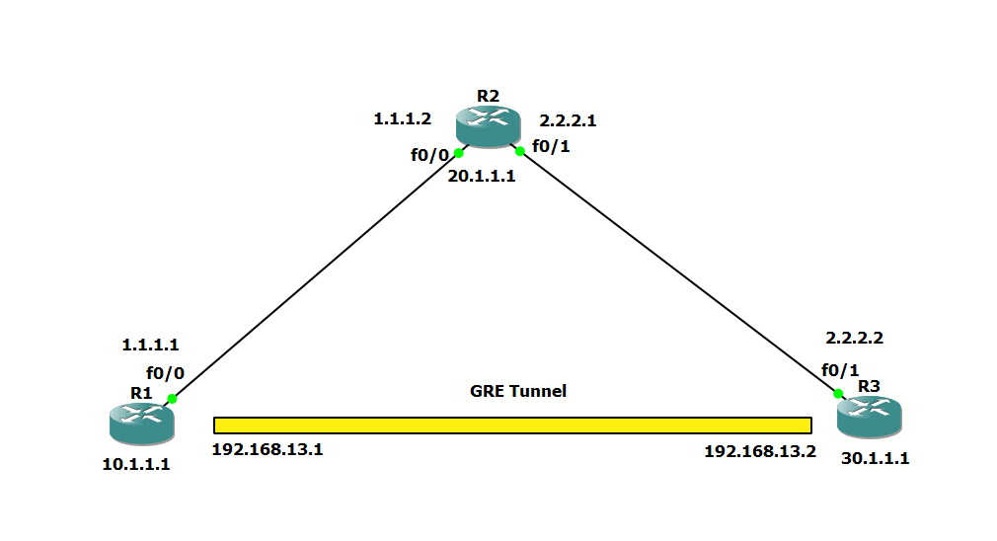

**Step 2:** Configure the System.

* 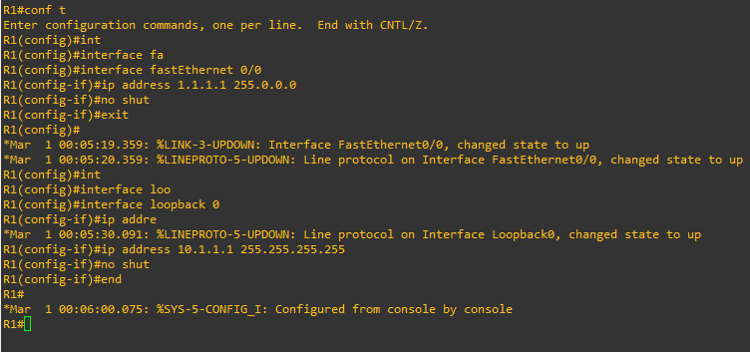**R1:**
* **R2:**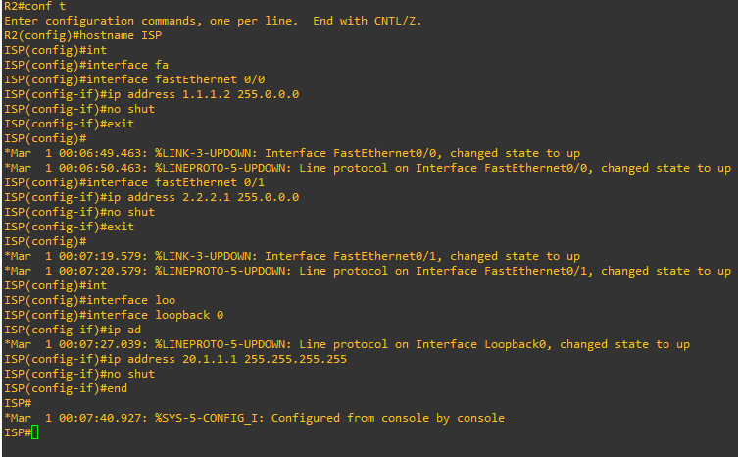
* **R3:**

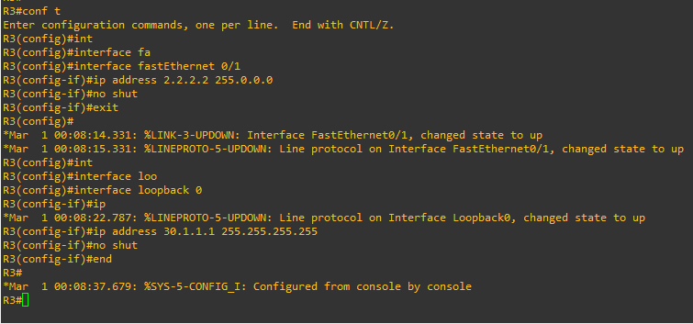**Step 3:** Check the connection between R1, ISP, R3.

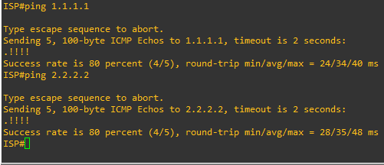

**Step 4:** Create the GRE Tunnel.

* **R1:**

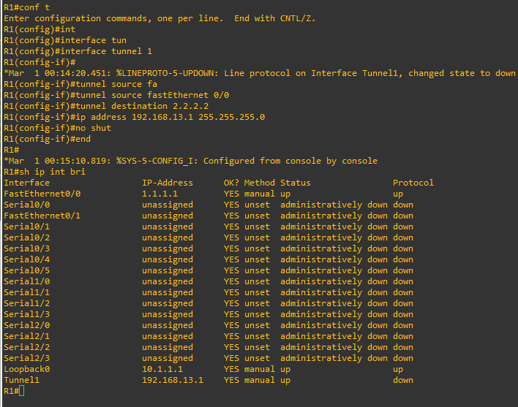

* 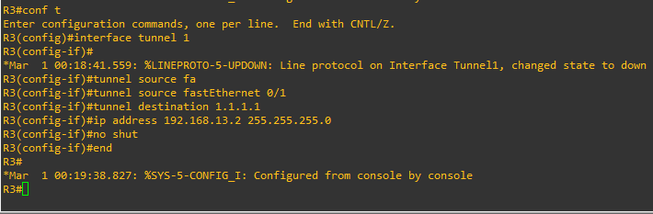**R3:**

**Step 5:** Assign a Static Route for R1 & R3.

* **R1:**
* **R3:**

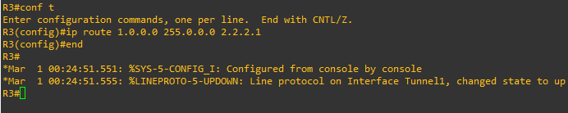

**Step 6:** Check whether the tunnel works.

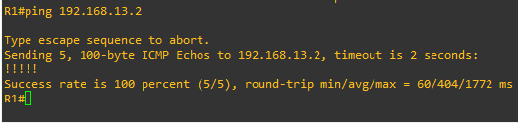

**Step 7:** Configure EIGRP for R1 & R3.

* **R1:**

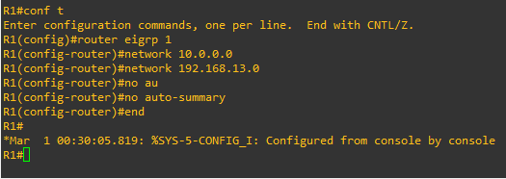

* 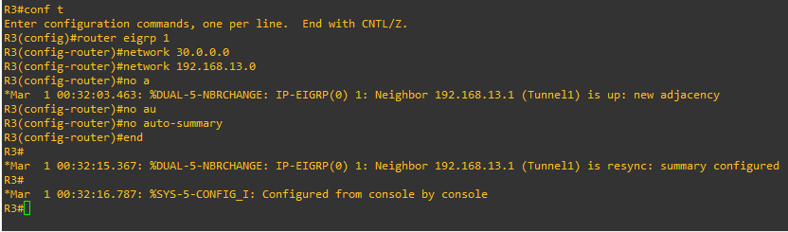**R3:**

**Step 8:** Check whether EIGRP is configured for R1 & R3.

* **R1:**

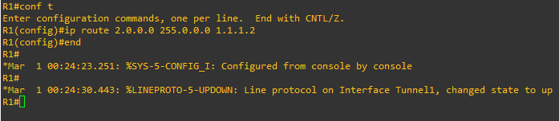

* **R2:**

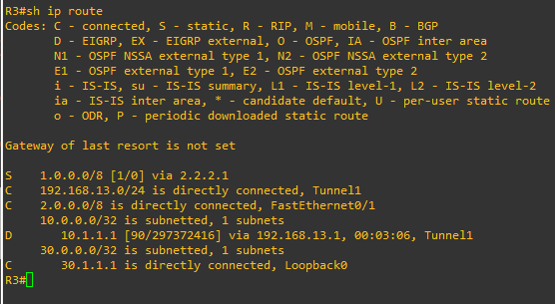

**Step 9:** To set MTU as the GRE Head.

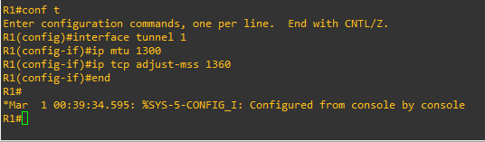

1. **Implement NAT:**

**What is NAT?**

Network Address Translation (NAT) is a process in which one or more local IP address is translated into one or more Global IP address and vice versa in order to provide Internet access to the local hosts. Also, it does the translation of port numbers i.e. masks the port number of the host with another port number, in the packet that will be routed to the destination. It then makes the corresponding entries of IP address and port number in the NAT table. NAT generally operates on a router or firewall.

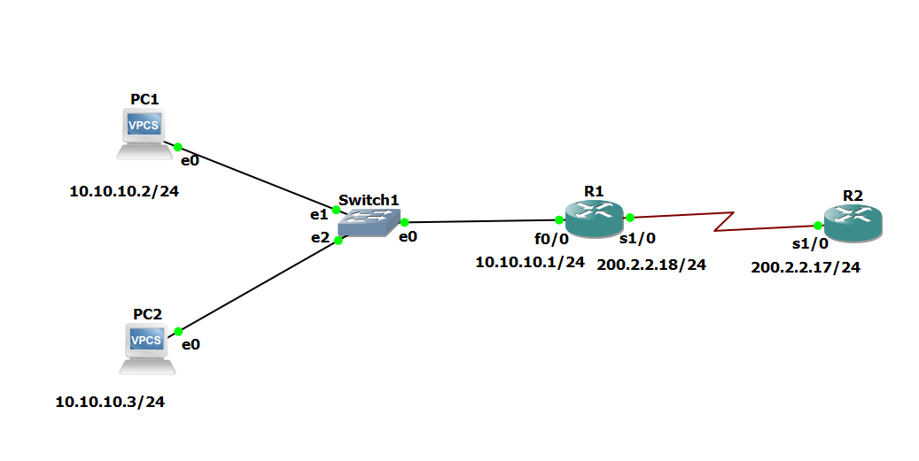**Step 1:** Design the Topology.

**Step 2:** Configure the network.

* **R1(gateway):**

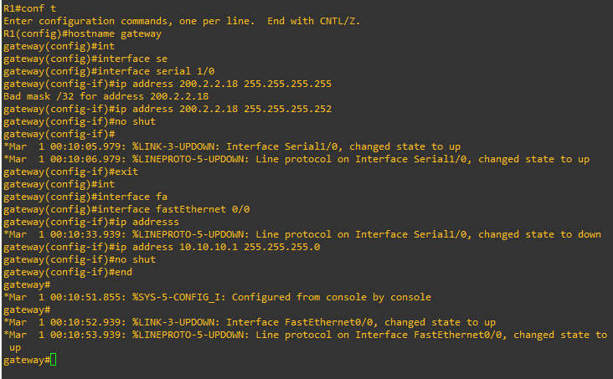

* **R2(ISP):**

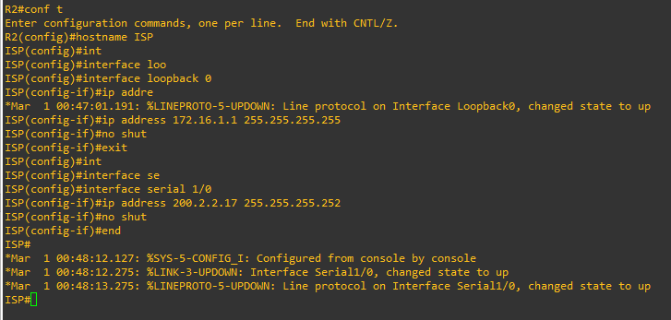

* 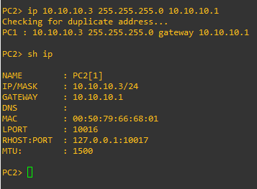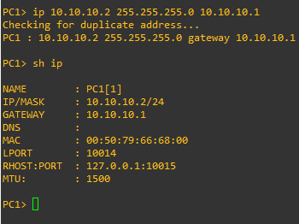**PC1**
* **PC2:**

**Step 3:** Create a Static Route.

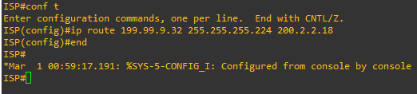

**Step 4:** Create a Default Route.

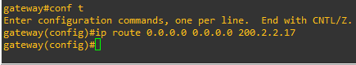

**Step 5:** Make a pool of IP Address which can be used as Public IP Address:

Run the command: **ip nat pool public-access 199.99.9.32 199.99.9.35 netmask 255.255.255.252**

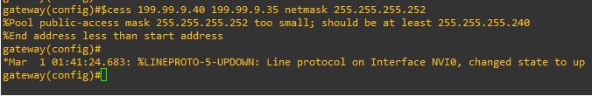

**Step 6:** Make an access list that will map the public IP addresses to the inside private IP addresses and define the NAT translation from inside list to outside pool.

**Step 7:** Now we will define which interface is inside and which one is outside.

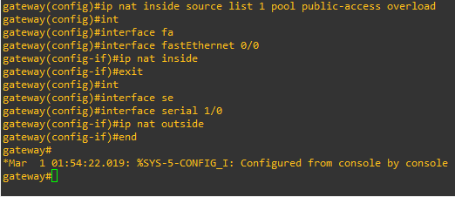

**Step 8:** Now ping from the PC to the loopback of ISP.

**PC1:**

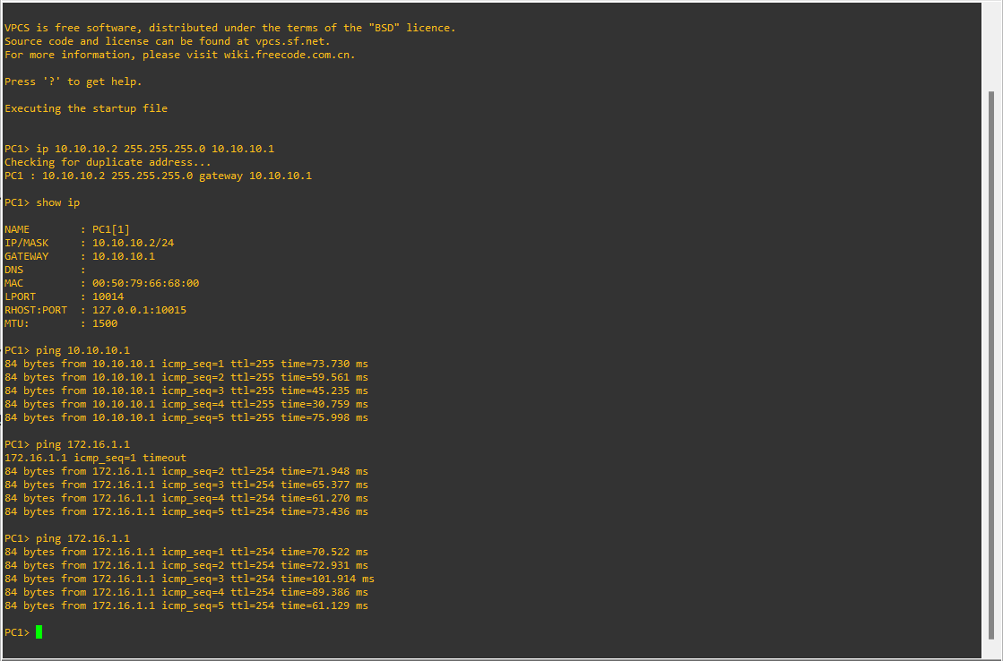

**PC2:**

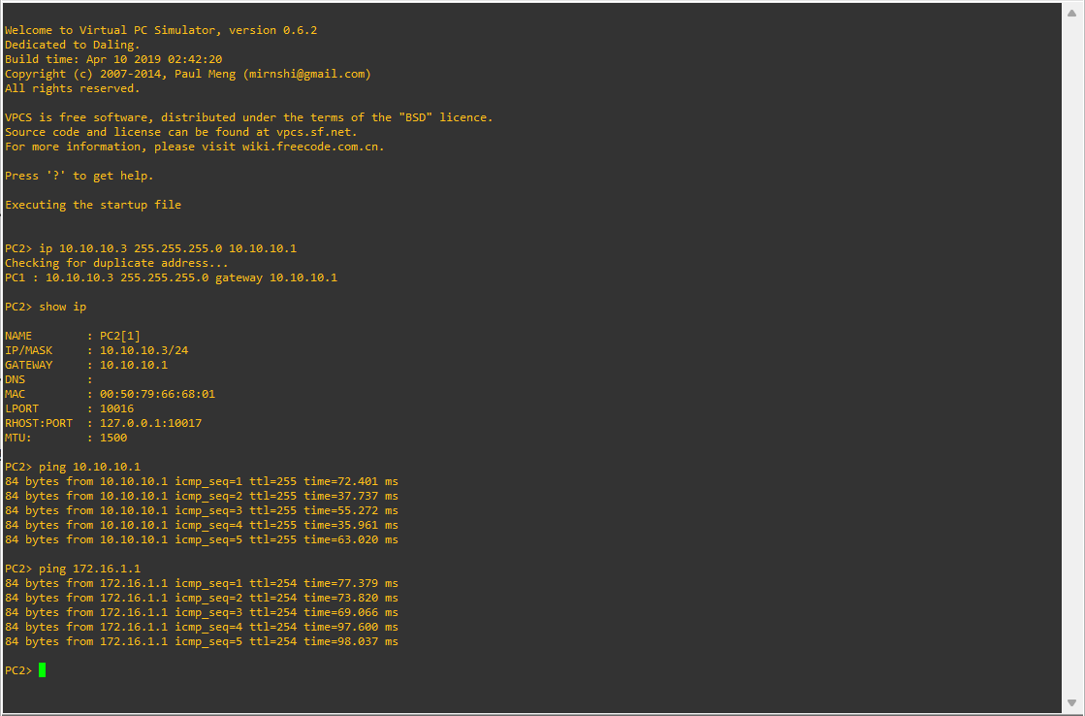

**Step 9:** Verify NAT & PAT Translations.

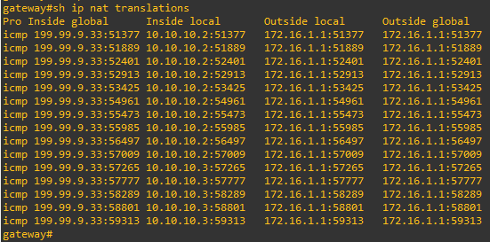

**Step 10:** Verify NAT & PAT Statistics.

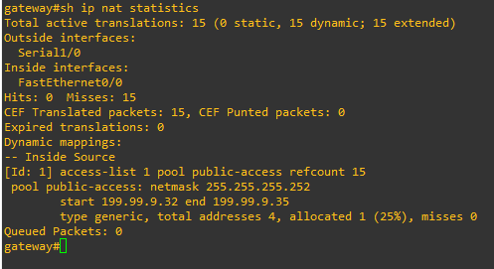

**Practical 5**

**Aim: Implement Inter-VLAN Routing.**

**What is Inter-VLAN Routing?**

* Inter-VLAN routing is a method of forwarding traffic between various VLANs in a network by deploying a router.
* When a router is present, VLAN logically divides the switch into distinct subnets.
* When connected to the switch, an administrator can configure the router to forward the traffic between the switch's multiple VLANs.
* The user nodes in the VLANs forward traffic to the router, which then forwards the traffic to the target network regardless of the VLAN configuration on the switch.

**Step 1:** Download and install the Layer 2 Switch.

* **You can download the Layer2Switch from this link:**

[**https://www.sysnettechsolutions.com/en/download-vios-l2-image-for-gns3/**](https://www.sysnettechsolutions.com/en/download-vios-l2-image-for-gns3/)

* **To install it on GNS3 follow the steps given here:**

[**https://www.sysnettechsolutions.com/en/add-layer-2-switch-in-gns3/**](https://www.sysnettechsolutions.com/en/add-layer-2-switch-in-gns3/)

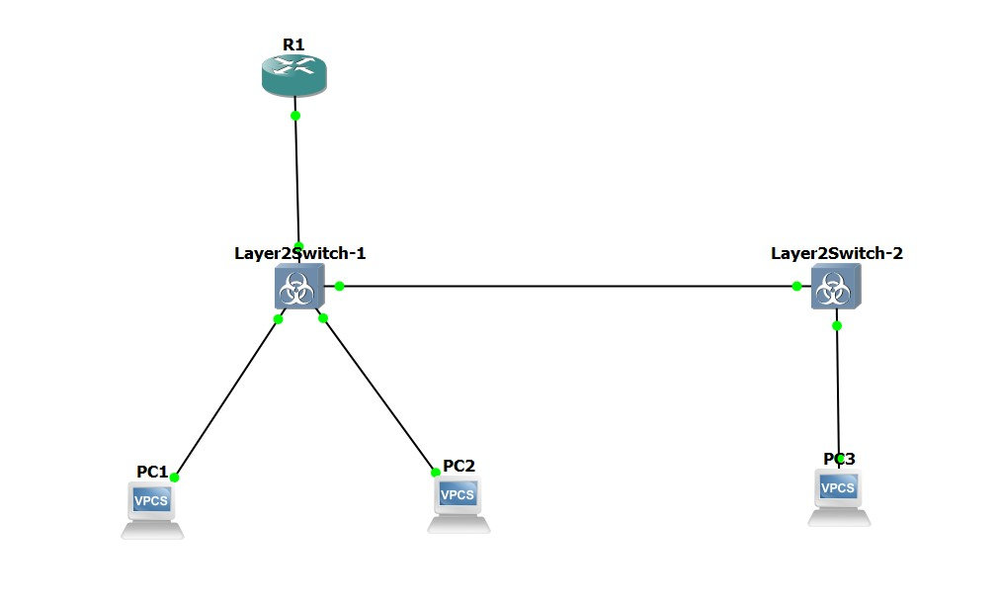**Step 2:** Build the topology.

**Step 3:** Configure the switches so that we can attach the wires as above.

**Configure the Layer2Switch-1.**

Set the RAM to 400 MB and change the adapter count to 4.

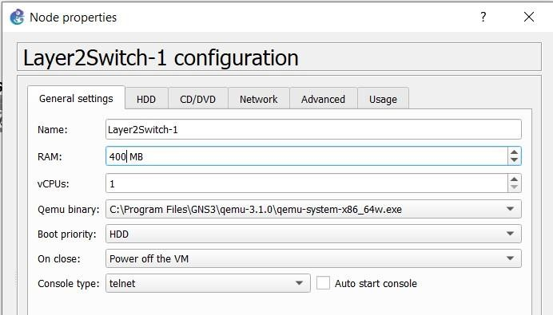

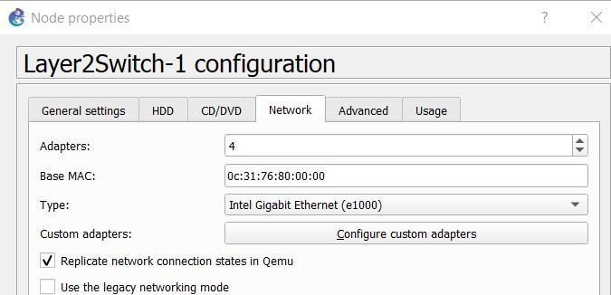

**Configure the Layer2Switch-2.**

Set the RAM to 300 MB and change the adapter count to 2.

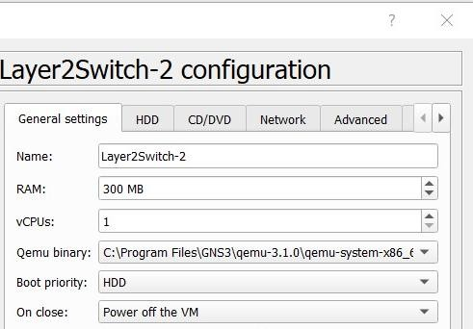

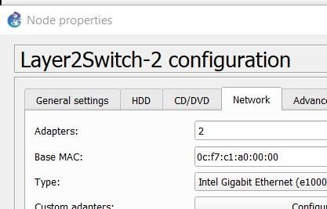

**Step 4:** Configure the Switches and the PCs.

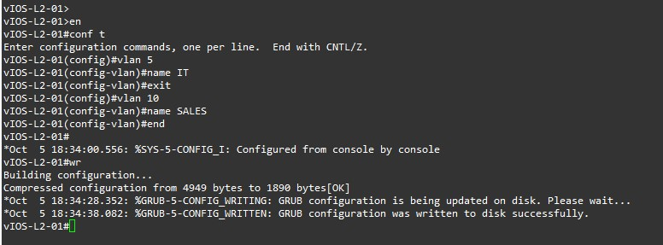**Layer2Switch-1:**

**Layer2Switch-2:**

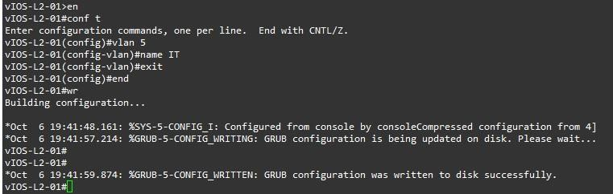

**PC1:**

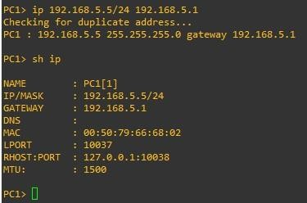

**PC2:**

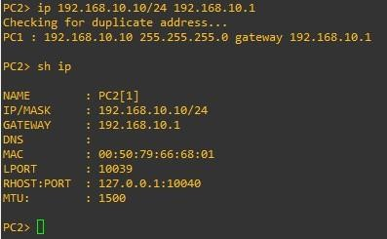

**PC3:**

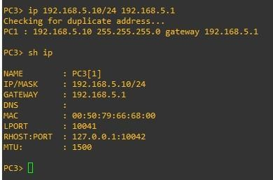

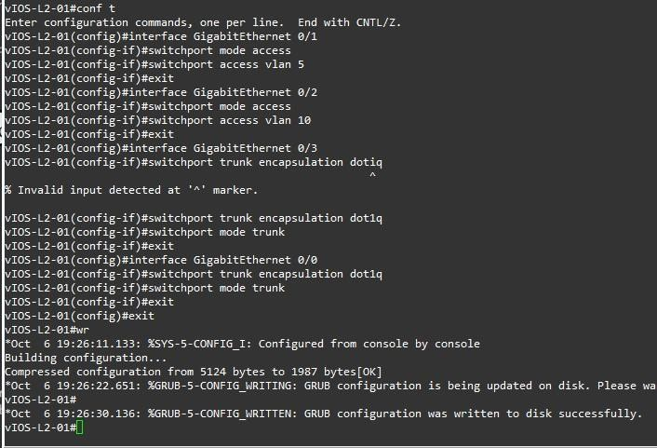**Step 5:** Now we configure trunk and the access interface for the Switches.

**Layer2Switch-1**

**Layer2Switch-2:**

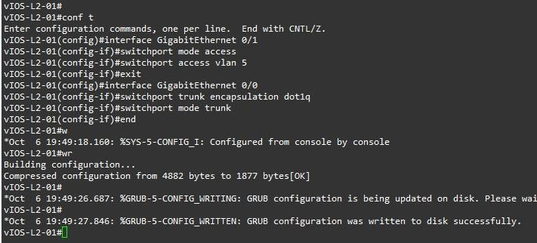

**Step 6:** Configure the Router.

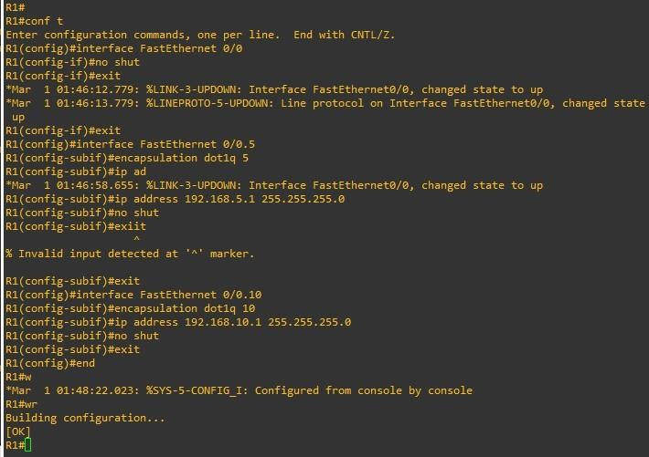

* After configuration the network topology should look similar to this.

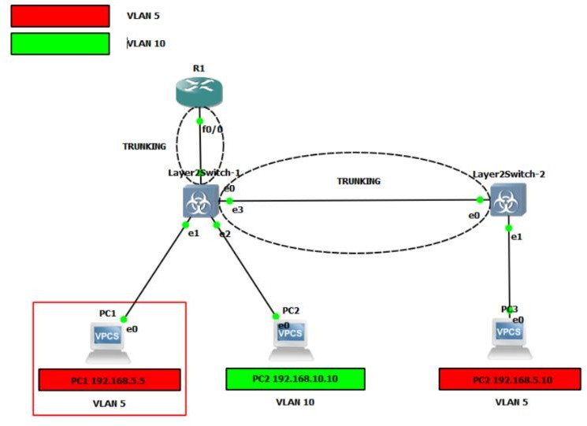

**Step 7:** Test the network.

**PC1:** Now we ping the PC1 to the V2 member PC2 and test the connection. Check that the routing between VLAN’s is working properly.

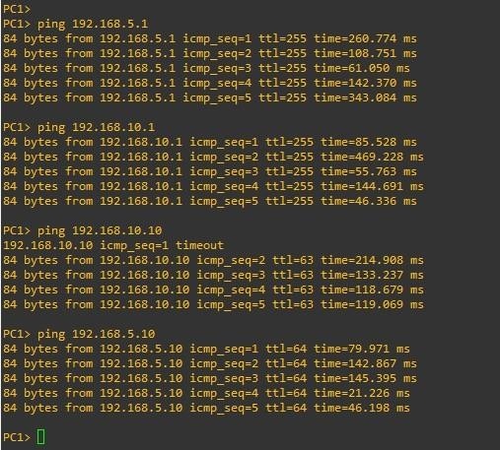

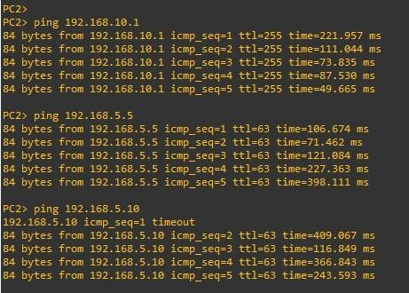**PC2:** Now we ping from PC2 to PCs that are a member of VLAN5.

**PC3:** Similarly we ping from PC3 to other PCs that are a member of VLAN10.

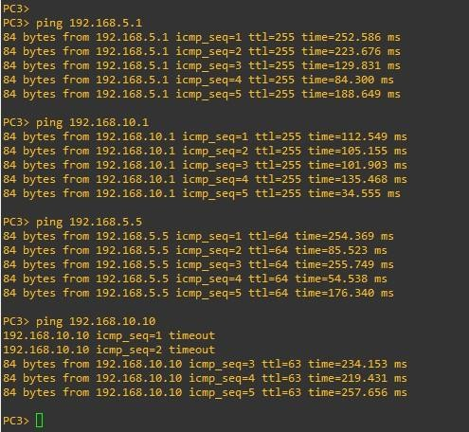

**Step 8:** Check the brief of VLAN on both the switches.

**Layer2Switch-1:**

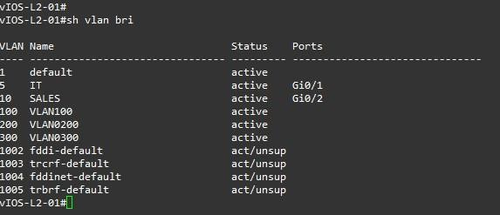

**Layer2Switch-2:**

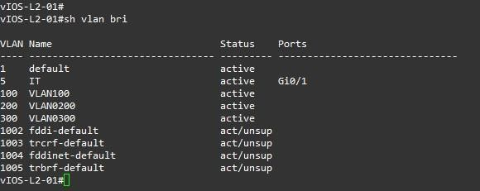

**Step 9:** Now we check the running configuration on both the switches.

**Layer2Switch-1:**

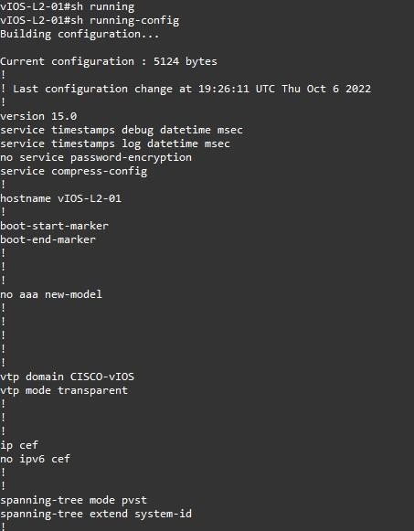

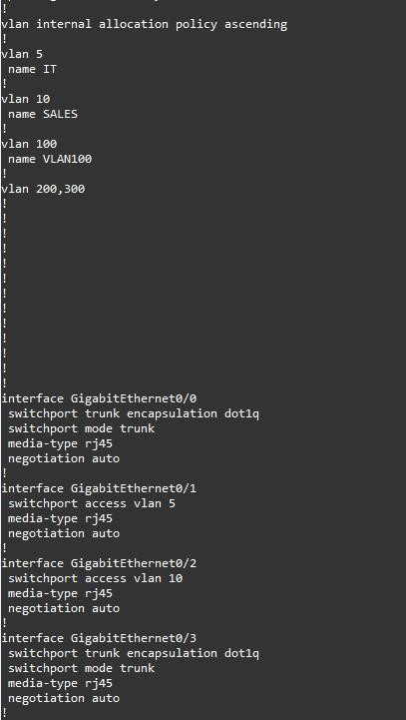

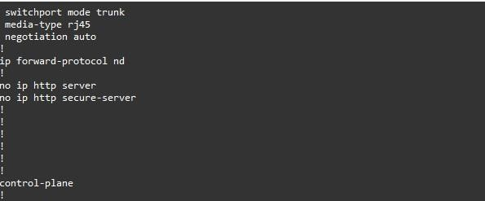

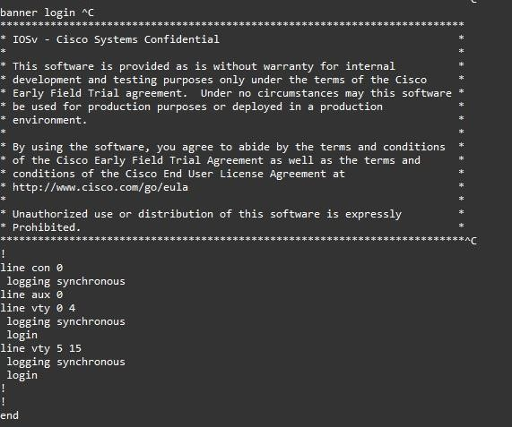

**Layer2Switch-2:**

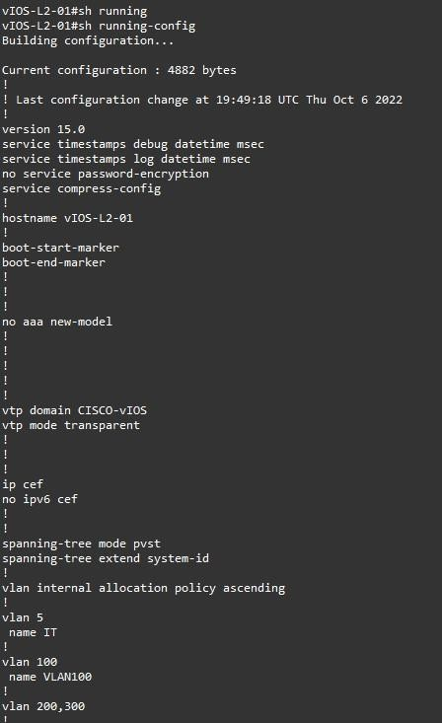

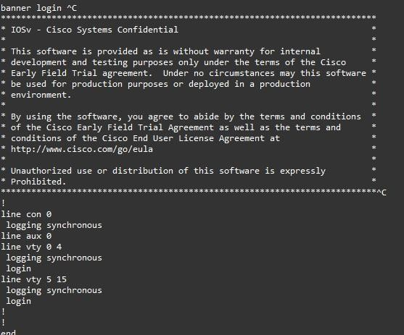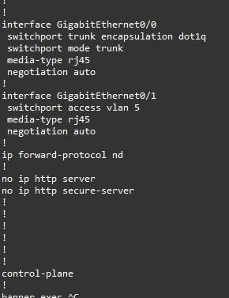

**Step 10:** Now we see the trunk interfaces of both the switches.

**Layer2Switch-1:**

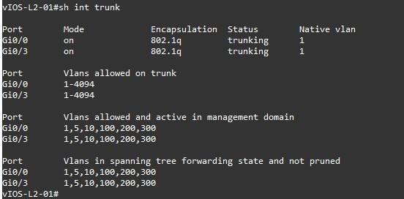

**Layer2Switch-2:**

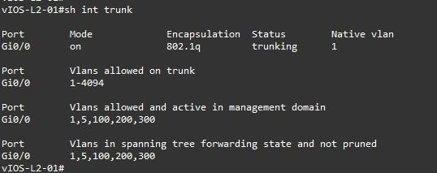

**Step 11:** Now we see the overall running configuration of Router R1.

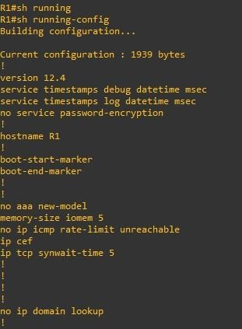

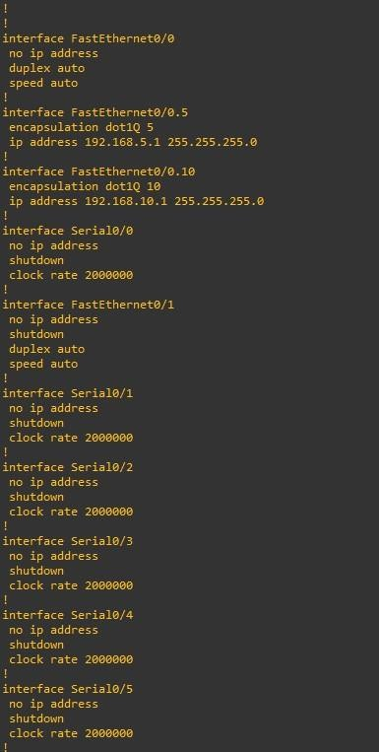

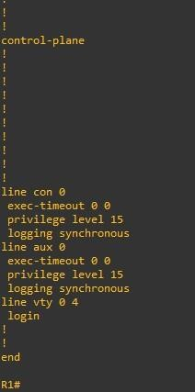

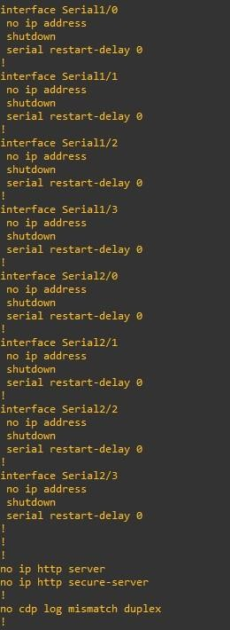

**Practical 6**

**Aim: Observe STP Topology Changes and implement RSTP**

**1. Implement Advanced STP Modifications and Mechanisms**

**2. Implement MST**

**1. Implement Advanced STP Modifications and Mechanisms**

**What is STP?**

Spanning Tree Protocol (STP) is a Layer 2 network protocol used to prevent looping within a network topology. STP was created to avoid the problems that arise when computers exchange data on a local area network (LAN) that contains redundant paths. If the flow of traffic is not carefully monitored and controlled, the data can be caught in a loop that circles around network segments, affecting performance and bringing traffic to a near halt.

Networks are often configured with redundant paths when connecting network segments.  Although redundancy can help protect against disaster, it can also lead to bridge or switch looping. Looping occurs when data travels from a source to a destination along redundant

paths and the data begins to circle around the same paths, becoming amplified and resulting in a broadcast storm.

STP can help prevent bridge looping on LANs that include redundant links. Without STP, it would be difficult to implement that redundancy and still avoid network looping. STP monitors all network links, identifies redundant connections, and disables the ports that can lead to looping.

**Step 1: Design the Topology.**

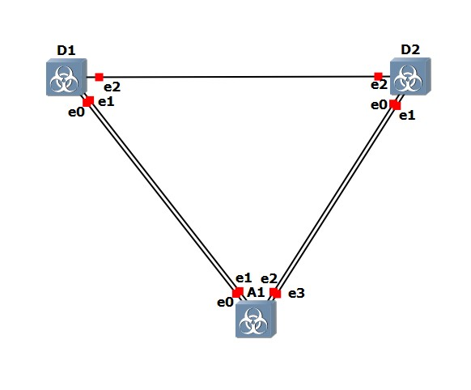

**Step 2: Configure the network.**

• **Configure Switch D1:**

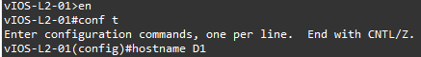

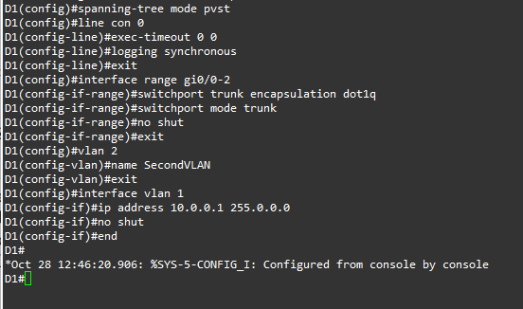

• **Configure Switch D2:**

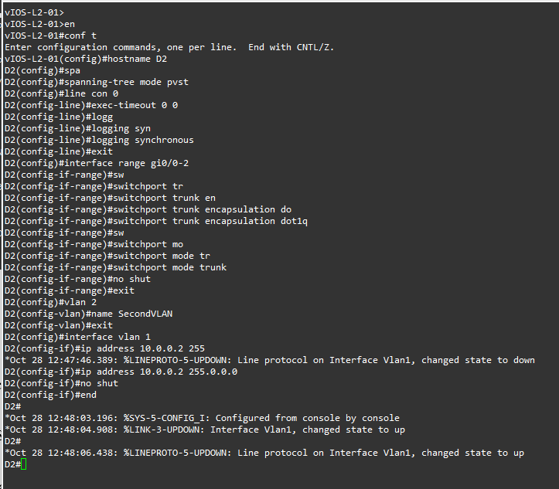

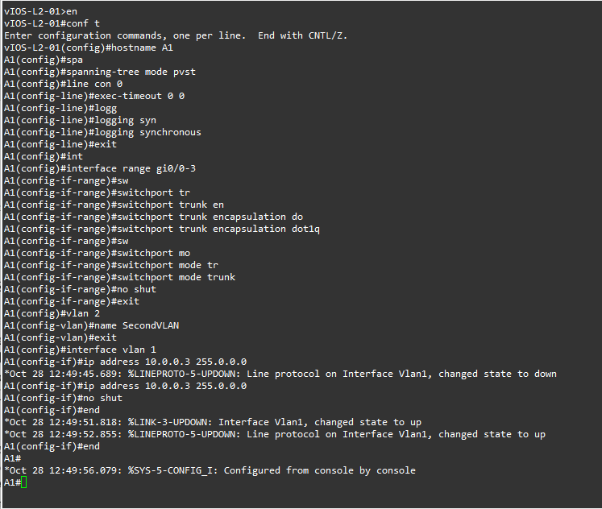• **Configure Layer 2 Switch 1 (A1):**

**Step 3: Discover the Default Spanning Tree.**

• **Find the root bridge.**

On A1, issue the command show spanning-tree root and observe what the output tells you about the root bridge. Amongst the lab devices being used to document this lab, A1 shows the root id with a cost of 19 and the root port as interface FastEthernet 0/1 for both VLAN1 and VLAN2.

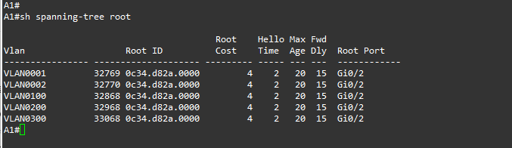

The root bridge is elected based upon which switch has the highest Bridge ID (BID).  The BID is made up of a configurable priority value (which defaults to 32768) and the base MAC address for the switch. Use the command show spanning-tree root to gather that information from your switches to support the root bridge decision.

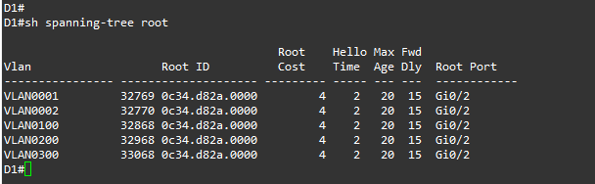

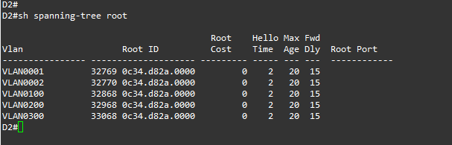



• **Find the Root Port for each switch.**

As we saw in the previous output of show spanning-tree root on each switch, the Path Cost can be different amongst switches. In this case, the path cost from A1 to D1 is 19, reflecting connectivity via a FastEthernet port, while the path cost from D2 to D1 is 4, reflecting connectivity via a GigabitEthernet port.







These are direct connections to the root, so port cost and path cost are the same. This can be seen in the output of show spanning-tree.

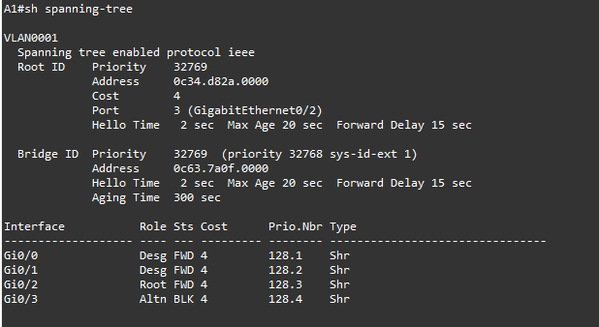

Our topology does not really illustrate the difference between port cost and path cost very well, so we will introduce a change in the network to achieve this. At D1, shutdown the g1/0/1 interface. The result of this is that D2 will have to change the port it considers root, and we will then see the difference between port cost and path cost.

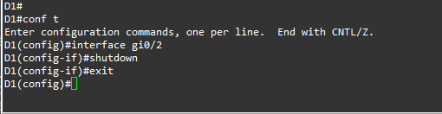

On D2, issue the command show spanning-tree and you will see the port cost and path cost values separating themselves.

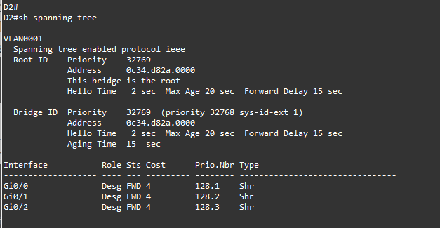

• **Identify Designated Ports.**

If you have not already done so, issue the no shutdown command for D1 interface g1/0/1. This will restore our full topology and allow for the non-root attached segment to exist (the links between A1 and D2).

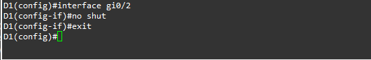

On D2, issue the show spanning-tree command, and you will see that there are two ports now identified as being in the Designated Port role.



And now look at the segments from the A1 side. Issue the show spanning-tree command on A1.

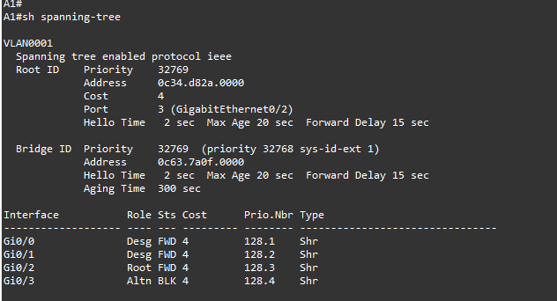

You may have noticed in the previous output that the two links from A1 to D1 were not being used.

**Step 4: Implement and Observe Rapid Spanning Tree Protocol.**

* **In Part 3, you will implement Rapid Spanning Tree (RSTP) on all the switches. Using the same basic rules, RSTP speeds up convergence significantly.**

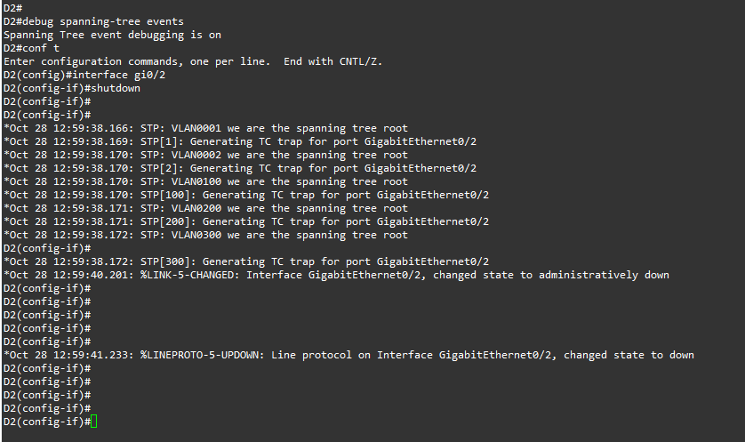On D2, issue the debug spanning-tree events command, and then issue the shutdown command for interface g1/0/1 and observe the output.

On D1, change the spanning tree mode to rapid-pvst:



On D1, issue the command show spanning-tree.

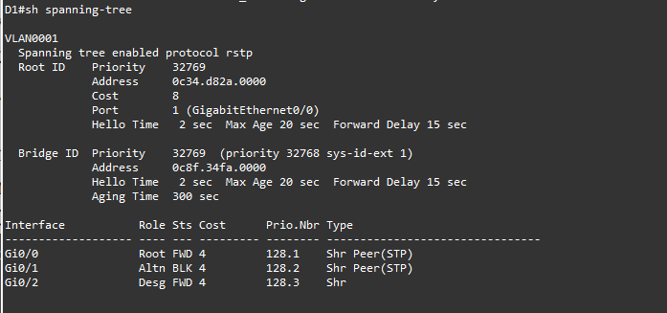

The type values tell the story. Rapid spanning tree is backwards compatible with common spanning tree. It achieves this backwards compatibility by falling back to using the timers and settings of common spanning tree. In other words, we will not see the benefits of rapid spanning tree if only one switch is running it.

On D2 and A1, change the spanning tree mode to rapid spanning tree.

For D2: (Note that I have only enabled the debugging mode for D2, this is why the output for D2 is different from D1 and A1 when the spanning-tree mode is set to rstp.)

For D2:

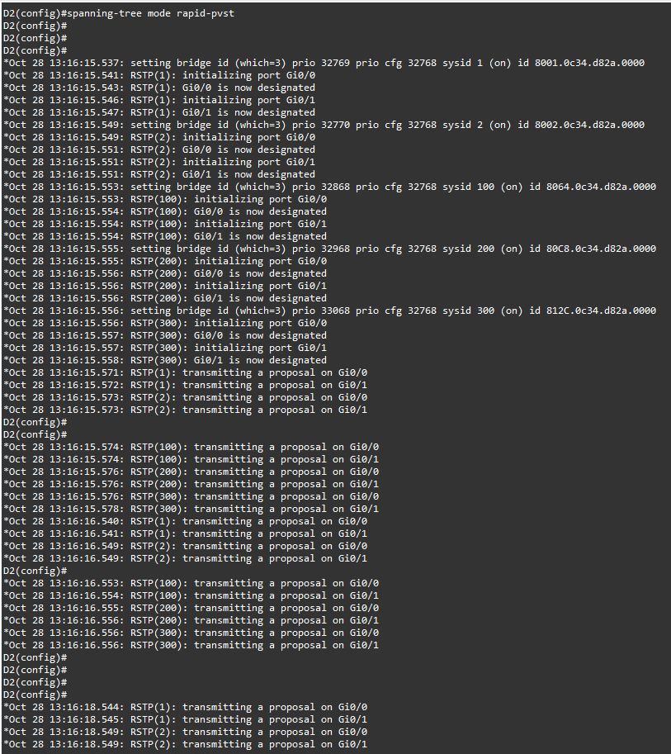

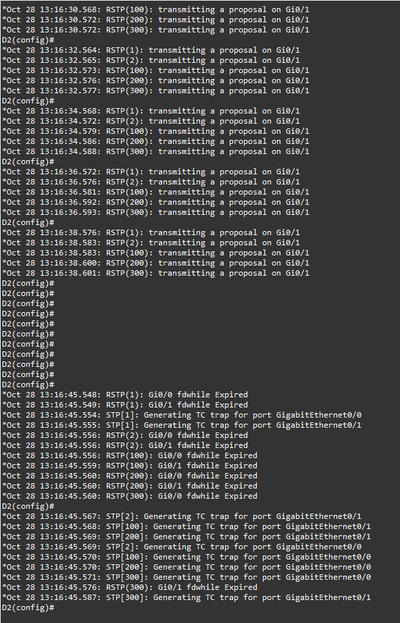

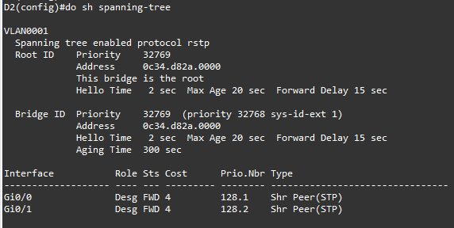

For A1:

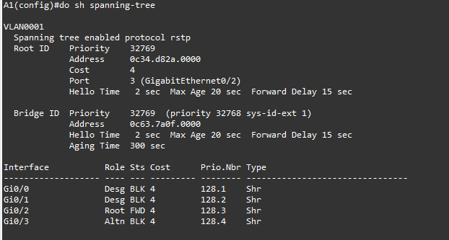

**2. Implement MST.**

**What is MST?**

Multiple Spanning Tree Protocol (MSTP), initially defined in IEEE 802.1s and later included in IEEE 802.1Q, supports mapping of multiple VLANs onto a single spanning-tree instance.  This reduces the number of spanning-tree instances required in a switched network with many VLANs.

Although RSTP provides faster convergence time than STP does, it still does not solve a problem inherent in STP: all VLANs within a LAN must share the same spanning tree. To solve this problem, the QFX Series products use Multiple Spanning Tree Protocol (MSTP) to create a loop-free topology in networks with multiple spanning-tree regions. An MSTP region allows a group of bridges to be modeled as a single bridge. An MSTP region contains multiple spanning-tree instances (MSTIs). MSTIs provide different paths for different VLANs. This functionality facilitates more efficient load sharing across redundant links.

An MSTP region can support up to 64 MSTIs, and each instance can support from 1 through 4094 VLANs.

**Step 1: Design the Topology.**

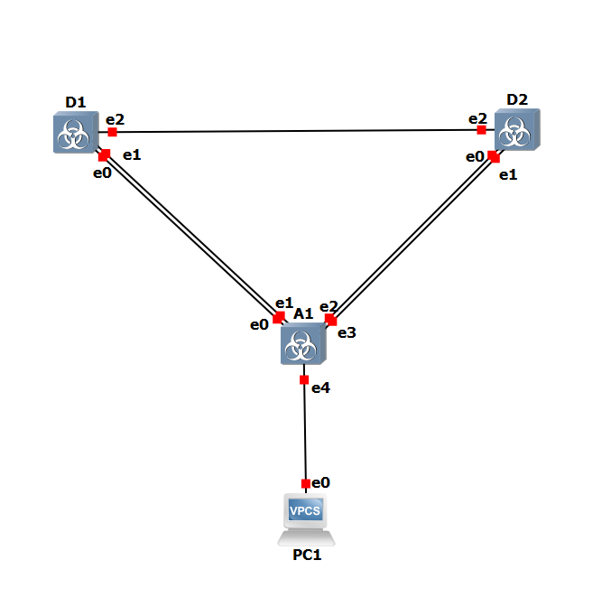

**Step 2: Configure the devices.**

• **Configure Switch D1:**

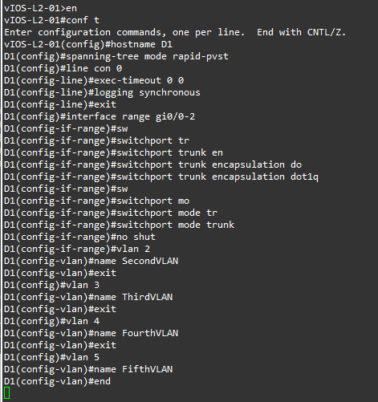

• **Configure Switch D2:**

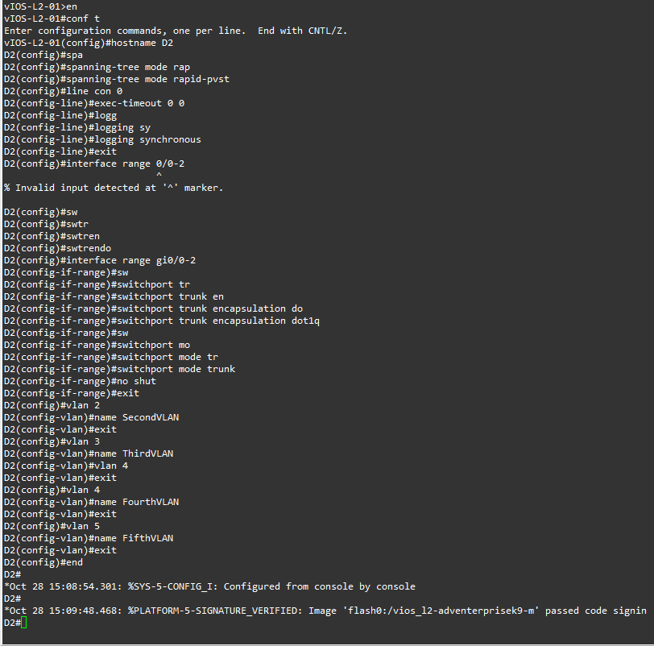

• **Configure Switch A1:**

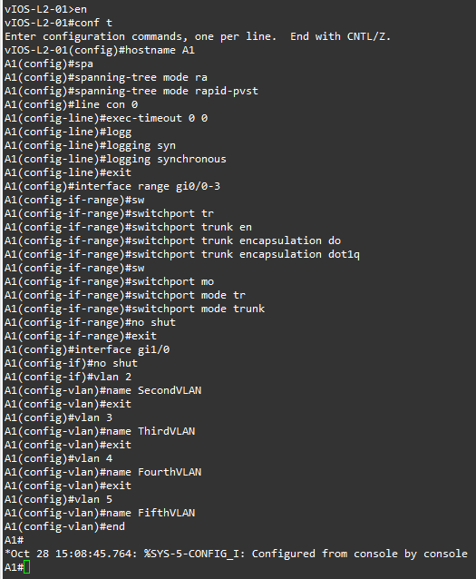

**Step 3: Implement and Observe MST.**

• **Configure MST on D1 and D2.**

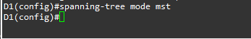On D1 and D2, issue the command spanning-tree mode mst.

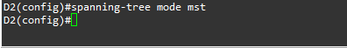

At this point, with no MST-specific configuration, MST Instance 0 is operational for all VLANs. Issue the command show spanning-tree and you will see in the output that the spanning tree information is about MST 0. Issue the command show spanning-tree mst and you will see the MST-specific STP information that is specific to MST 0 only. Take note of the information displayed for interfaces g1/0/5 and g1/0/6 because they are connected to a switch that is not running MST. Their type is listed as P2p Bound (PVST).

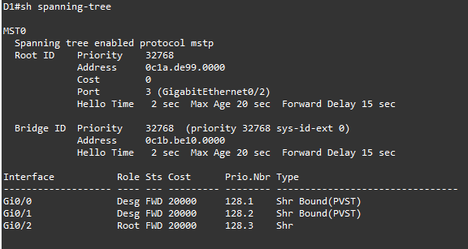

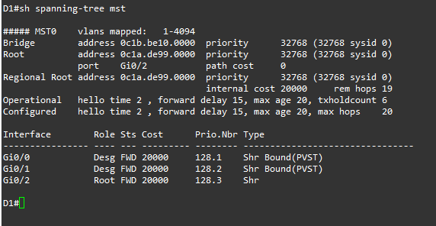

The basic behaviour of MST is the same as spanning tree, where a root bridge must be selected, then root ports, and finally best paths to the root bridge from all non-root bridges. In the current network, we can see that D1 has been elected the root bridge.  The bridge priority defaults to 32768, so the election is based on D1 having a lower base MAC address. The switch elected as root may be different in your lab topology, but the rules for election remain the same. Issue the command show spanning-tree root on switch A1. Switch A1 is running five instances of spanning tree.

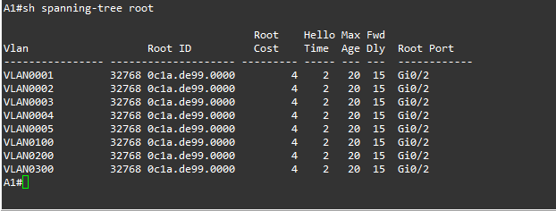

Issue the show spanning-tree root command on D2 and the output will be different.  This is because with MST, only one instance of the spanning-tree algorithm runs, regardless of the number of VLANs mapped to it.

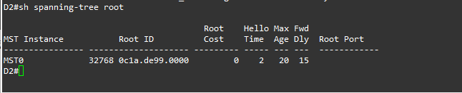

Configure A1 to use MST.

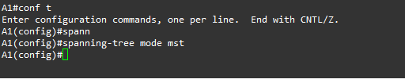

**Step 4: Configure, Tune and Verify Basic MST Operation.**

In the last part, you configured all three switches to run MST. In this part, you will further configure, tune, and verify MST to support the unique topological requirements.

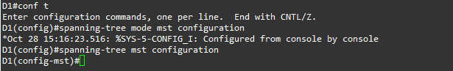• **Create and verify an MST configuration.**

Enter MST configuration mode using the command spanning-tree mst configuration.

Configure an MST region name. Our example will be CCNPv8.



Configure an MST configuration revision number. Our example will be 1.



Configure instance 1 to include VLAN 2.

Configure instance 2 to include VLAN 4.



Commit the configuration by typing exit and returning to global configuration mode.

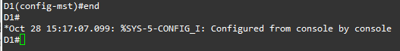

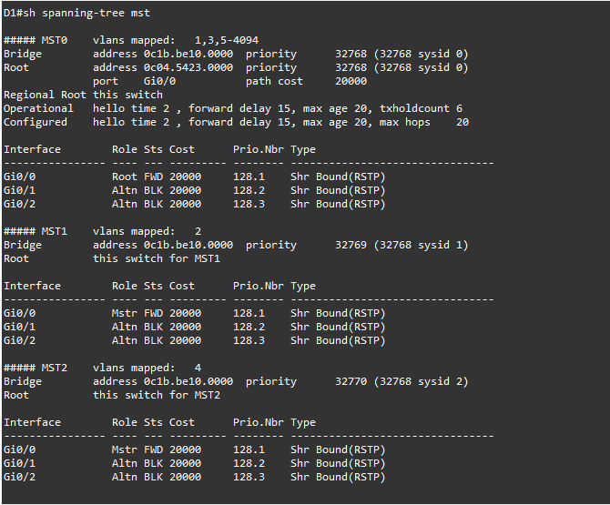Issue the command show spanning-tree mst to verify the configuration is in place.

This configuration does not propagate to other switches. Each switch exchanges digest information summarizing the VLAN-to-Instance mappings it has configured. If a switch receives a BPDU with a different digest, it assumes that the sender is in a different MST region. The output below is what A1 shows in the topology used to create this lab. Notice that the ports connected to D1 are classified as P2p Bound (RSTP).

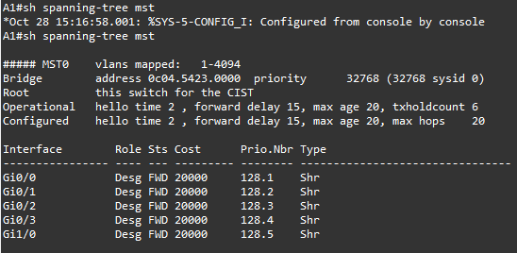

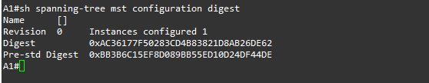

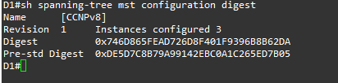And here is the digest from D1:

Configure MST on D1, change the revision number to 2 and add VLAN 3 to instance 1 and VLAN 5 to instance 2.

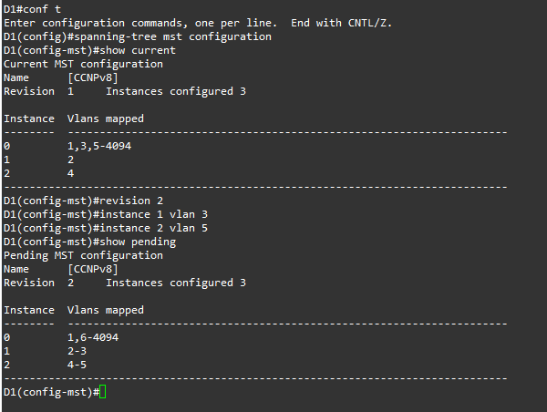

Now configure D2 and A1 with the same configuration settings (name CCNPv8, revision2, instance 1 vlans 2-3, instance 2 vlans 4-5). After completing the configuration on D2 and A1, the output of show spanning-tree mst on A1 should be similar to the following output. D1 in this case is the root for all 3 instances.

D2:

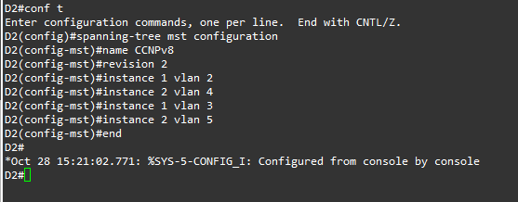

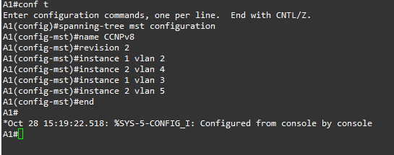

A1:

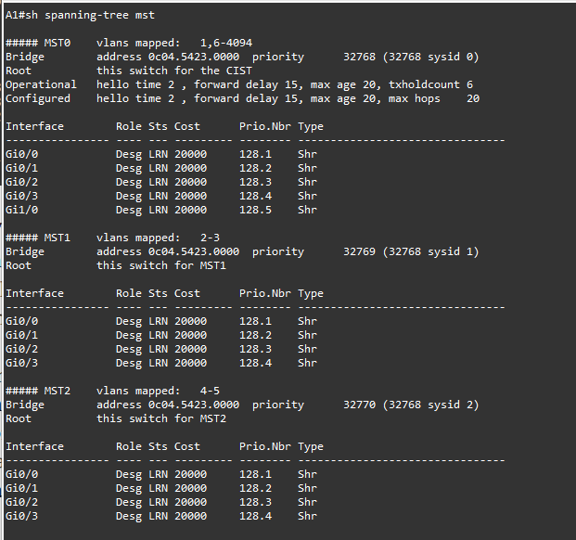

• **Controlling the Root Bridge.**

Just like with PVST+ and Rapid PVST+, the current root bridge was elected based on the lowest Bridge ID (consisting of the Priority, extended system ID equal to the VLAN ID, and base MAC address values).

With the priority and extended system IDs being identical, the root bridge’s MAC is numerically smaller than the local bridge’s MAC. The result is that in a completely un-configured network, one single switch will be elected as the root bridge. The resulting choice of switch may or may not be desirable.

With PVST+ or Rapid PVST+, root bridge selection is done for each VLAN. With MST, the root bridge is based on instances.

There are two basic ways to manipulate the configuration to control the location of the root bridge:

* The spanning-tree mst instance-id priority value command can be used to manually set a priority value
* The spanning-tree mst instance-id root {primary | secondary} command can be used to automatically set a priority value.

Modify D1 and D2 so that D1 is elected the primary root bridge for MST Instance 1 and D2 is elected the primary root bridge for MST Instance 2. D1 should be elected as the secondary root bridge for MST

Instance 2, and D2 should be elected as the secondary root bridge for MST Instance 1.  You will need to make configuration changes on both D1 and D2. The commands used at D1:

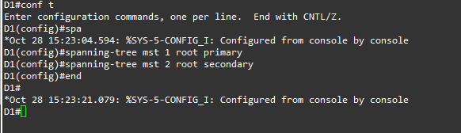

After you have configured both D1 and D2, go to A1 and issue the command show spanning-tree root. In this output, you will see the root bridges differentiated.

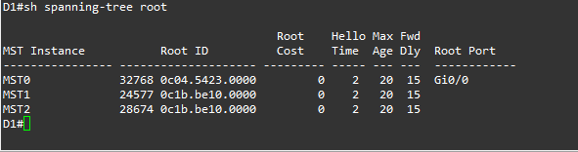

• **Adjust port cost values to impact root and designated port selection.**

As the network is implemented right now, there are two direct paths between switch A1and the root bridge for each MST. Path and port costs are evaluated to determine the shortest path to the root bridge. In the case where there are multiple equal cost paths to the root bridge, additional attributes must be evaluated. In our case, the lower interface number (for example, F0/1) is chosen as the Root Port, and the higher interface number (for example, F0/2) is put into a spanning tree Blocking state. You can see which ports are blocked with the show spanning-tree vlan-id command or the show spanning-tree blockedports command. For now, examine VLAN 1 on D1.

On A1, issue the commands show spanning-tree vlan 1 and show spanning-tree blockedports.

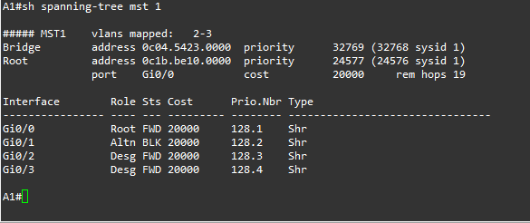

On A1, shutdown interfaces F0/1 and F0/2, assign a new port cost of 1000 to F0/2 using the spanning- tree mst 1 cost value command, and then issue the no shutdown command on the ports.

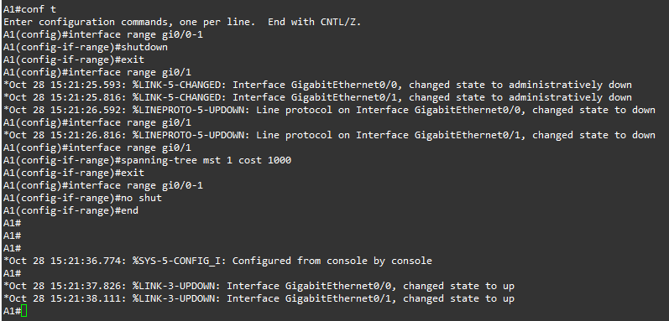

Now verify that this impacts root port selection on A1 using the show spanning-tree vlan 1 and show spanning-tree blockedports commands.

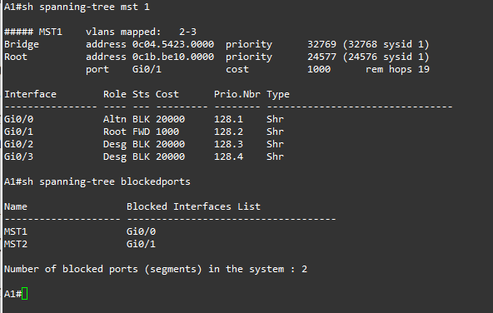

• **Adjust port priority values to impact root port selection.**

The next method to impact root port selection is configured on the root bridge itself.  In our current network topology, A1 has two connections to the root bridge for MST Instance 2, switch D2. The root port has been selected, in this case based on the lowest port ID. Port ID is made up of two values, labelled as Prio (Priority) and Nbr (Number).

The port priority can be any value between 0 and 240, in increments of 16 (older switches may allow setting the priority in different increments).

On A1, issue the command show spanning-tree mst 2 and take note of the port ID values listed.

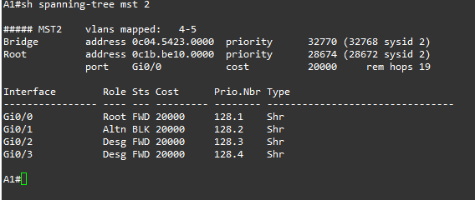

Modify the port priority of D2 interface G1/0/6 so that it becomes the preferred port by issuing the spanning-tree mst 2 port-priority value interface configuration command. Use a value of 64.

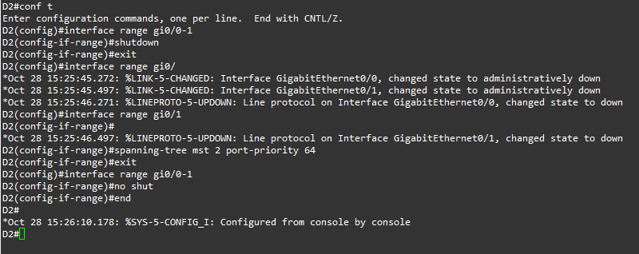

On A1, issue the show spanning-tree mst 2 command and you will see that Fa0/4 is now the selected root port. This selection is based on the lower priority value of D2 interface G1/0/6. Notice that the lower priority value does not appear in any A1 output.

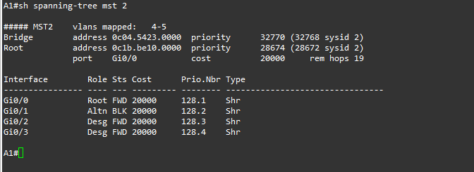

**Practical 7**

**Aim:**

**1. Implement EtherChannel**

**2. Tune and Optimize EtherChannel Operations**

**1. Implement EtherChannel.**

**What is EtherChannel?**

* EtherChannel is a port link aggregation technology in which multiple physical port links are grouped into one logical link.
* It is used to provide high speed links and redundancy. Maximum of 8 links can be aggregated to form a single logical link.
* EtherChannel protocols – To form an EtherChannel, there are 2 protocols, **port aggregation protocol (PAgP)** and **link aggregation control protocol (LACP).**
* **Port Aggregation Protocol (PAgP) –**

Port Aggregation Protocol is a Cisco proprietary protocol used to form an EtherChannel.

* **Link aggregation control protocol (LACP) –**

LACP is an IEEE standard, which is a part of the IEEE 802.3ad specification. It allows the user to combine numerous physical Ethernet links into one logical link.

* There are different modes in which you can configure your interface. These are namely:
  + **ON:** In this mode, the interface will be a part of EtherChannel, but no negotiation takes place.
  + **Desirable:** In this mode, the interface will continuously attempt to convert other side interface into an EtherChannel.
  + **Auto:** In this mode, the interface will become a part of EtherChannel if and only if it is requested by the opposite interface.
  + **Off:** No EtherChannel configured on the interface.

**Step 1: Design the Topology.**

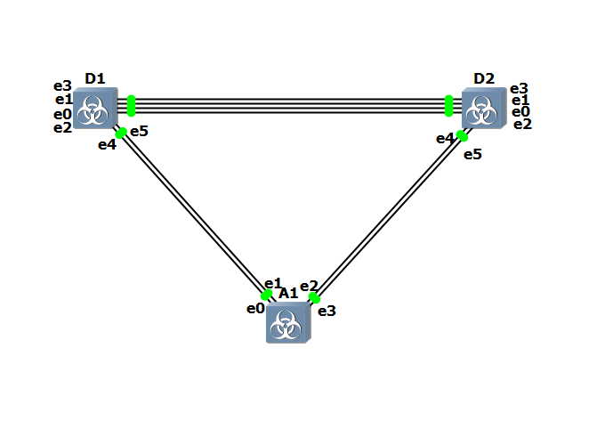

**Step 2: Configure the network.**

* **Examine the default port status and manipulate DTP.**

If the switches are in their default configuration, this connection between the two switches defaults to be an access port in VLAN 1, which can be seen in the output of show interfaces gi0/3 switchport of D1 and interfaces gi0/3 switchport of A1.

**D1:**

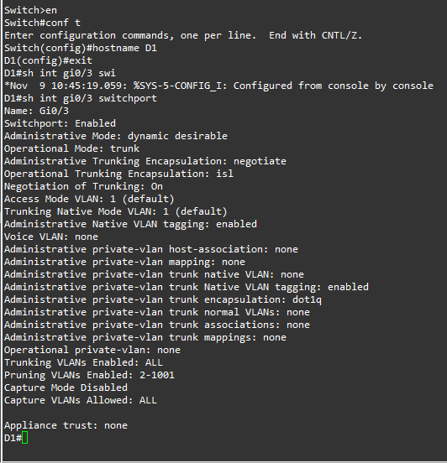

**A1:**

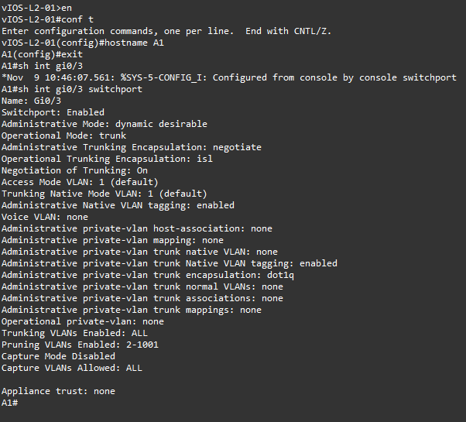

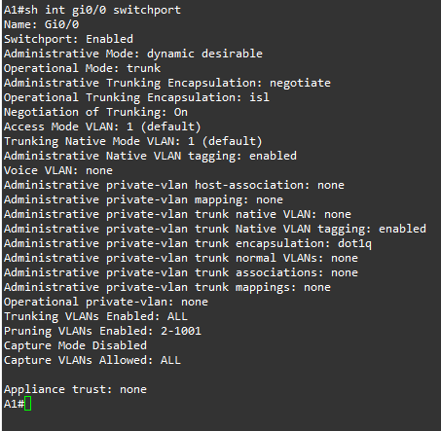

Check the interface switchport status and you will see that it is in trunk mode. The output of show interfaces trunk will show the protocol as desirable. So if we check A1 and D1 we will get the mode as desirable.

**A1:**

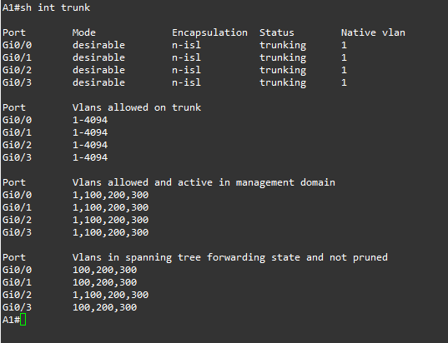

**D1:**

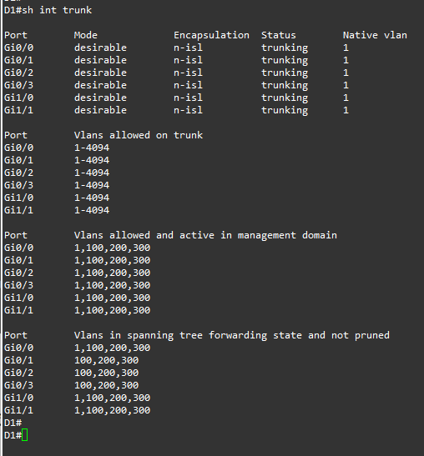

* DTP datagrams continue to be sent if the port is set statically to trunk mode.
* However, if the port is set statically to the access mode, both sending and processing DTP datagrams on that port are deactivated.
* To see this, configure D1 interface gi1/0 with the switchport mode trunk command.
* After a few moments, you should once again see that A1 has automatically negotiated a trunk, this time between A1’s gi0/0 and D1’s gi1/0.

**D1:**

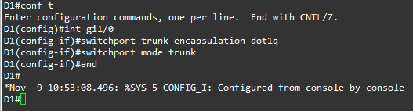

**A1:**

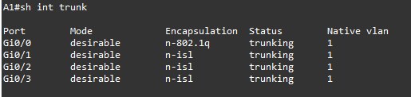

**We see A1 gi0/0 has automatically negotiated a trunk.**

* On A1, shutdown interfaces gi0/0 and gi0/1 as they are connected to A1.
* Then go to D1 and configure interfaces gi1/0 and gi1/1 as trunks with the additional command switchport non-negotiate.
* A few moments after you re-enable the interfaces at A1, you will see that they do not form trunks with D1.

**A1:**

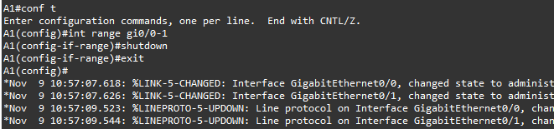

**D1:**

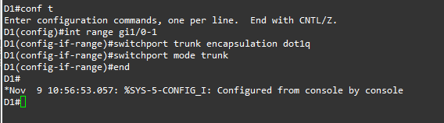

**A1:**

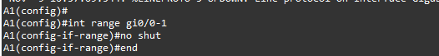

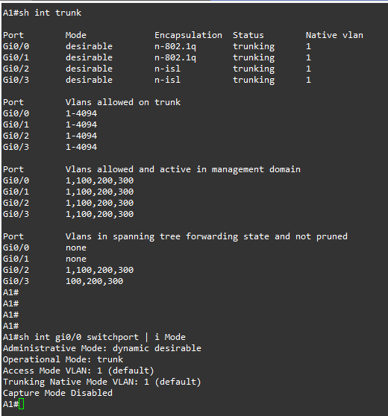

We have no shutdown the interface we have shutdown a while ago. And we check the gi0/0 switchport of A1.

At each switch, issue the global configuration command default interface range to reset the interfaces back to their defaults.

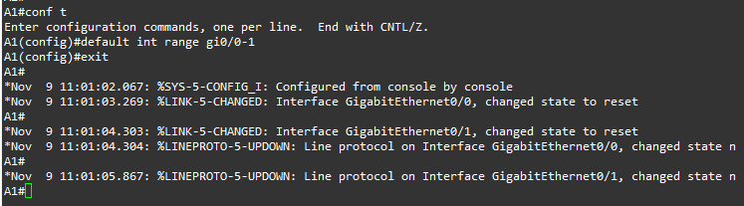**A1:**

**D1:**

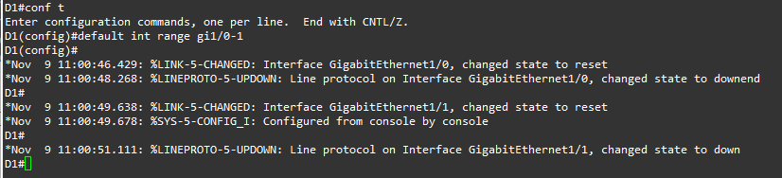

**Step 3:** Configure Basic Device Settings

**D1:**

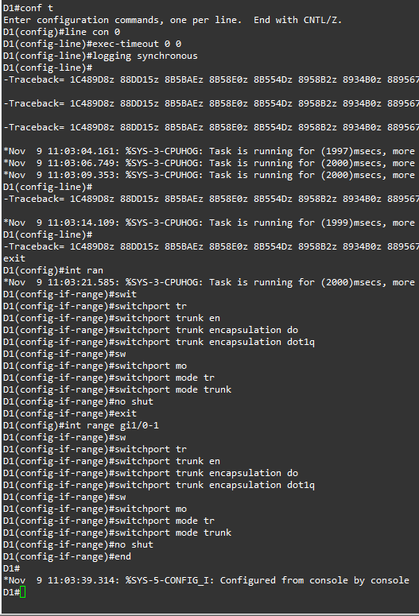

**D2:**

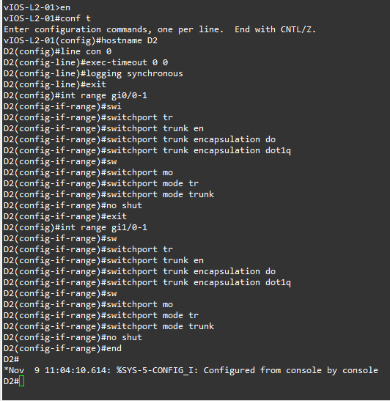

**A1:**

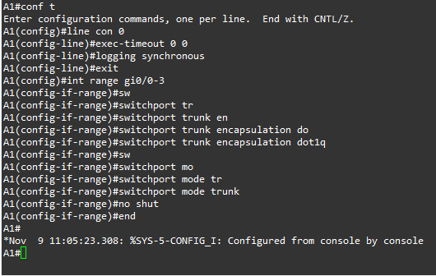

**Step 4: Configure Static EtherChannel.**

In this part, you will configure an EtherChannel without a negotiation protocol. The focus for this part is to establish the process for creating and modifying the EtherChannel bundle. For this part you will work with D2 and A1.

**Step 5: Configure and verify trunking between D2 and A1.**

Configure the ports interconnecting D2 and A1 as static trunk ports with the switchport non-negotiate command.

**Verify the trunks have formed.**

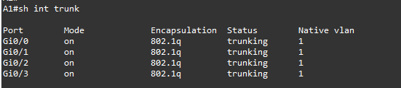

* **Configure and verify a static EtherChannel link between D2 and A1.**

Add the command channel-group 1 mode on to all the trunk interfaces between D2 and A1.

**D2:**

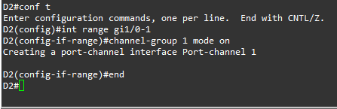

**A1:**

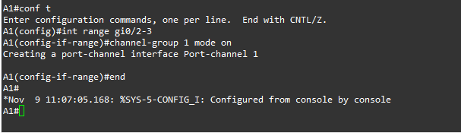

Verify the EtherChannel has formed by examining the output of the show etherchannel summary command. Also check the spanning tree status. You will see that there is a change to the topology because Po1 replaced interfaces gi0/2 and gi0/3 with a lower cost.

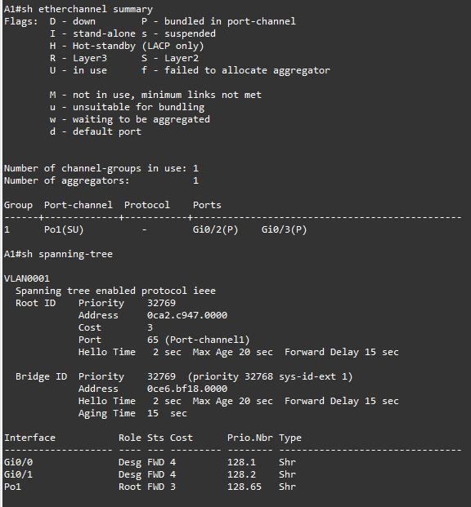

**A1:**

**You will notice the 2 port which are connected with D2 are now in Port channel 2 and the cost is lower.**

**Make a change to the EtherChannel.**

With very few exceptions, changes to the EtherChannel configuration must be made at the port-channel level.

Changes you make directly to the member interfaces of a port-channel may create synchronization issues that will cause the group to fail or underperform.

On D2 and A1, create VLAN 999 with the name NATIVE_VLAN.

On D2 and A1, modify interface port-channel 1 so that it uses VLAN 999 as the native VLAN.

**D2:**

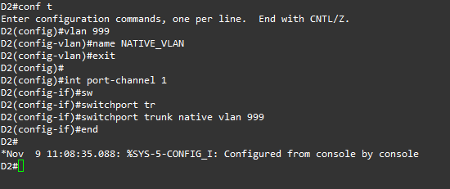

**A1:**

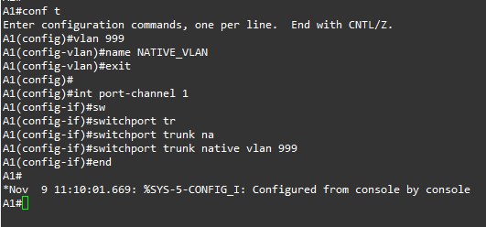

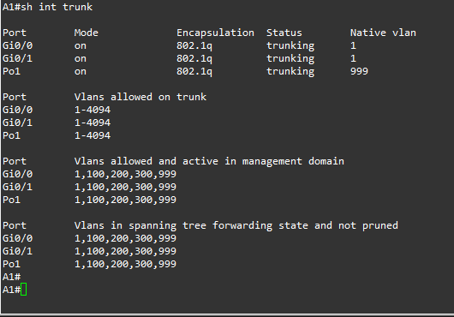**Verify the change has been applied by examining the output of show interfaces trunk.**

**Step 6: Implement EtherChannel Using PAgP.**

* In this part you will configure an EtherChannel using the Cisco proprietary Port Aggregation Protocol, or PAgP. PAgP works between Cisco switches only.
* The protocol has two modes - Desirable or Auto.
* These modes work in a fashion similar to modes of the same name in Dynamic Trunking Protocol; Desirable actively communicates a desire to build an EtherChannel bundle, while Auto passively agrees to a bundle if the switch at the other end desires it.
* Therefore, if both ends are configured in Auto mode, the bundle will not form.
* Additionally, PAgP can be configured for non-silent operation. Normally, PAgP operates in silent mode, and will add interfaces to a bundle without having received PAgP packets from the connected device.

**Configure and verify trunking between D1 and A1.**

Verify the trunks are still working.

**A1:**

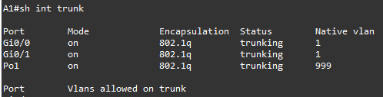

**Configure and verify an EtherChannel using PAgP between D1 and A1.**

Add the command channel-group 2 mode desirable non-silent to all the trunk interfaces between D1 and A1.

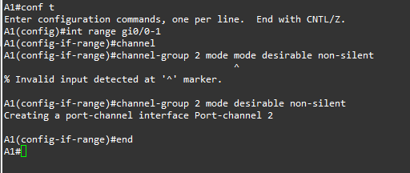**A1:**

Verify the EtherChannel has formed by examining the output of the show etherchannel summary command.

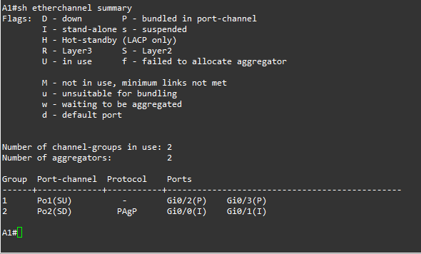

**Make a change to the EtherChannel.**

Changes to the EtherChannel configuration must be made at the port-channel level. Changes you make directly to the member interfaces of a port-channel may create synchronization issues that will cause the group to fail or underperform.

On D1, create VLAN 999 with the name NATIVE_VLAN.

**D1:**

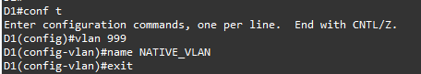

On D1 and A1, modify interface port-channel 2 so that it uses VLAN 999 as the native VLAN.

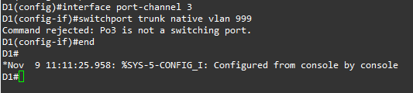

**A1:**

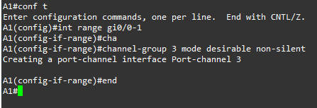

Verify the change has been applied by examining the output of show interfaces trunk | i Port|Po3’ on D1.

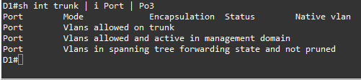

**Step 7: Implement EtherChannel using LACP.**

* In this part, you will configure an EtherChannel using the open standard Link Aggregation Control Protocol, or LACP.
* This protocol also has two modes – Active and Passive. These modes work in a similar fashion to modes of PAgP; the Active mode actively communicates a desire to build an EtherChannel bundle, while the Passive mode passively agrees to a bundle if the switch at the other end initiates it.
* Therefore, if both ends are configured in passive mode, the bundle will not form. For this part you will work with D1 and D2.

**Configure and verify trunking between D1 and D2.**

Verify the trunks are still operational.

**D2:**

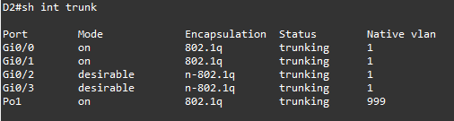

**Configure and verify an EtherChannel using LACP between D1 and D2.**

Add the command channel-group 4 mode active to all the trunk interfaces between D1 and D2.

**D1:**

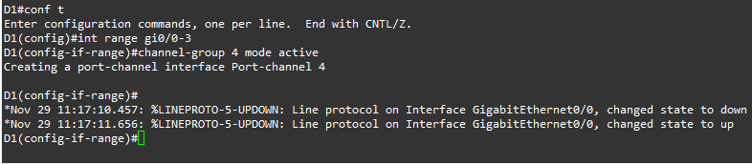

**D2:**

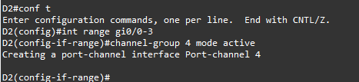

* Verify the EtherChannel has formed by examining the output of the show etherchannel summary command.
* Also check the spanning tree status. You will see that the two interfaces are no longer referenced by Spanning Tree, but the port channel is.
* Because there is only one (logical) trunk between D1 and D1, there are no Spanning Tree blocked ports.

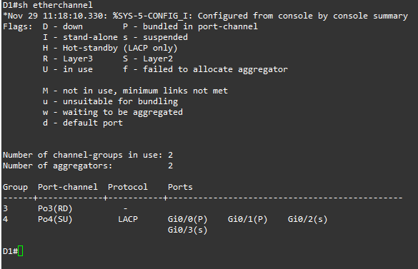**D1:**

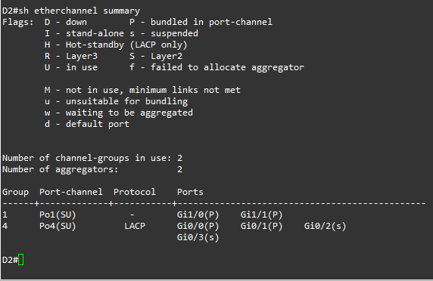

**D2:**

**Make a change to the EtherChannel.**

* Once again, it is important to understand that changes to the EtherChannel configuration must be made at the port-channel level.
* Changes you make directly to the member interfaces of a port-channel may create synchronization issues that will cause the group to fail or underperform.
* On D1 and D2, modify interface port-channel 4 so that it uses VLAN 999 as the native VLAN.

**D1:**

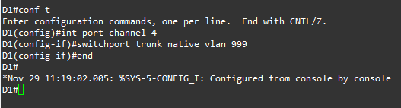

**D2:**

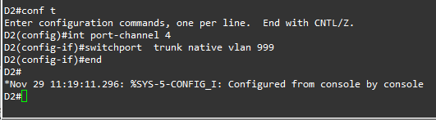

Verify the change has been applied by examining the output of show interfaces trunk | i Port|Po4 on D1 and D2.

**D1:**

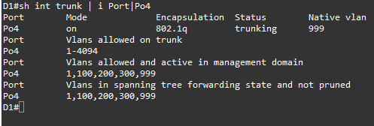

**D2:**

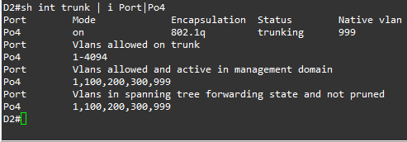

**2. Tune and Optimize EtherChannel Operations.**

**Step 1: Design the Topology.**

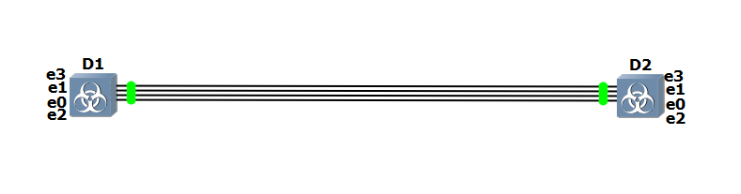

**Step 2: Configure the network.**

**D1:**

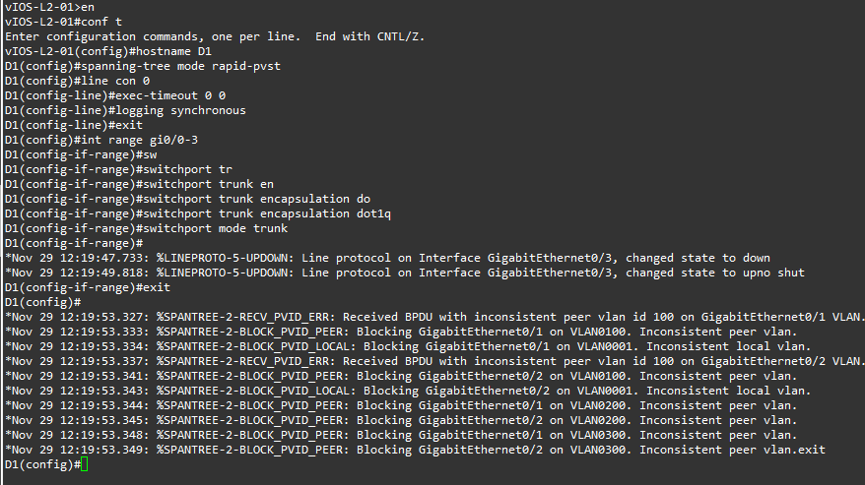

**D2:**

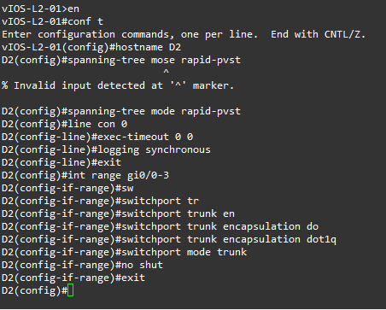

**Step 3: Tune LACP-based EtherChannel’s.**

* An EtherChannel bundle using LACP as its negotiation protocol can have as many as 16 assigned members with 8 active ports passing traffic, and the other 8 ports on standby.
* The minimum and maximum number of ports allowed to be involved in a port channel can be managed through configuration as well.
* For the group of links connecting D1 and D2, you will set up an EtherChannel bundle using LACP as the negotiation protocol, with a minimum of 2 links and a maximum of 3.
* As a part of this configuration, you will control which switch is the master. Next, you will enable LACP fast packets, reducing the time out period from 30 seconds to 1 second.

**Configure master switch criteria.**

* Each switch connected using LACP has a system ID value. Those numbers are compared, and the switch with the lowest number is considered the master.
* The system ID value is a combination of a system priority that defaults to 32768 and the base MAC address.

Use the show lacp sys-id privileged EXEC command to see what the sys-id value is for D1 and D2.

Based on the output shown below, we can deduce that D1 would be the bundle master if all default values remained unchanged.

**D1:**

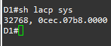

**D2:**

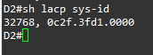

On D2, modify the lacp sys-id by changing the system priority. Use the lacp system priority value global configuration command to set the value to 1, and then verify that the value has been changed.

**D2:**

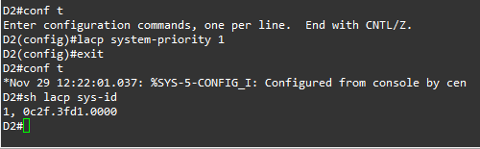

**You can see the priority is 1 now.**

**Configure bundle size and member preferences.**

* By default, interfaces are selected to be included in the active bundle based on their interface id.
* For a given configuration, the lower numbered interfaces are added to the bundle until the bundle has reached its maximum size.
* Any interfaces that remain are put in hot standby mode.

**Issue the shutdown command for the interfaces connecting D1 and D2.**

**D1:**

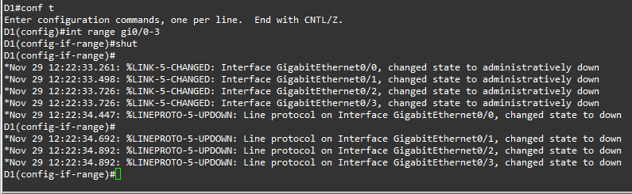

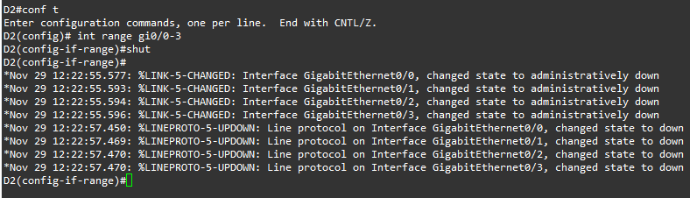

**D2:**

Configure the connections between D1 and D2 into a single LACP EtherChannel bundle.

Use Channel Group number 12 and the Active mode. Configure the interfaces for LACP Fast.

Then issue the no shutdown command for the interfaces connecting D1 and D2.

**D1:**

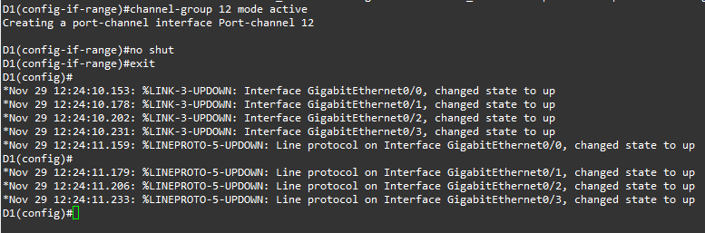

**D2:**

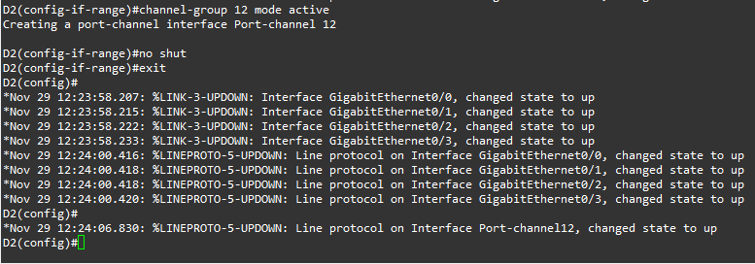

On D1 and D2, configure the port-channel 12 interface with a LACP minimum bundle size of 2 interfaces, and the maximum bundle size of 3 interfaces.

**D1:**

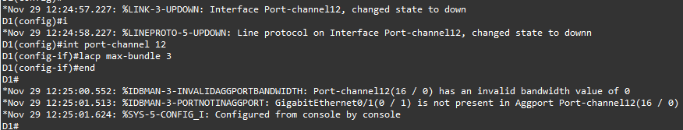

**D2:**

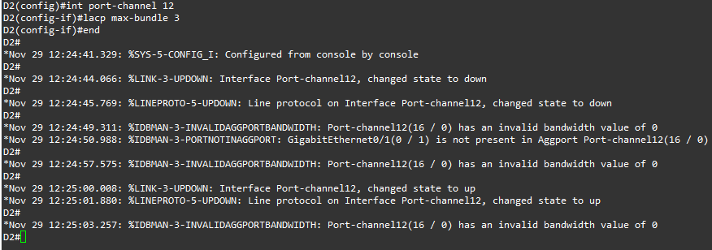

Verify that the EtherChannel bundle has formed and take note of the ports that are included versus the port that is in hot standby mode.

**D1:**

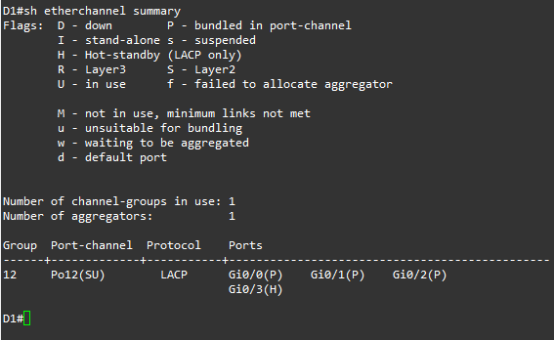

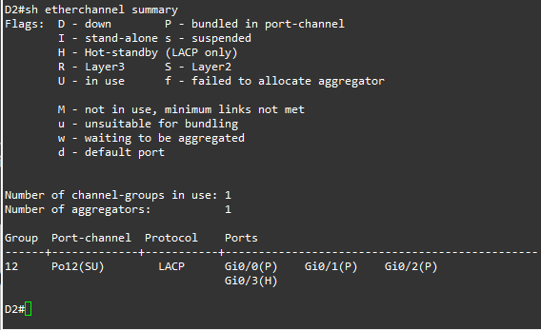**D2:**

Verify the mode, state, and rate of LACPDU being sent for port members on D1 nad D2:

**D1:**

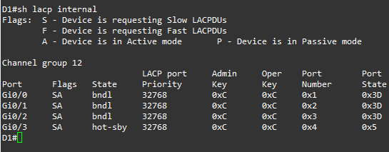

**D2:**

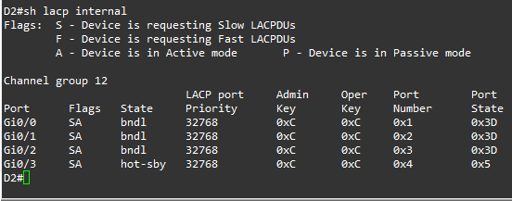

**Step 4: Explore EtherChannel Load Balancing.**

* The load balancing method used to send traffic through an EtherChannel is a global setting on the switch.
* All EtherChannel’s on a given switch will use the method selected for that switch.
* The load balancing methods used at either end of an EtherChannel bundle do not have to match.

**D1:**

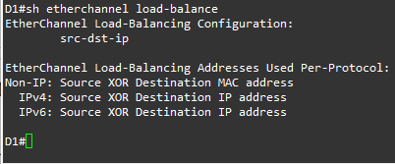

**D2:**

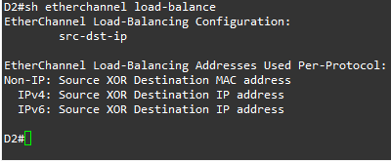

Select a channel-group and specify the source and destination address (in the form of a MAC, IP, or Port number) and the switch tells you what the exit port will be.

The example that follows shows that traffic with the same source MAC always exits using the same interface.

Use this command on your switches to verify how the default load-balancing scheme is working, and then try out the other load-balancing mechanisms to see how the behaviour changes.

**Practical 8**

**Aim: OSPF Implementation**

**1. Implement Single – Area OSPF v2**

**2. Implement Multi – Area OSPFv2**

**3. OSPFv2 Route Summarization and Filtering**

**4. Implement Multiarea OSPFv3**

**1. Implement Single-Area OSPFv2:**

**Step 1:** Assess the requirements for the network.

* 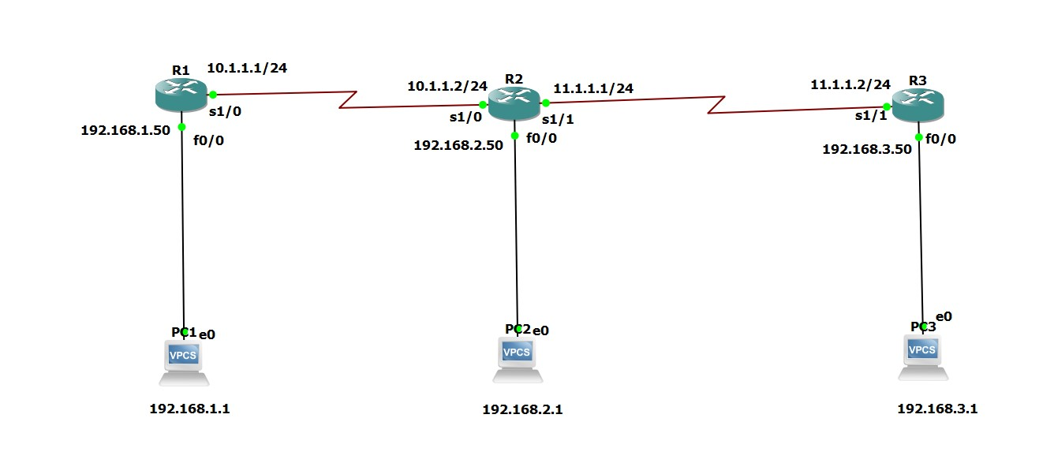For the network, I will be using 3 Routers and 3 PCs.**Step 2:** Deign the topology of the network.

**Step 3:** Build and Configure the network.

* Configuring & saving Router 1:

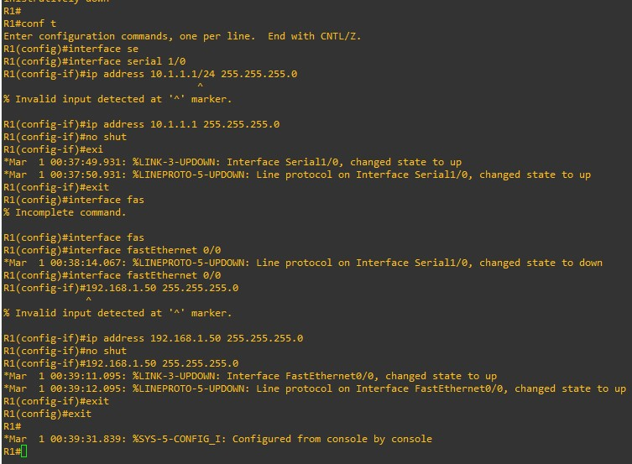

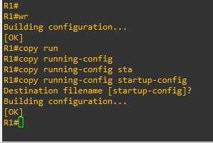

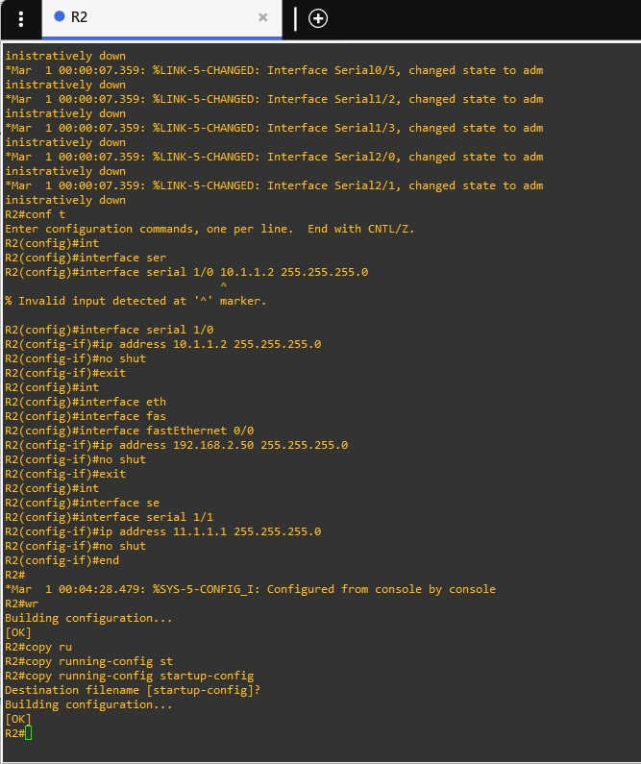

* Configuring & saving Router 2:
* Configuring & saving Router 3:

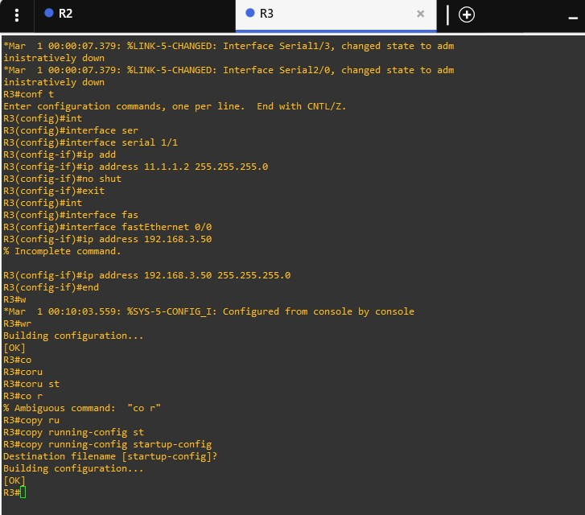

* Configure PC 1:

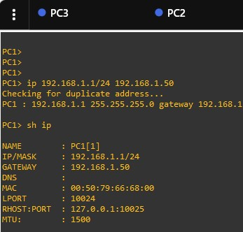

* 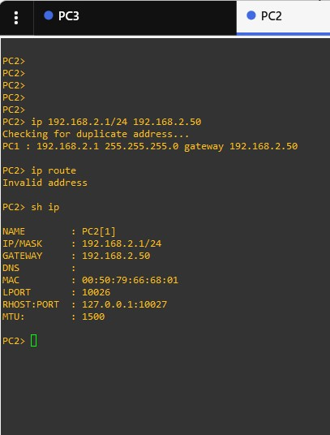Configure PC 2:
* Configure PC 3:

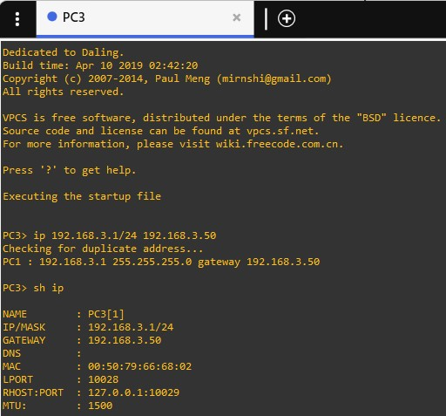

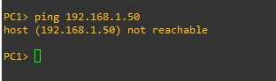**Step 4:** Perform ping operation on all 3 PC’s before applying OSPFv2.

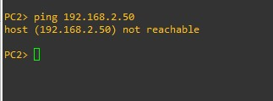

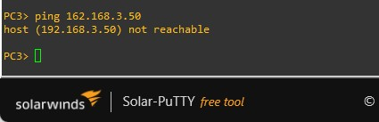

* Check whether all the interfaces are up.

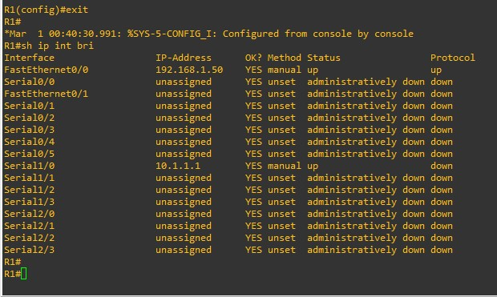

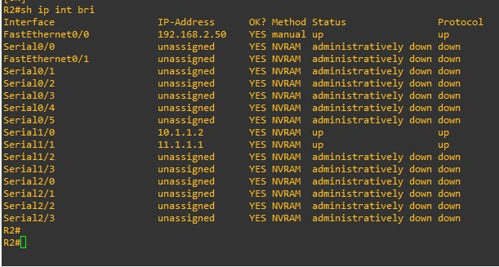

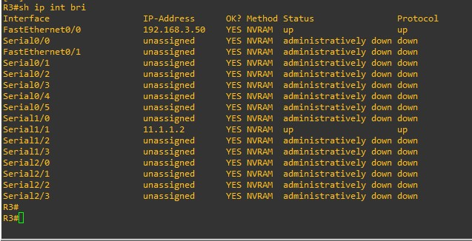

**Step 5: Configure and test the Single – Area OSPFv2 for IPv4 on R1, R2 and R3.**

* Configure Single – Area OSPFv2 on R1:

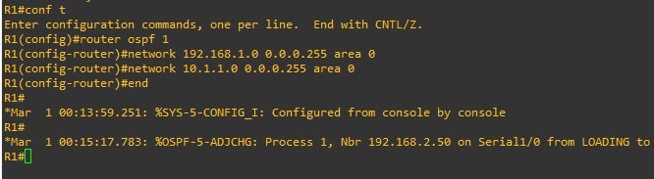

* Test the Single – Area OSPFv2 on R1:

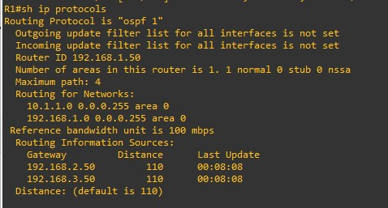

This shows the neighbour of Router 1 (which is only possible via OSPF)

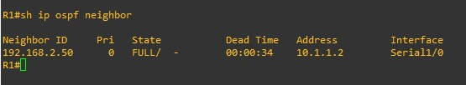

This will show the various routes used by OSPF. The ‘O’ at the start indicates a single

area network.

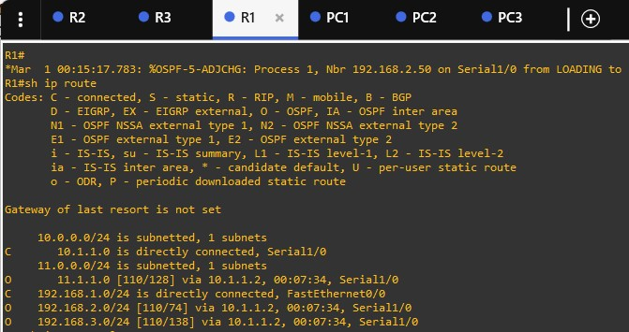

• Configure Single – Area OSPFv2 on R2:

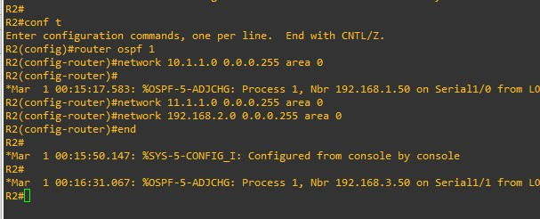

• Test the Single – Area OSPFv2 on R1:

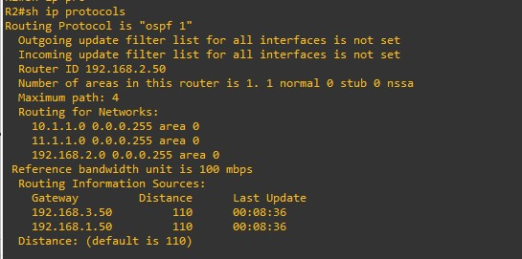

This shows the neighbour of Router 2 (which is only possible via OSPF)

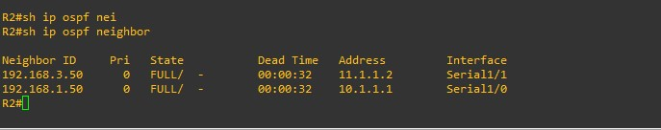

This will show the various routes used by OSPF. The ‘O’ at the start indicates a single

area network.

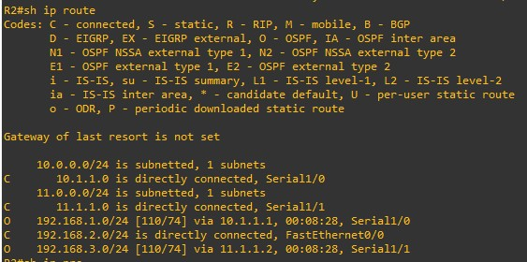

• Configure Single – Area OSPFv2 on R3:

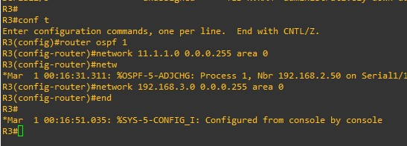

• Test the Single – Area OSPFv2 on R1:

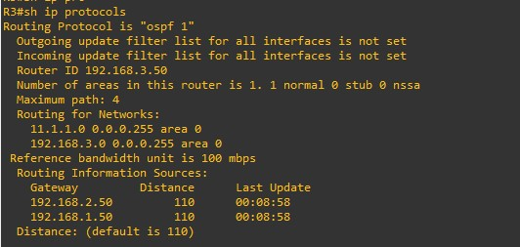

This shows the neighbour of Router 3 (which is only possible via OSPF).

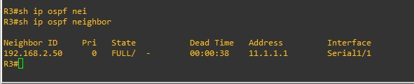

This will show the various routes used by OSPF. The ‘O’ at the start indicates a single

area network.

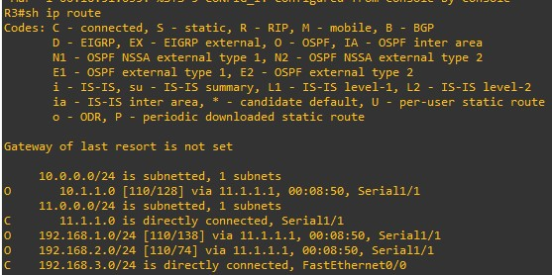

**Step 6: Perform ping operation on all 3 PC’s after applying OSPFv2.**

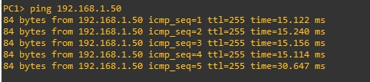

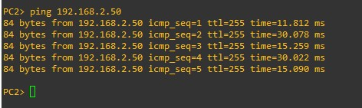

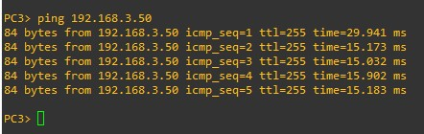

**2. Implement Multi-Area OSPFv2:**

**Step 1: Assess the components.**

• We use 4 routers.

**Step 2: Design the Topology.**

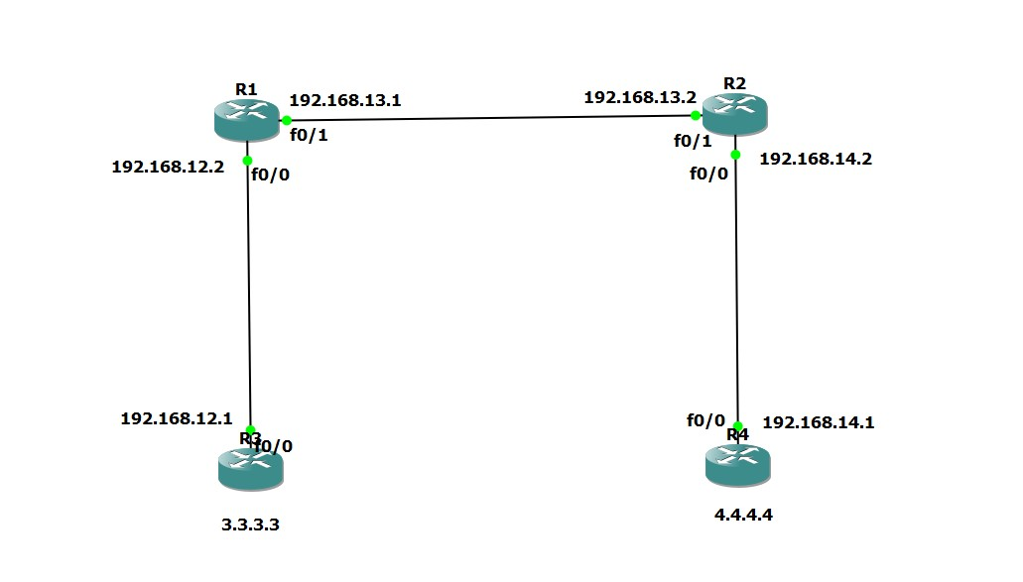

**Step 3: Build and configure the network.**

• Router 1 (R1):

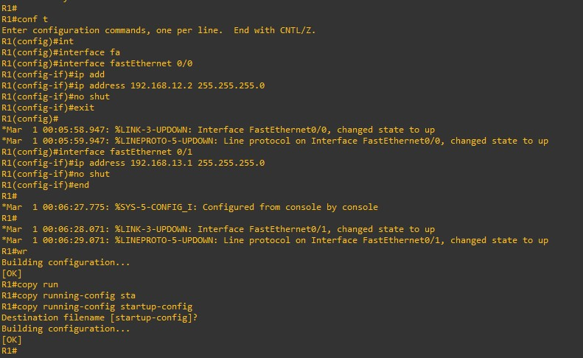

• Router 2 (R2):

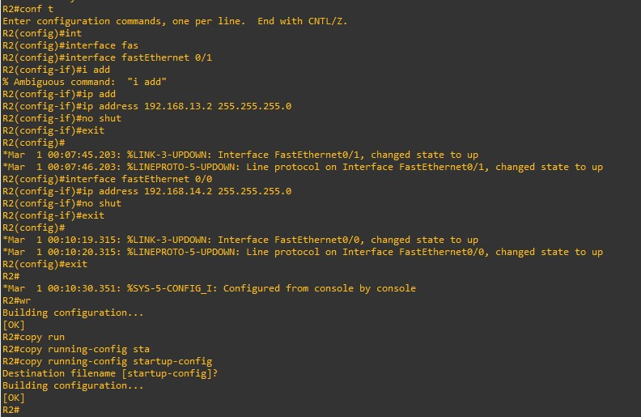

• Router 3 (R3):

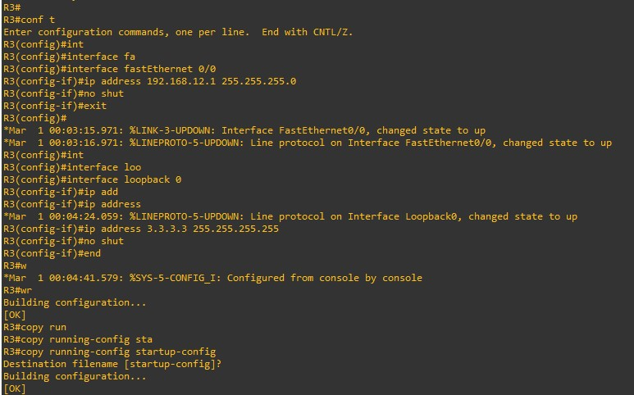

• Router 4 (R4):

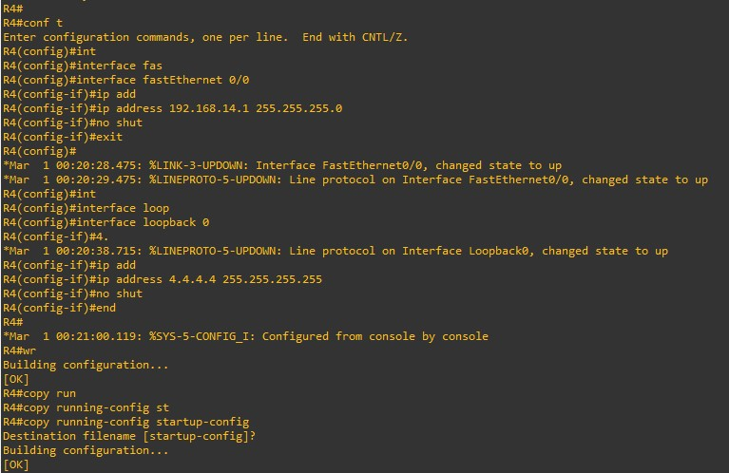

**Step 4: Configure and test the system for Multi – Area OSPFv2.**

• Router 1 (R1):

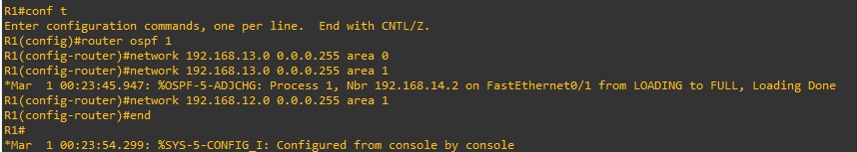

To verify Multi – Area OSPFv2 for Router 1.

R1 has formed a neighbour adjacency with R2 and R3.

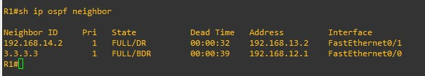

We see three OSPF entries. The first one is for 3.3.3.3/32, the loopback interface of

R3. It shows up with an O since this is an intra-area route. R1 has also learned about

4.4.4.4/32 and 192.168.24.0/24. These two entries show up as O IA since they are

inter-area routes.

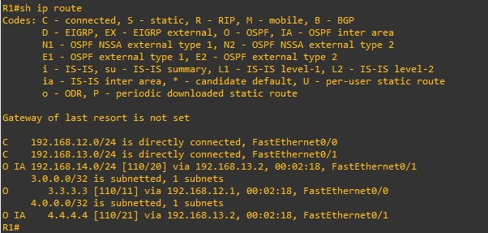

Test the Single – Area OSPFv2 on R1:

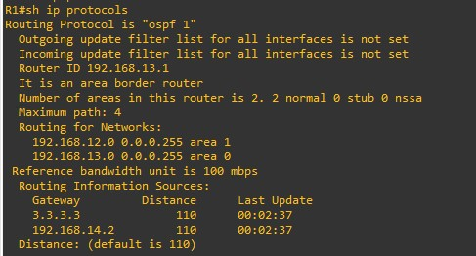

• Router 2 (R2):

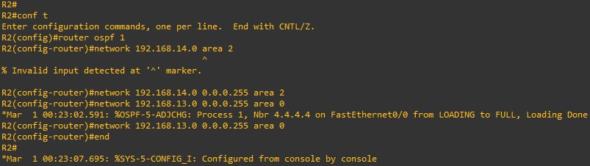

To verify Multi – Area OSPFv2 for Router 2.

R2 has formed neighbour adjacencies with R1 and R4.

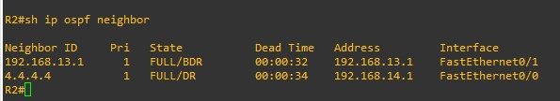

We see that R2 has learned about 3.3.3.3/32 and 192.168.13.0/24 which area inter-

area routes. 4.4.4.4/32 is an intra-area route.

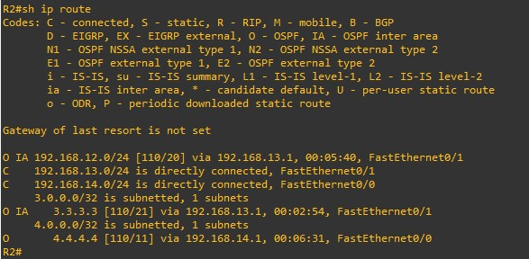

Test the Single – Area OSPFv2 on R2:

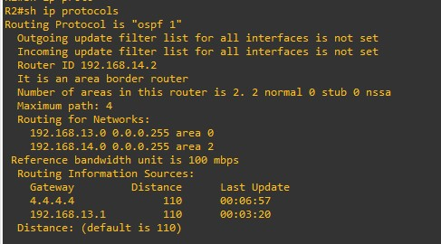

• Router 3 (R3):

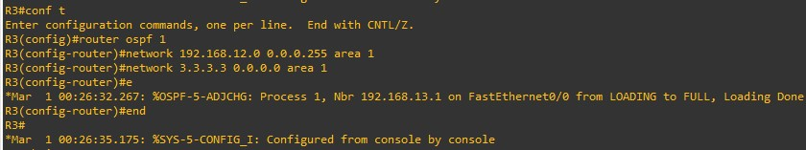

To verify Multi – Area OSPFv2 for Router 3.

R3 has formed neighbour adjacency with R1.

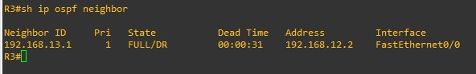

Everything that R3 has learned is from another area, that’s why we only see inter-area

routes here.

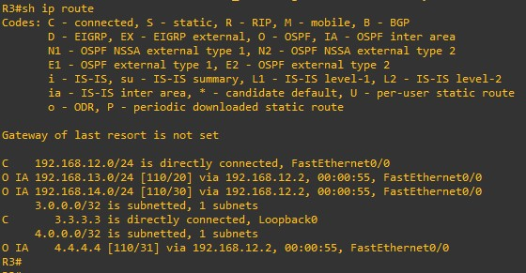

Test the Single – Area OSPFv2 on R3:

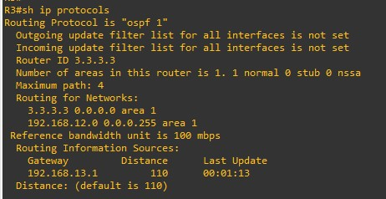

• Router 4 (R4):

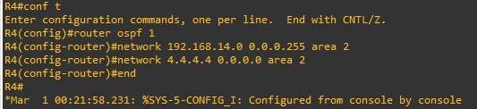

To verify Multi – Area OSPFv2 for Router 4.

R4 has formed neighbour adjacency with R2.

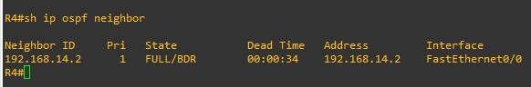

Everything that R4 has learned is from another area, that’s why we only see inter-area

routes here.

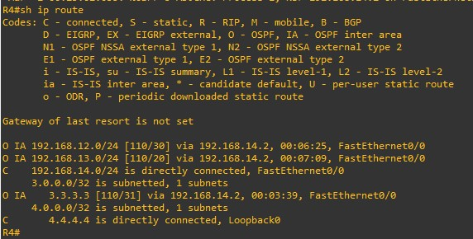

Test the Single – Area OSPFv2 on R4:

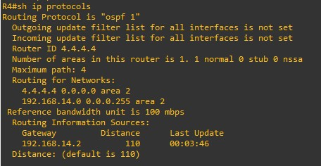

**3. OSPFv2 Route Summarization and Filtering**

**Step 1:** Follow the same Topology as the Multi – Area OSPFv2.

**Step 2:** Add more loopbacks to Router 3 and configure the OSPF accordingly.

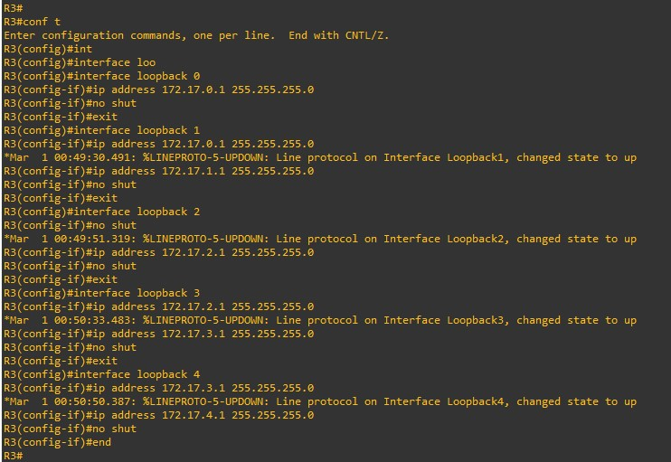

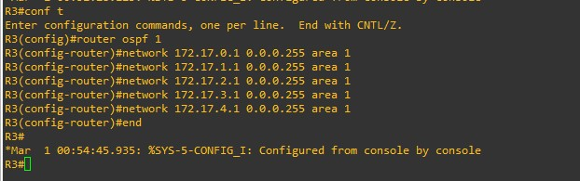

If we perform ‘show ip route’ on R2 we can see all the loopbacks of R3. Over here

nothing is being summarized.

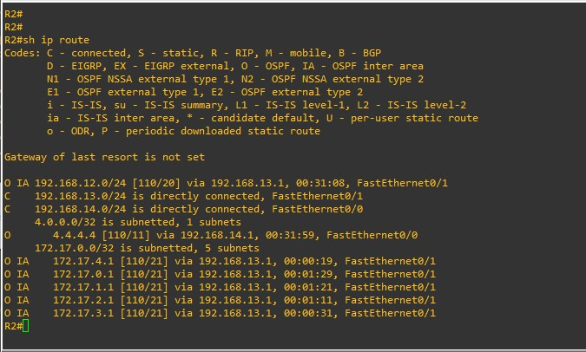

But if we want to summarize the data being received, we will perform the summary

operation on R1.

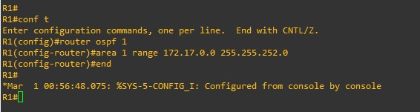

Here we can see that the network area is sub-netted into 2 subnets rather than 5. From

this we can see OSPF summarization based on the range of the subnets and their masks.

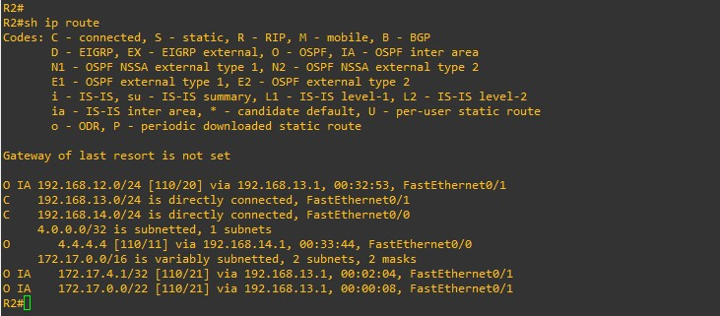

**4. Implement Multiarea OSPFv3**

**Step 1:** Build the topology.

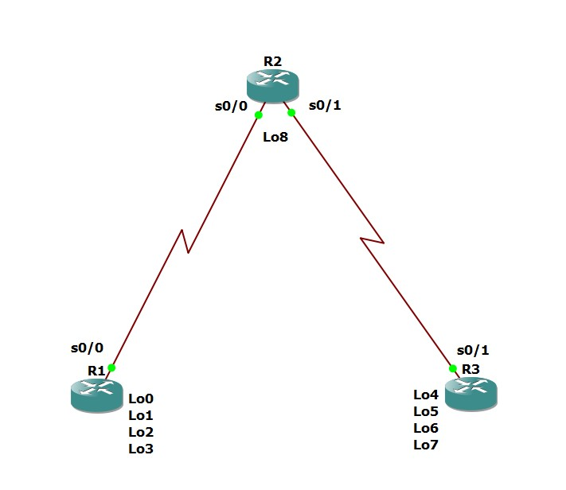

**Step 2: Configure IP address and Loopback in all the router according to the topology. We will use IPv6 for OSPF version 3.**

There’s a different command for IPv6 configuration, follow as below.

* **R1:**

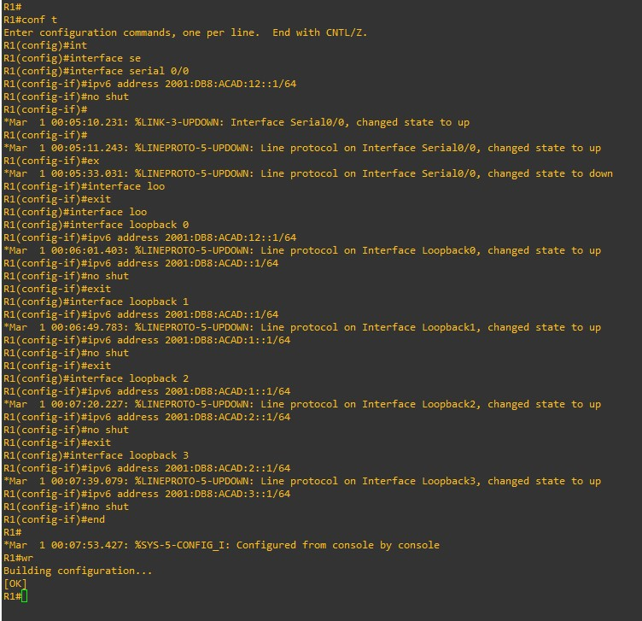

* **R2:**

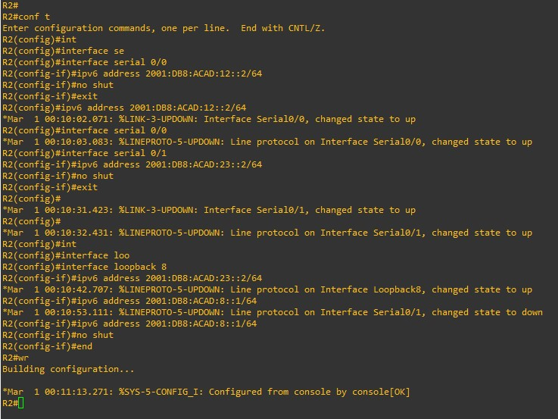

* **R3**

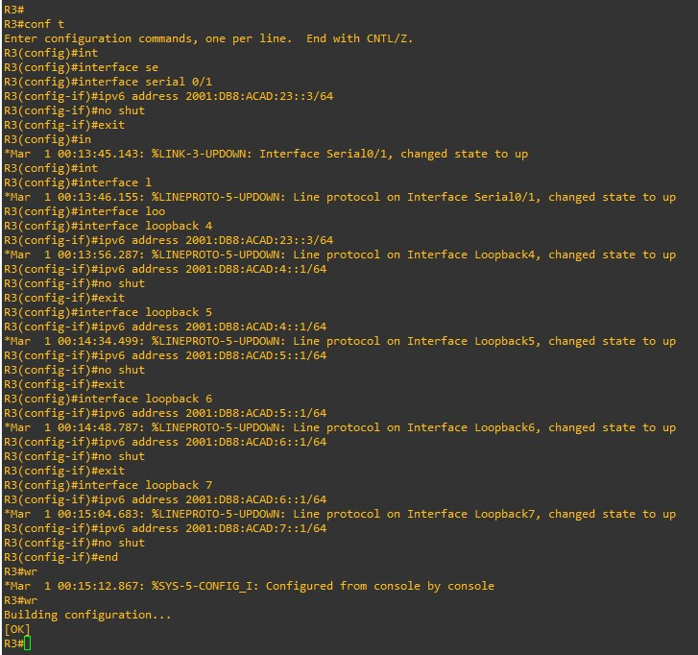

**Step 3: Once IP is assigned to all, we have to do IPv6 unicast and we have to assign router ID to the routers.**

* **R1:**

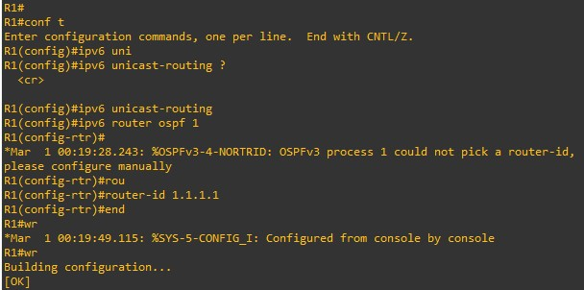

* **R2:**

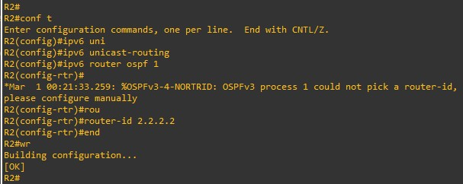

* **R3:**

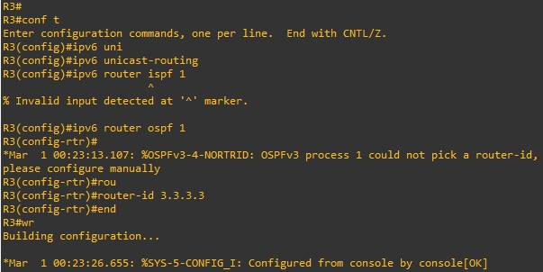

**Step 4: Now we will configure multi-area OSPFv3 in all the router.**

* **R1:**

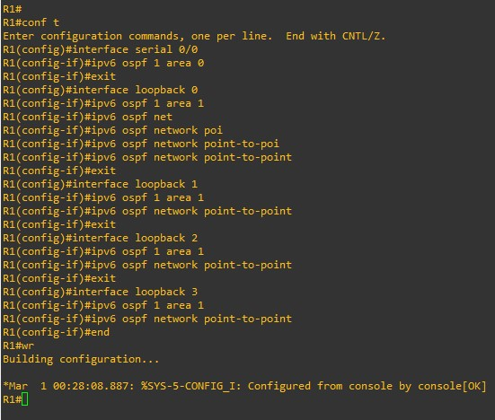

* **R2:**

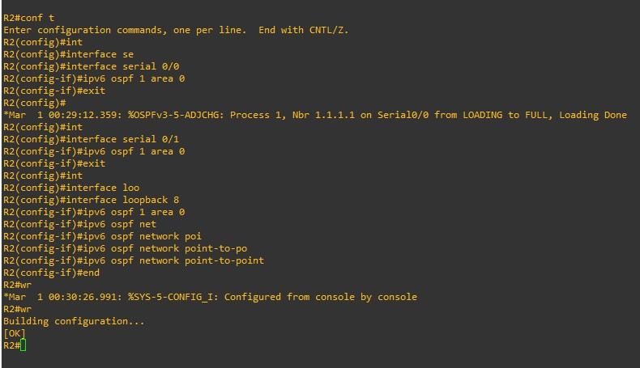

* **R3:**

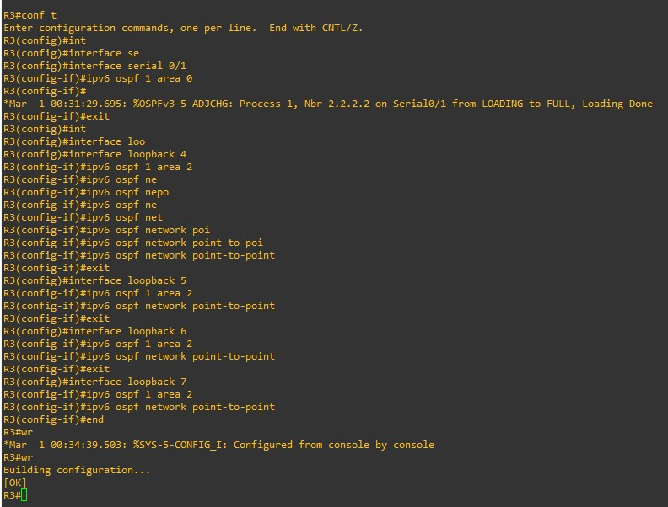

**Step 5: Use the show ipv6 protocols command to verify multi-area OSPFv3 status.**

* **R1:**

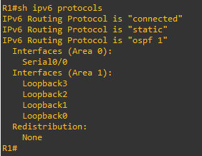

* **R2:**

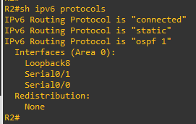

* 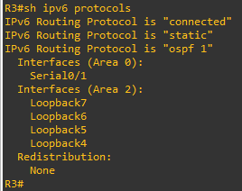**R3:**

**Step 6: Use the ‘show ipv6 ospf’ command to verify configurations.**

* **R1:**

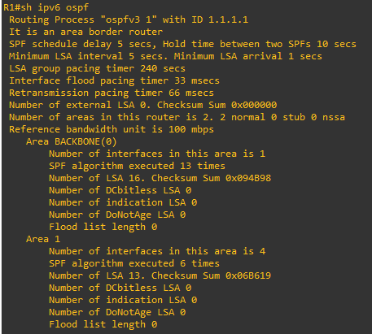

* **R2:**

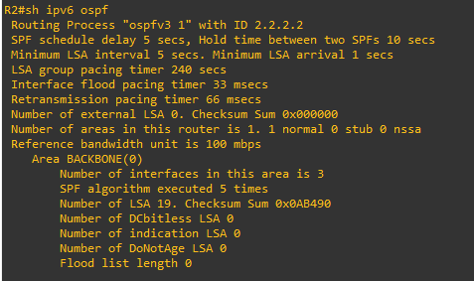

* **R3:**

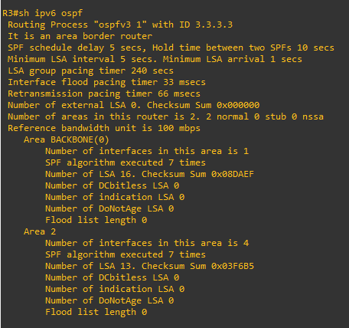

**Step 7: Verify OSPFv3 neighbors and routing information.**

* **R1:**

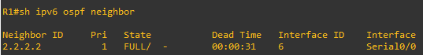

* **R2:**

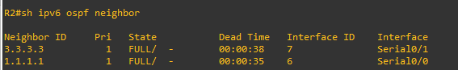

* **R3:**

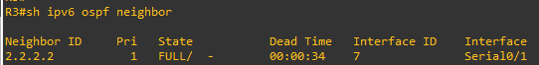

**Step 8: Check ‘show ipv6 route ospf’ to see the OSPF configuration.**

* **R1:**

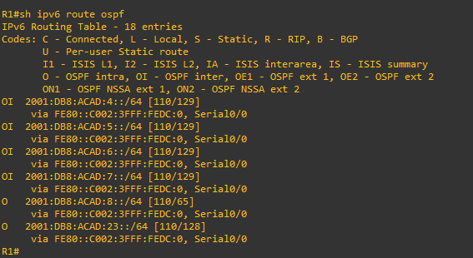

* **R2:**

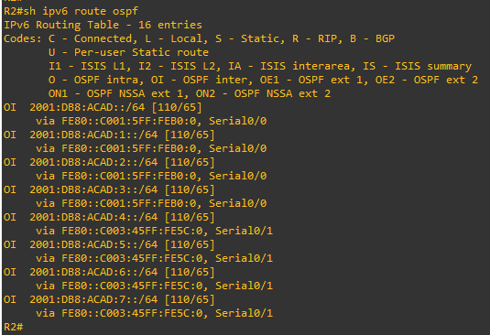

* **R3:**

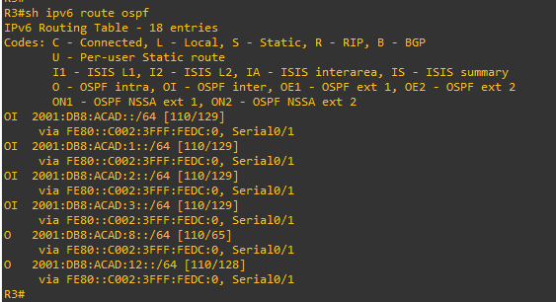

**Step 9: Issue the ‘show ipv6 ospf database’ command on all routers to check the IPv6 OSPF Database**

* 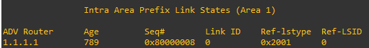**R1:**
* **R2:**

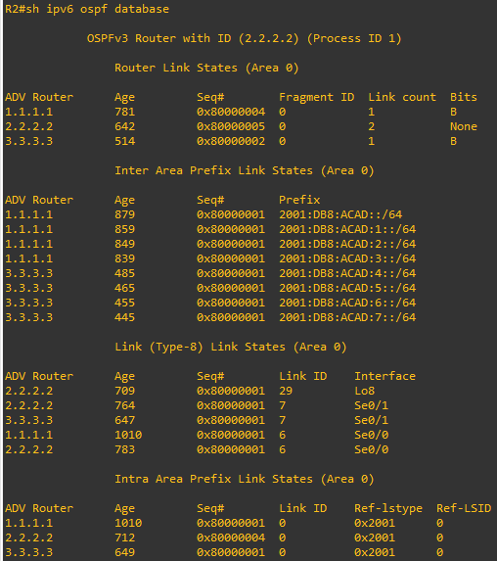

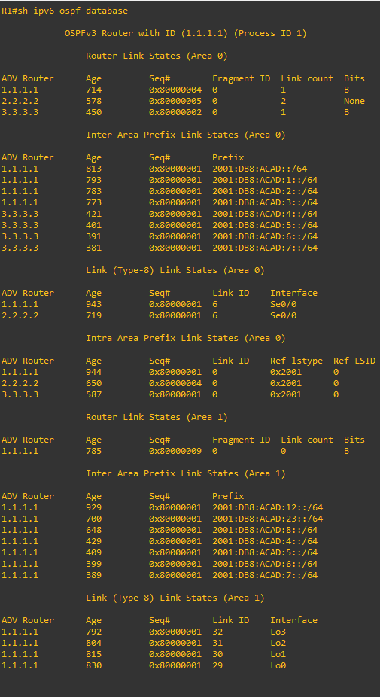

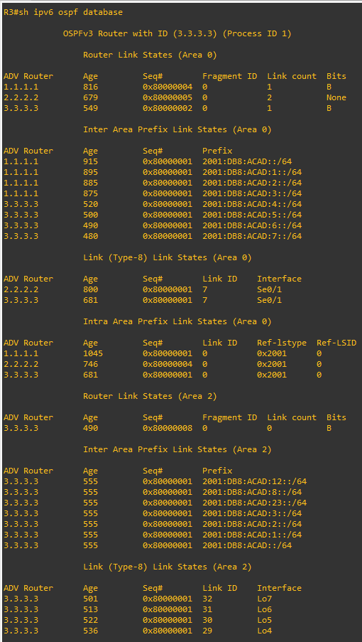**R3:**

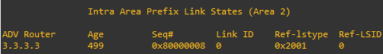

Now you have successfully configured multi-area OSPF v3 using IPv6.

**Practical 9**

**Aim: Implement BGP Communities**

**1. Implement eBGP for Ipv4.**

**2. Implement MP (Multi-protocol) -BGP**

**3. Implement BGP path Manipulation**

**1. Implement eBGP for Ipv4.**

**Part 1: Build the Network and Configure Basic Device Settings and Interface Addressing**

**Step 1: Topology**

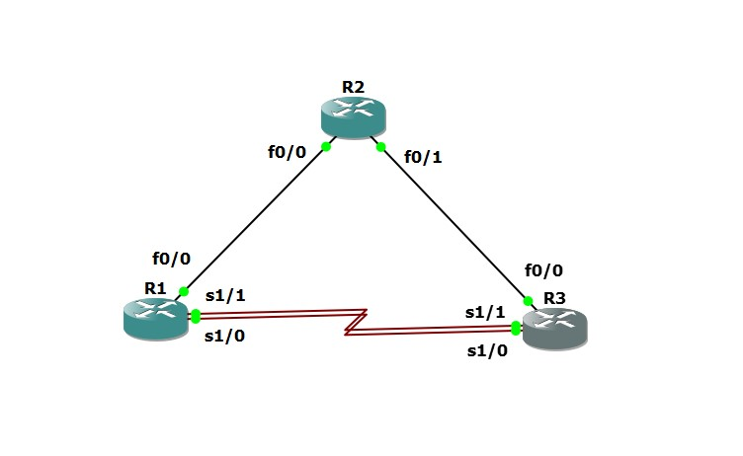

**Step 2: Configure all 3 Routers.**

• Router R1

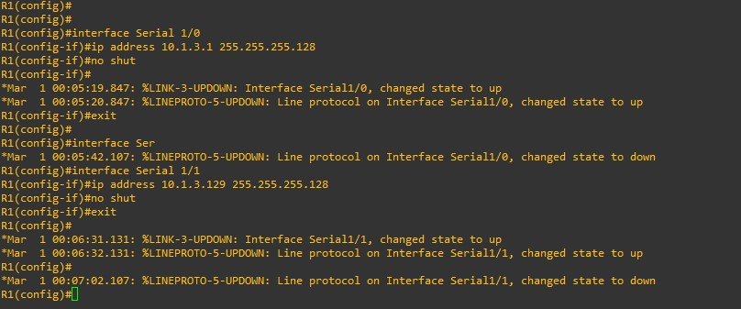

**• Router R2**

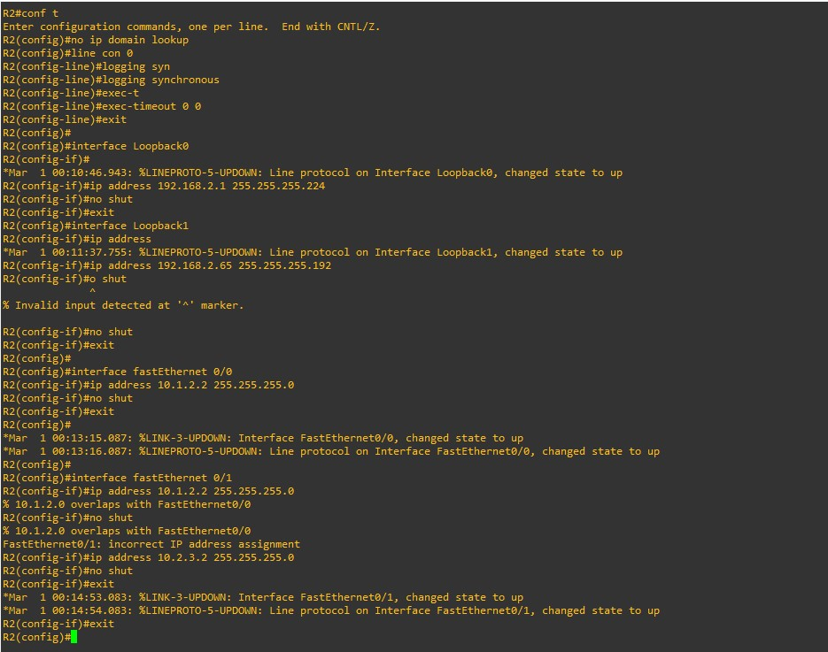

**• Router R3**

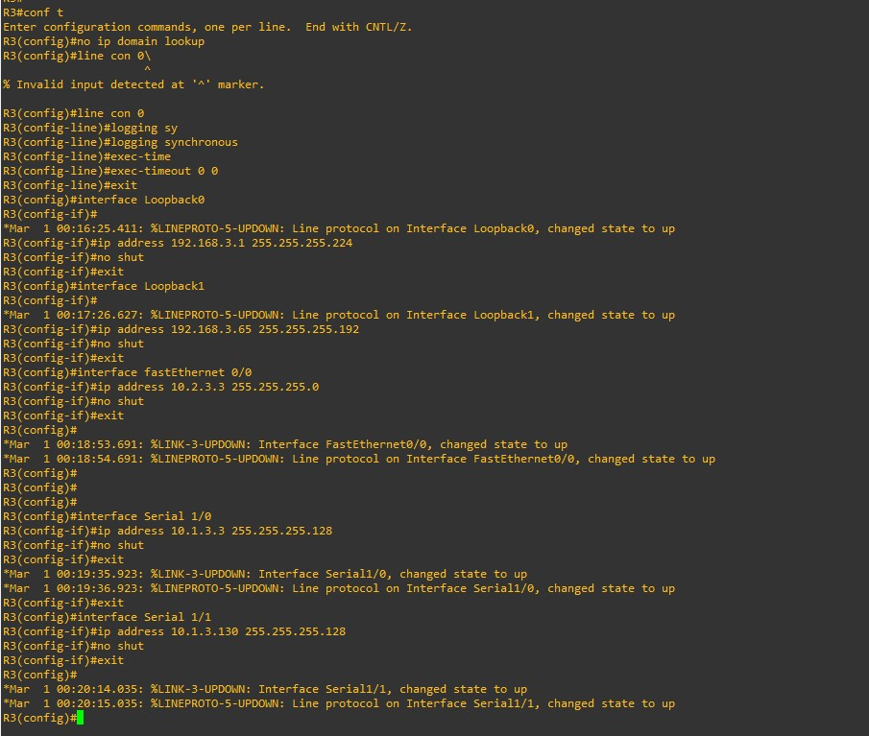

**Part 2: Configure and Verify eBGP for IPv4 on all Routers**

**Step 1: Implement BGP and neighbor relationships on R1.**

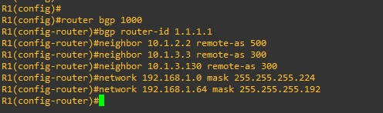

**Step 2: Implement BGP and neighbor relationships on R2.**

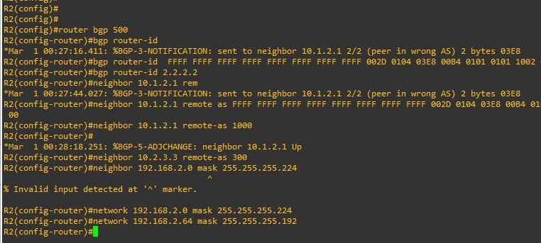

**Step 3: Implement BGP and neighbor relationships on R3.**

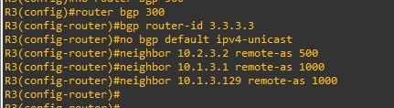

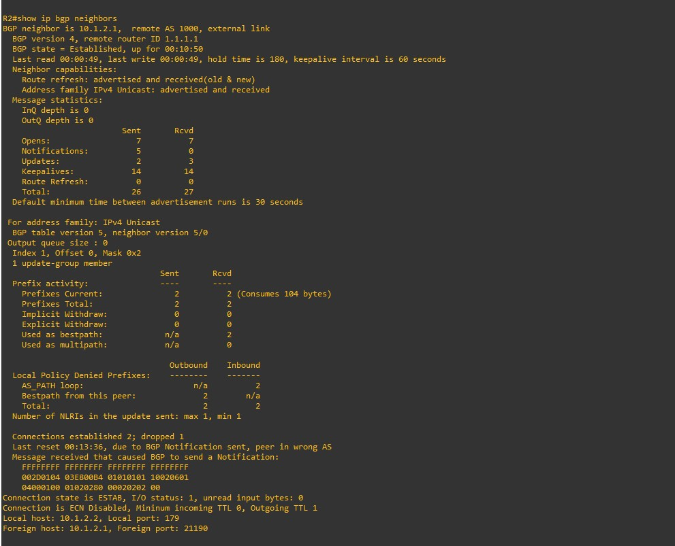**Step 4: Verifying BGP neighbor relationships.**

**• The interfaces on R3 need to be activated in IPv4 AF configuration mode.**

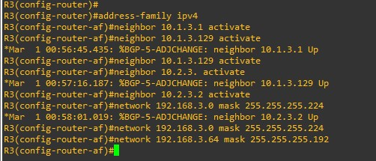

**• Verify that the BGP state between R2 and R3 has now been established.**

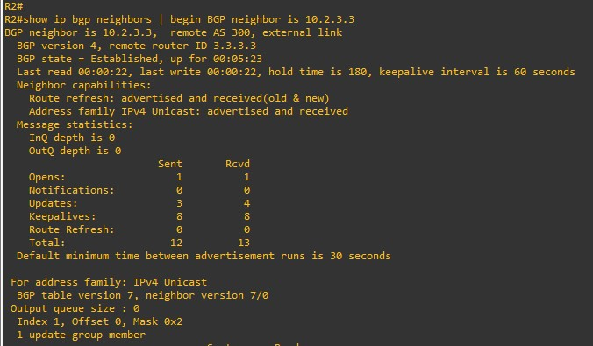

**Step 5: Examining the running-configs.**

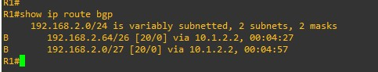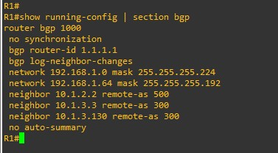

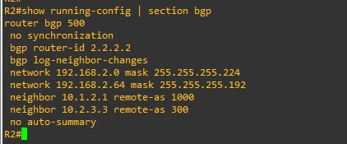

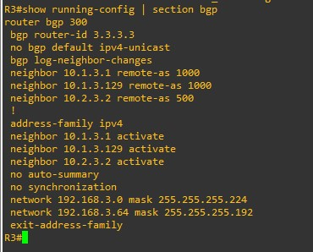

**Step 6: Verifying BGP operations.**

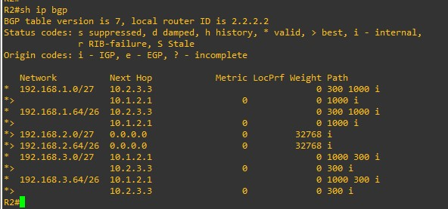

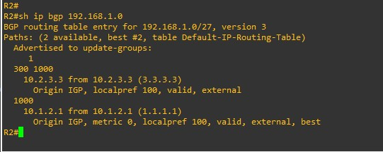

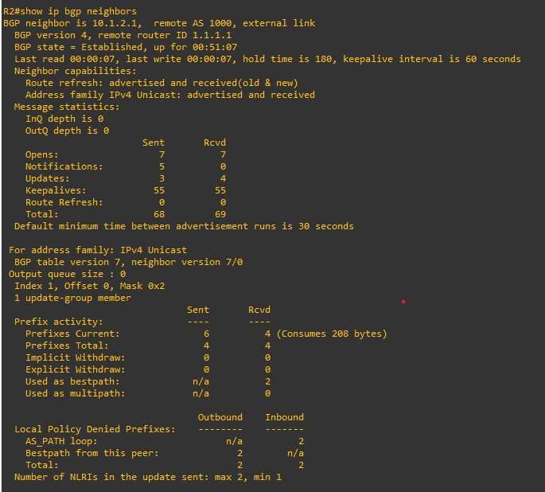

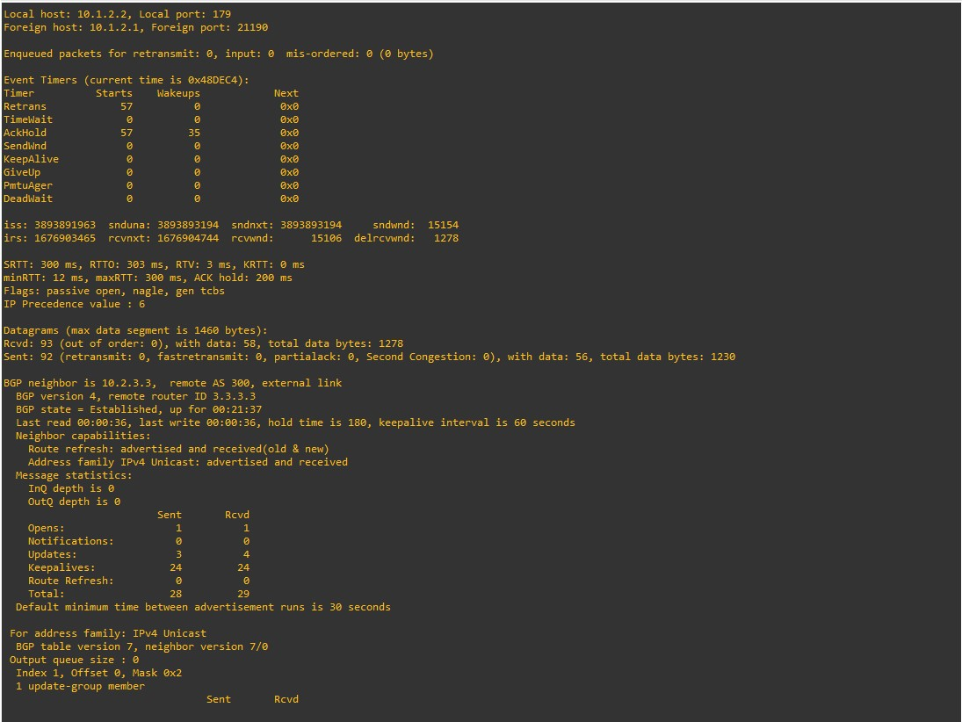

**2. Implement MP(Multi-protocol) -BGP**

**Part 1: Build the Network and Configure Basic Device Settings and Interface Addressing**

**Step 1: Topology**



**Step 2: Configure basic settings for each router.**

**• Router R1**

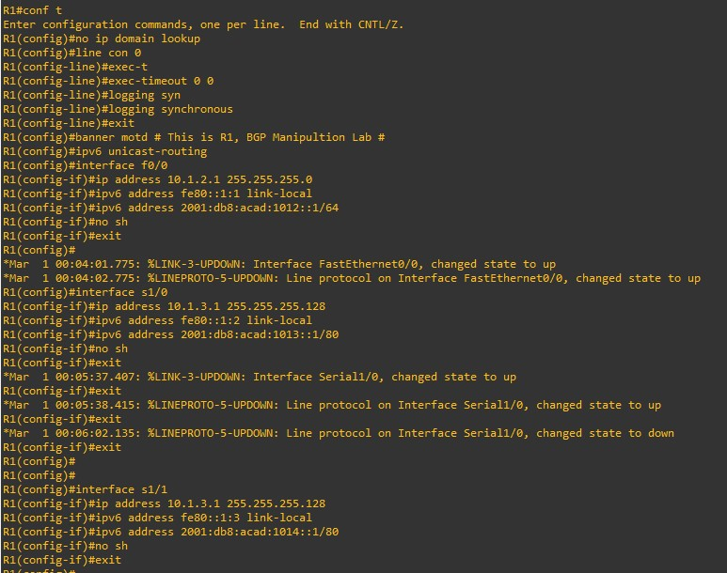

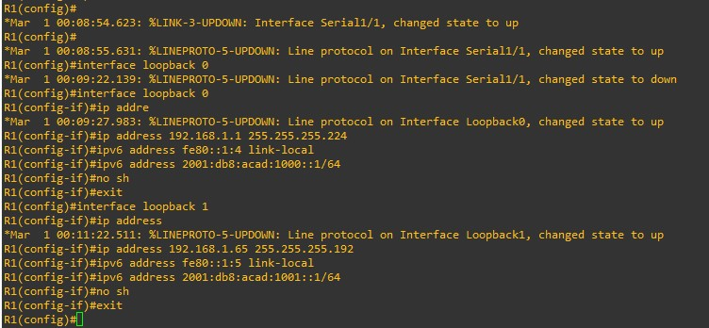**• Router R2**

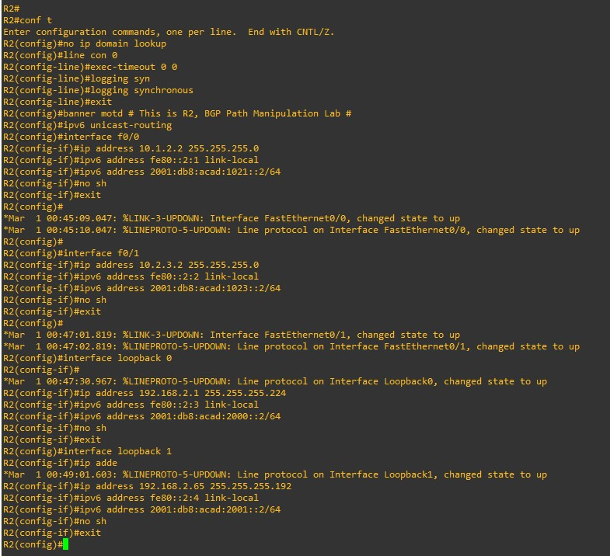

**• Router R3**

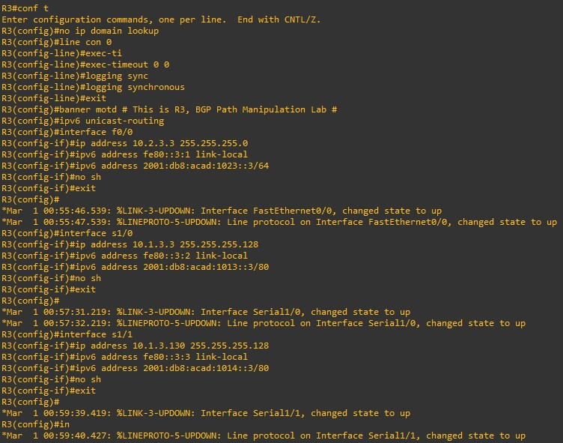

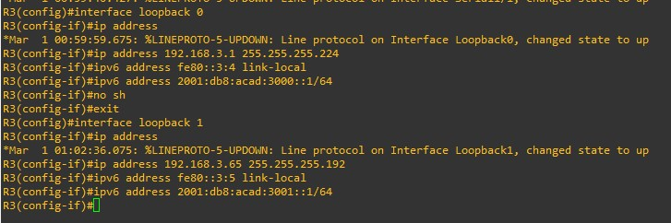

**Part 2: Configure and Verify Multi-Protocol BGP on all Routers**

**Step 1: On R1, create the core BGP configuration**

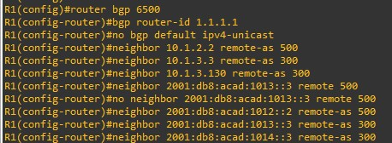

**Step 2: On R1, configure the IPv4 unicast address family.**

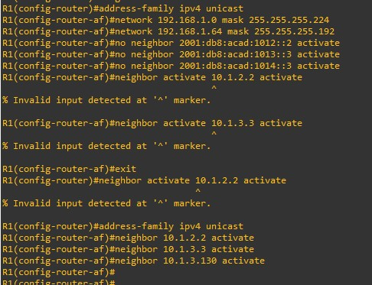

**Step 3: On R1, configure the IPv6 unicast address family.**

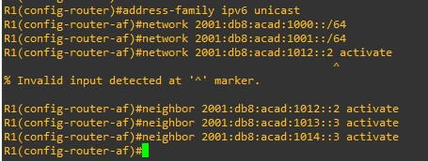

**Step 4: Verify that MP-BGP is operational.**

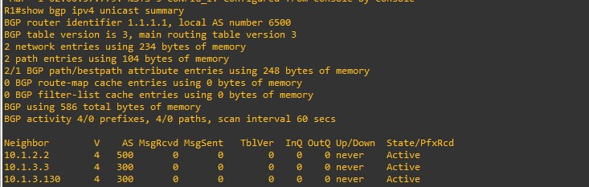

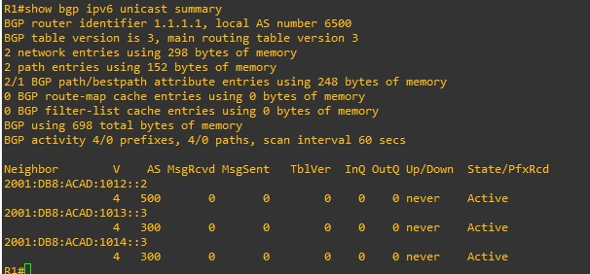

**• Use the show bgp ipv4 unicast and show bgp ipv6 unicast commands to view the specified BGP tables.**

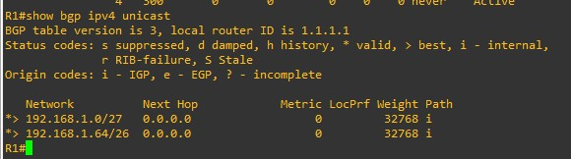

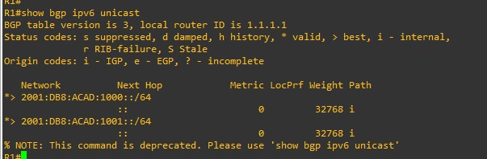

**• Viewing Routing tables.**

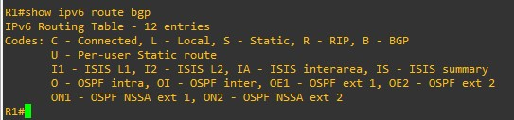

**3. Implement BGP path Manipulation**

**Part 1: Build the Network and Configure Basic Device Settings and Interface Addressing**

**Step 1: Topology**



**Step 2: Configure basic settings for each router.**

**• Router R1**

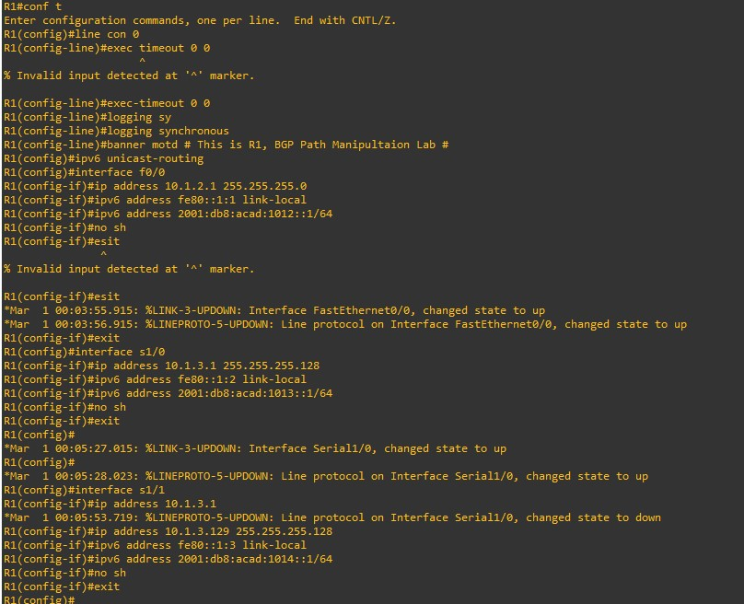

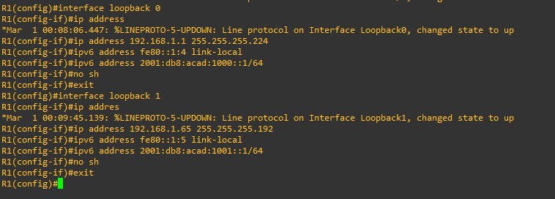

**• Router R2**

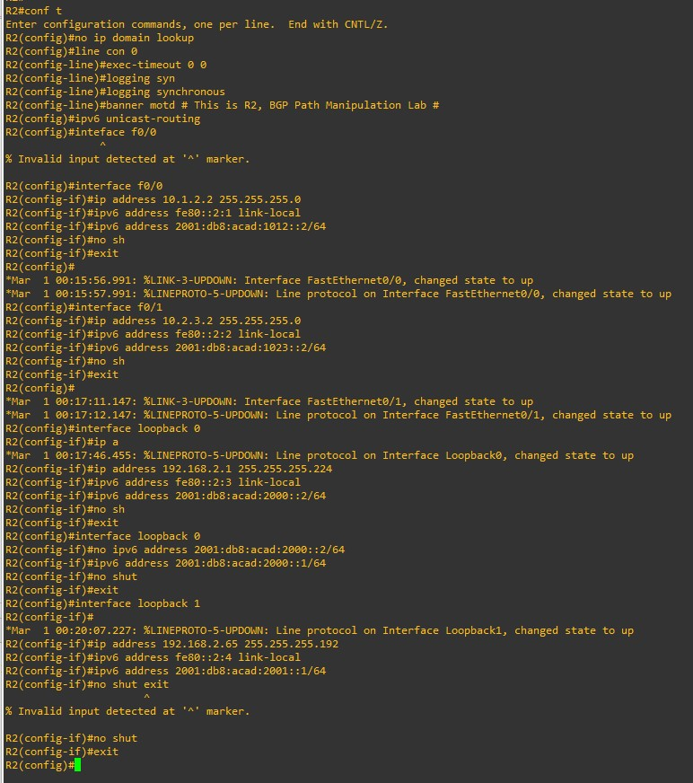

**• Router R3**

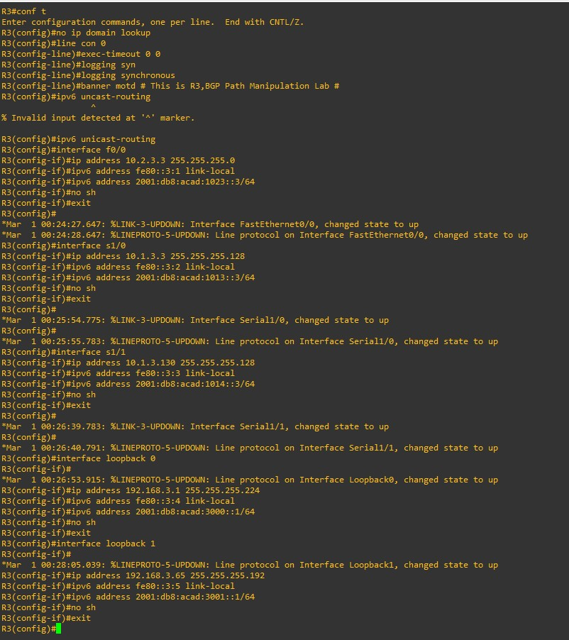

**Part 2: Configure and Verify Multi-Protocol BGP on all Routers**

**Step 1: On R1, create the core BGP configuration.**

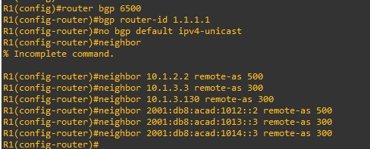

**Step 2: On R1, configure the IPv4 unicast address family.**

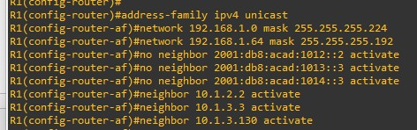

**Step 3: On R1, configure the IPv6 unicast address family.**

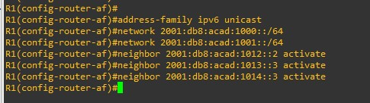

**Step 4: Configure MP-BGP on R2 and R3 as you did in the previous step.**

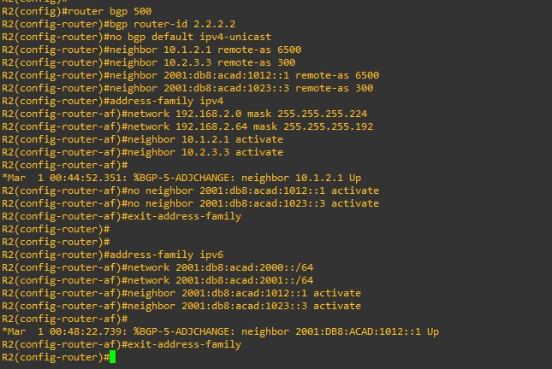

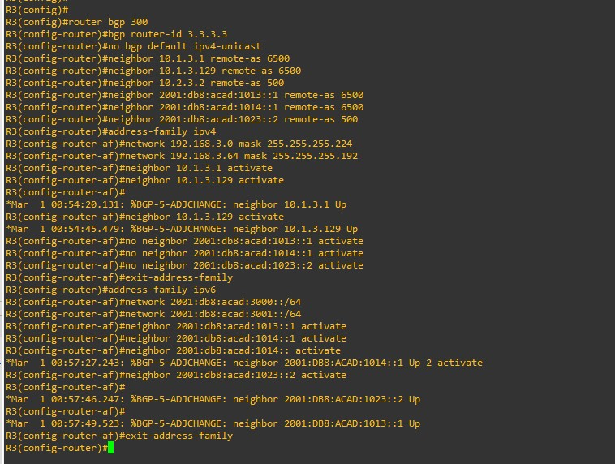

**Step 5: Verify that MP-BGP is operational.**

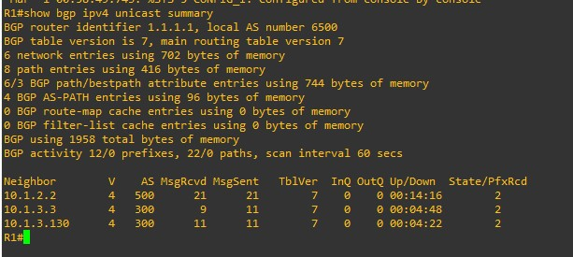

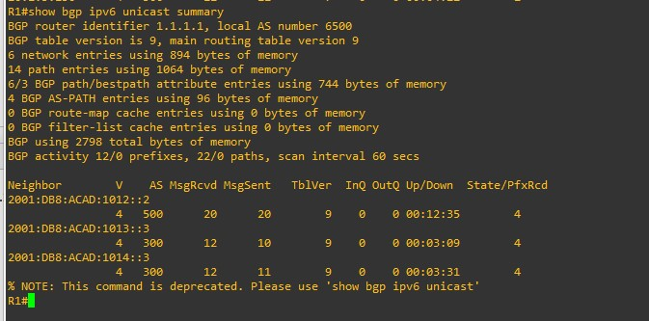

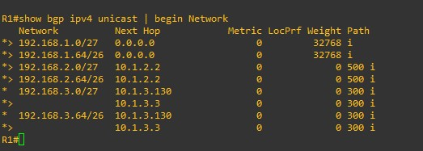

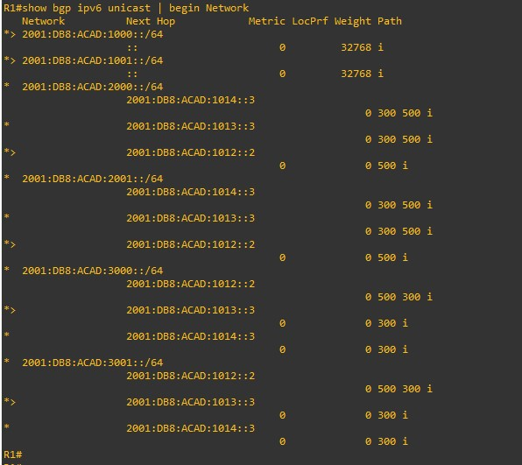

**• View Routing Tables:**

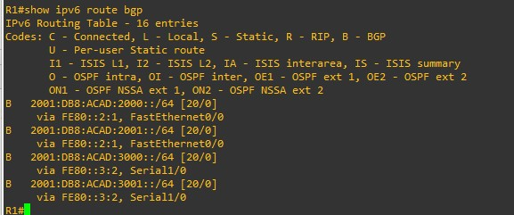

**Part 3: Configure and Verify BGP Path Manipulation Settings on all Routers**

**Step 1: Configure ACL-based route filtering.**

**• On R1, issue the command show bgp ipv4 unicast | i 300 to see what prefixes ASN300 is sharing via BGP. Take note of those prefixes that do not originate in ASN300.**

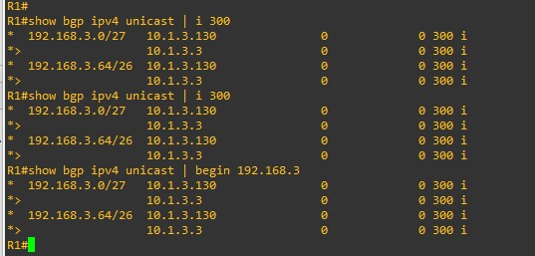

**• On R3, configure an access list designed to match the source address and mask of the networks belonging to ASN300:**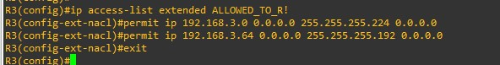

**• On R3, apply the ALLOWED_TO_R1 ACL as a distribute list to the IPv4 neighbor adjacencies with R1.**

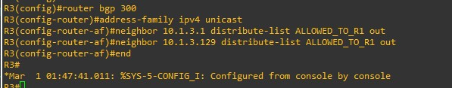

**• Perform a reset of the IPv4 adjacency with R1 for the outbound traffic without tearing down the session.**



**• On R1, issue the command show bgp ipv4 unicast | i 300 to see what prefixes routes ASN300 is now sharing via BGP. All of the prefixes should now originate in ASN300:**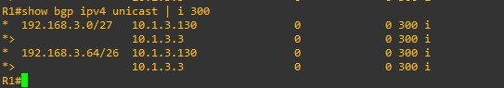

**Step 2: Configure prefix-list-based route filtering.**

**• On R1, issue the command show bgp ipv4 unicast | begin 192.168.3 to see what prefixes ASN500 is sharing via BGP. Take note of those prefixes that do not originate in ASN500.**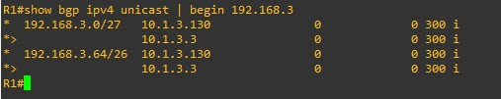

**• On R1, configure a prefix list designed to match the source address and mask of networks belonging to ASN500.**



**• Apply the ALLOWED_FROM_R2 prefix list to the IPv4 neighbor adjacencies for R2.**

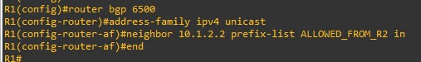

**• Perform a reset of the IPv4 adjacency with R2 for the inbound traffic without tearing down the session**



**• On R1, issue the command show bgp ipv4 unicast | i 500 to see what prefixes routes ASN500 is now sharing via BGP. All of the prefixes should now originate in ASN500.**

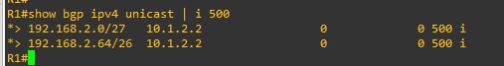

**Step 3: Configure an AS-PATH ACL to filter routes being advertised.**

**• On R2, issue the command show bgp ipv4 unicast | begin Network to see what prefixes ASN6500 is sharing via BGP.**

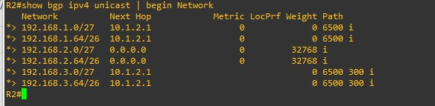

**• On R1, configure AS-PATH ACL to match the routes from the local ASN.**

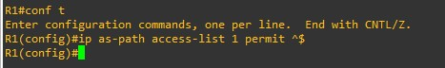

**• On R1, apply the AS-PATH ACL as a filter-list on the adjacency configured with R2.**

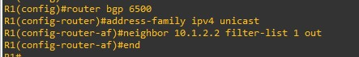

**• On R1, perform a reset of the IPv4 adjacency with R2 for the outbound traffic without tearing down the session**



**• On R2, issue the command show bgp ipv4 unicast | i 6500 to see what prefixes routes ASN6500 is now sharing via BGP. All of the prefixes should now originate in ASN6500.**

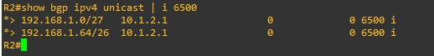

**Step 4: Configure IPv6 prefix-list-based route filtering.**

**• On R1, issue the command show bgp ipv6 unicast neighbors 2001:db8:acad:1012::2 routes to see what IPv6 prefixes ASN500 is sharing via BGP.**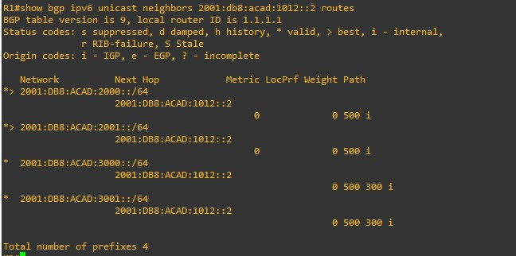

**• On R1, configure an IPv6 prefix list designed to match the source address and mask of networks belonging to ASN500.**



**• Apply the IPV6_ALLOWED_FROM_R2 prefix list to the IPv6 neighbor adjacencies for R2**

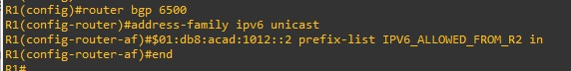

**• Perform a reset of the IPv6 adjacency with R2 for the inbound traffic without tearing down the session.**



**• On R1, issue the command show bgp ipv6 unicast neighbors 2001:db8:acad:1012::2 routes to see what IPv6 prefixes routes ASN500 is now sharing via BGP. All of the IPv6 prefixes should now originate in ASN500.**

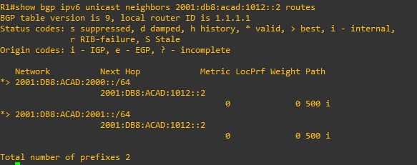

**Step 5: Configure BGP path attribute manipulation to effect routing**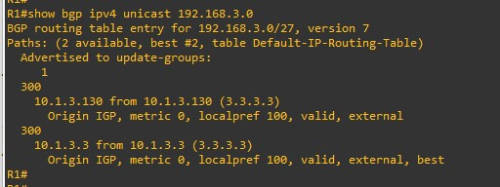

**• On R1, configure a prefix list designed to match the source address and mask of networks belonging to ASN300.**

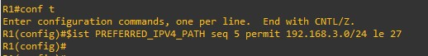

**• Create a route-map named USE_THIS_PATH_FOR_IPV4 that matches on the prefix list you just created and sets the local preference to 250.**

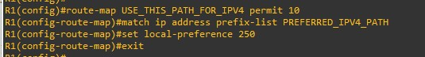

**• Next, apply this route map to the BGP neighbor 10.1.3.130.**

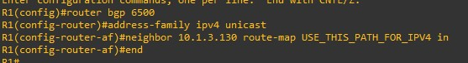

**• Perform a reset of the IPv4 adjacency with R3 for the inbound traffic without tearing down the session.**



**• On R1, issue the command show ip route bgp and take note of the next hop addresses for the 192.168.3.0/27 and 192.168.3.64/26 networks; it should be 10.1.3.130 for both. Issue the command show bgp ipv4 unicast and you should see the local preference value in the appropriate column.**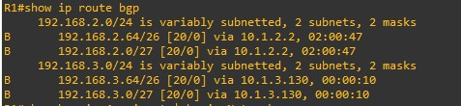

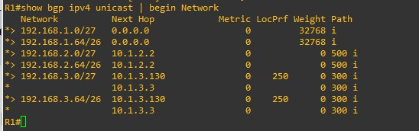

**• Final Config R1:**

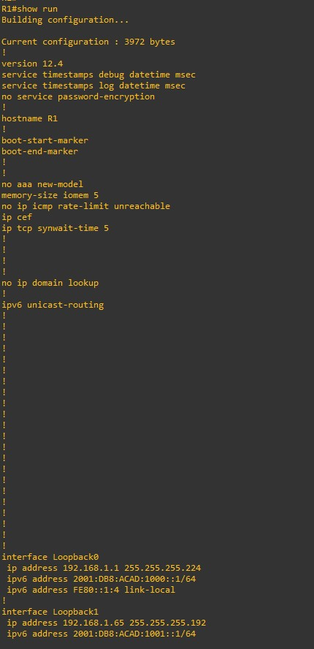

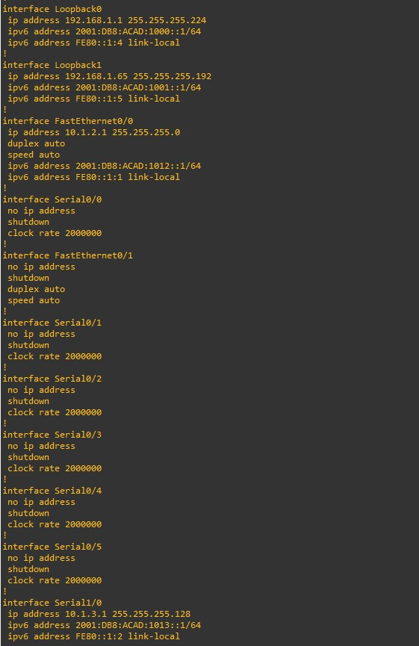 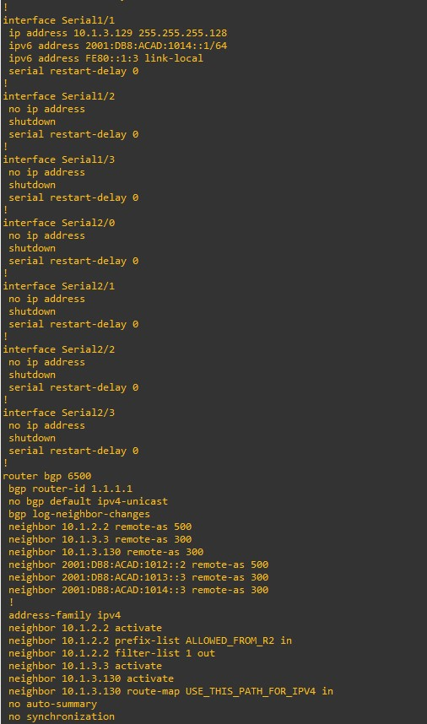

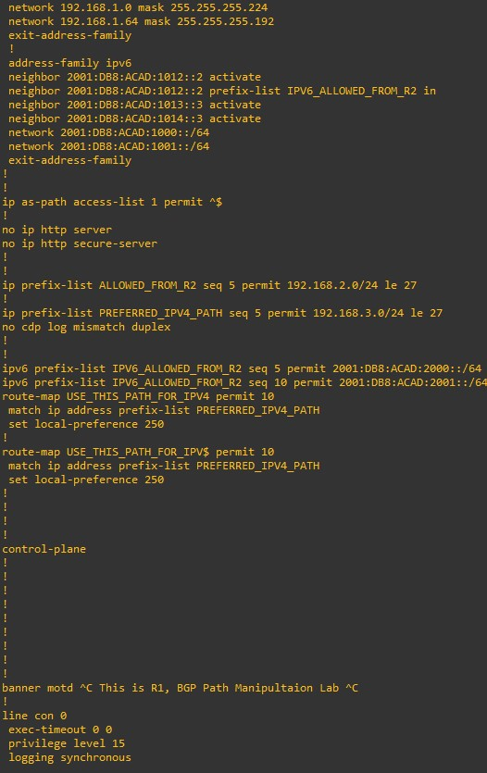

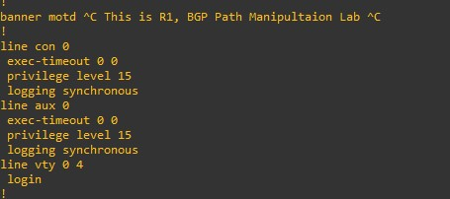

**• Final Config R2:**

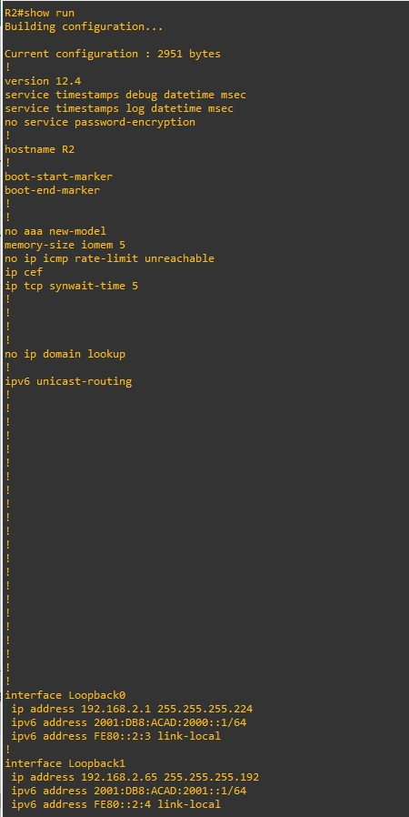 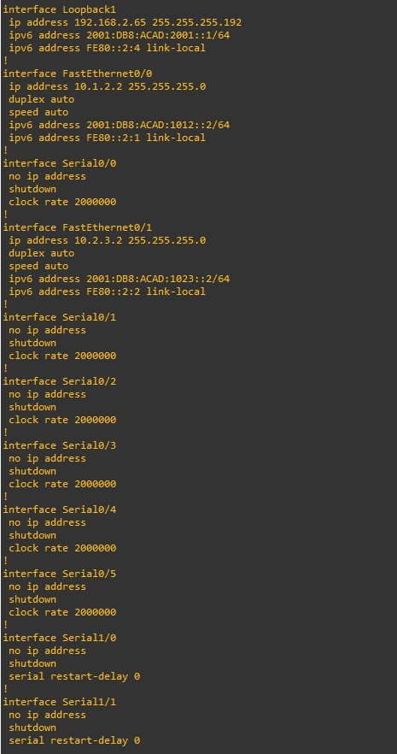

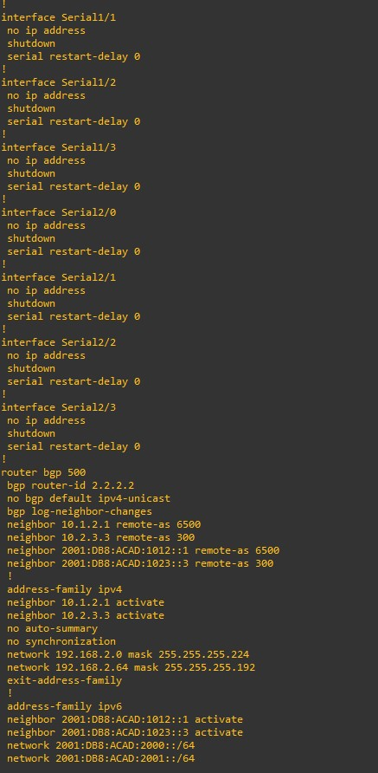 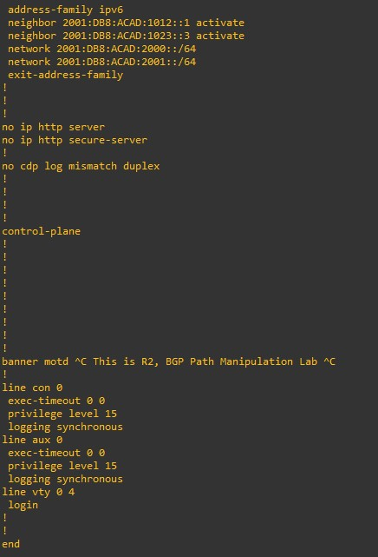

**• Final Config R3:**

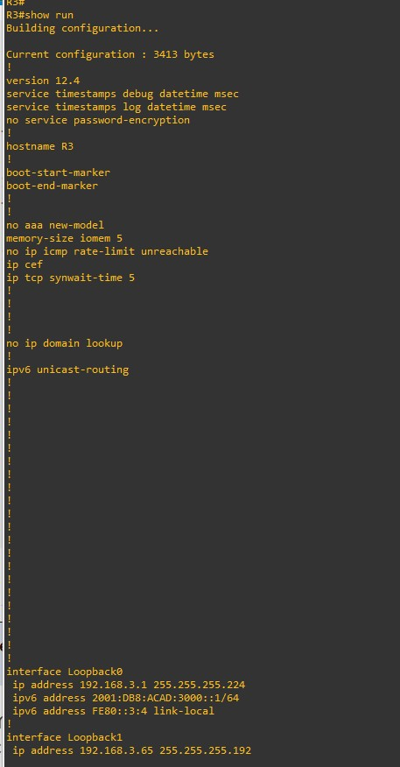 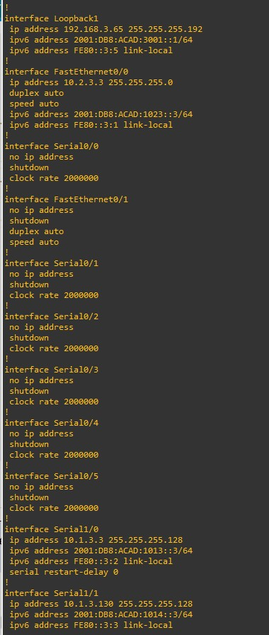

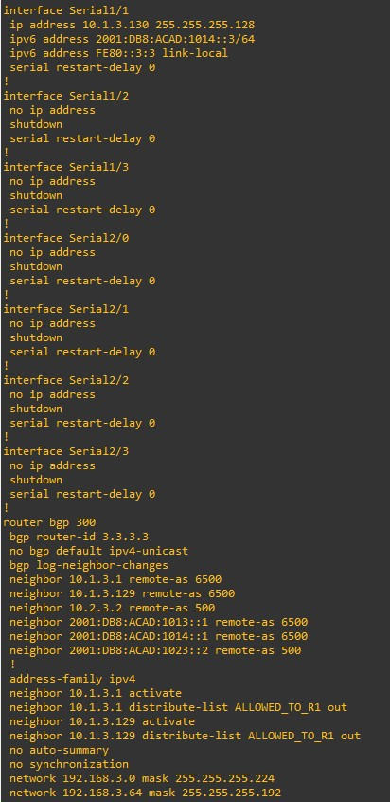 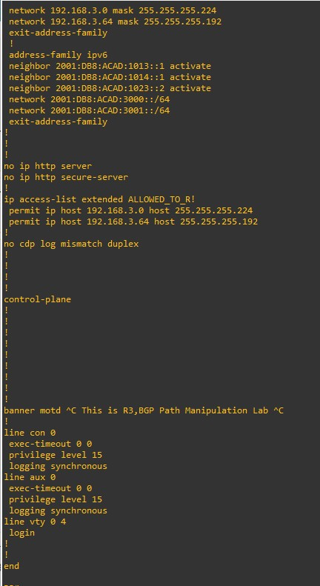

**Practical 9**

**Aim: Implement IP Sec Site -to -Site VPNs.**

* **What is IP Sec VPN?**
* IPsec is a set of protocols that work together to establish encrypted connections between devices. It contributes to the security of data sent over public networks. Ipsec is a popular VPN protocol that works by encrypting IP packets and authenticating the source of the packets.
* Users can connect to an Ipsec VPN by launching a VPN client application. This usually necessitates the user having the application installed on their device.
* VPN logins are usually password-based. While data sent over a VPN is encrypted, if user passwords are compromised, attackers can log into the VPN and steal this encrypted data. Using two-factor authentication (2FA) can strengthen Ipsec VPN security, since stealing a password alone will no longer give an attacker access.

**Step 1: Design the network topology.**

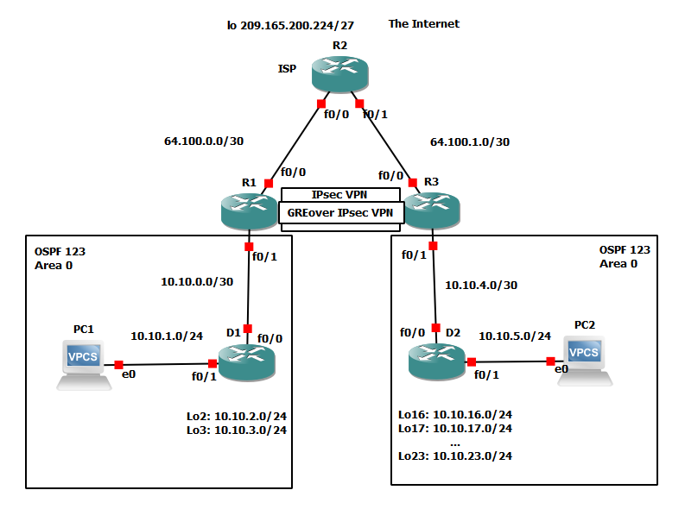

**Step 2: Configure the network.**

* **Router 1 (R1):**

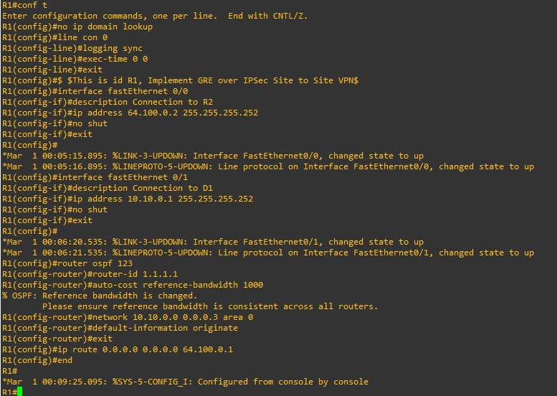

* **Router 2 (R2):**

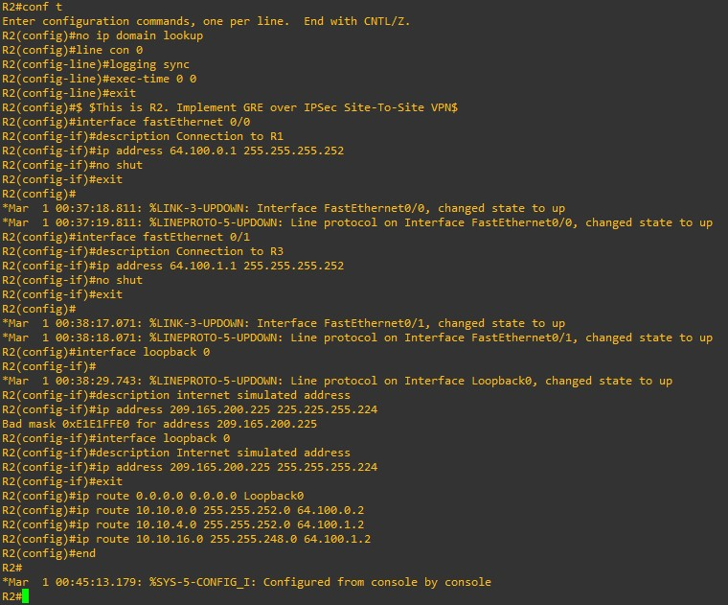

* **Router 3 (R3):**

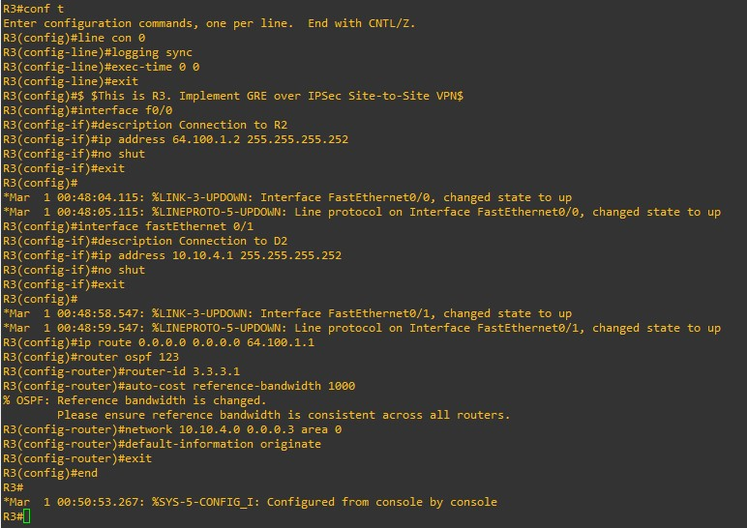

* **Router 4 (D1):**

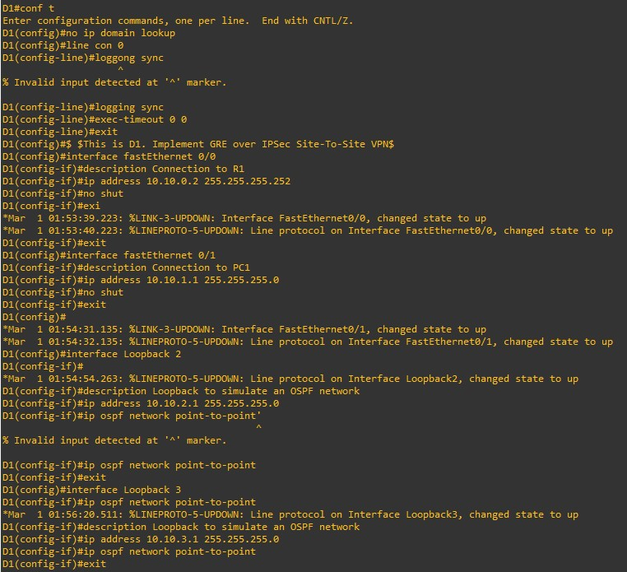

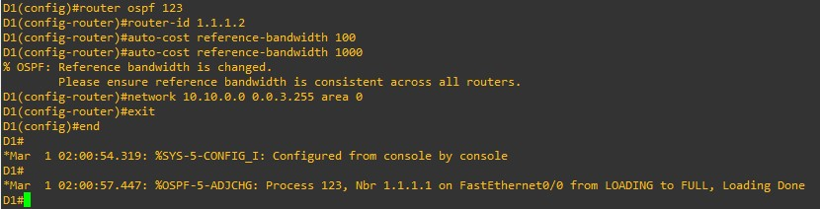

* **Router 5 (D2):**

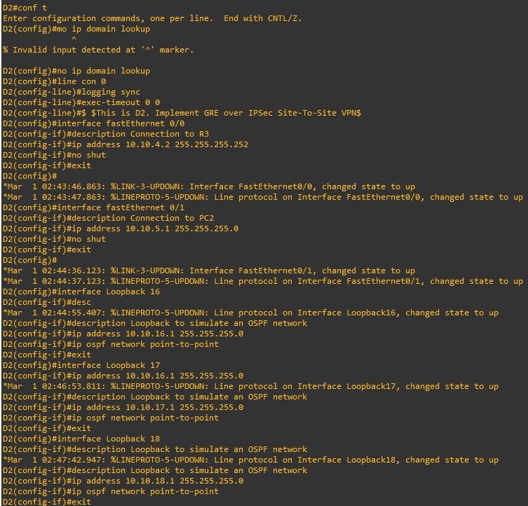

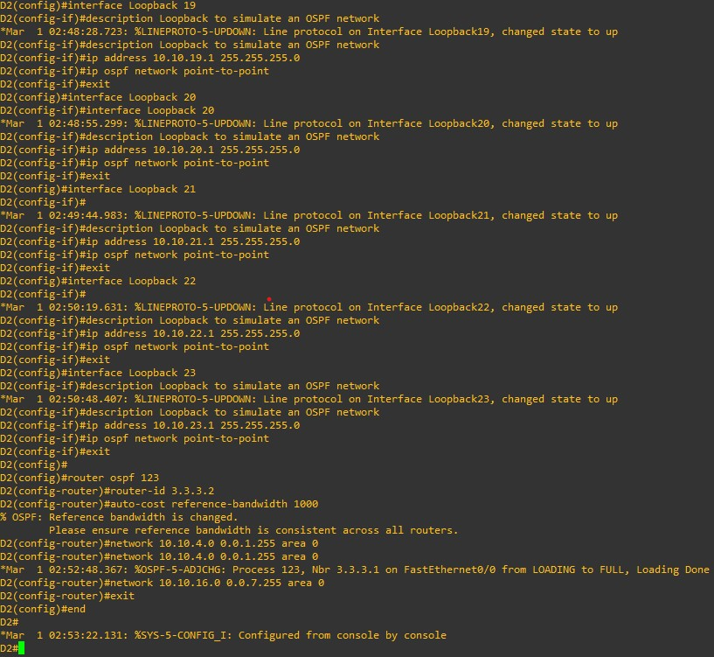

**PC 1:**

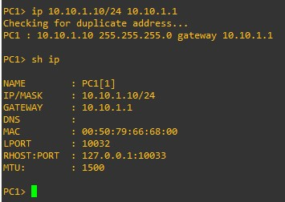

* **PC2:**

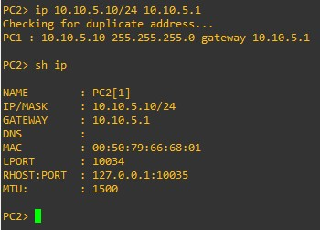

**Step 3: On PC1, verify end-to-end connectivity.**

From PC1, ping PC3(10.10.5.10).

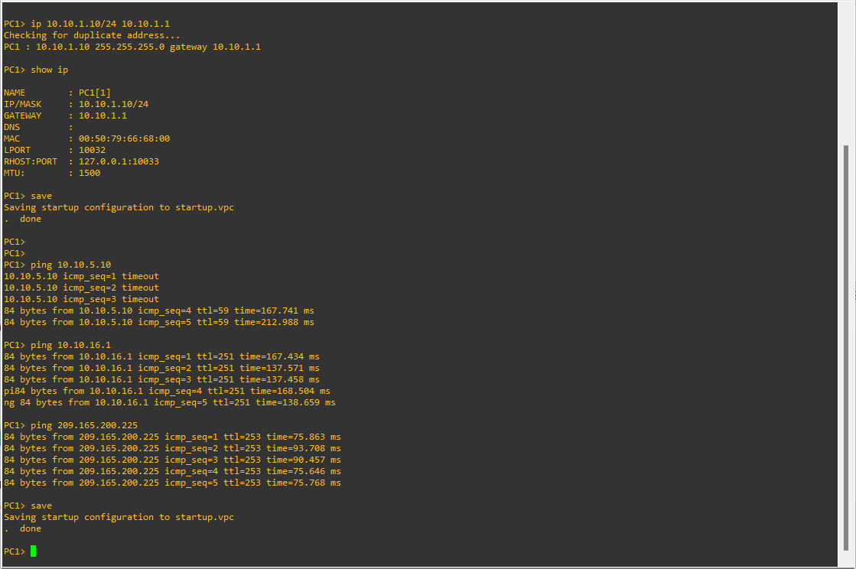

From PC1, ping the first loopback on D3 (10.10.16.1).

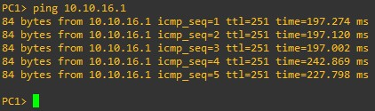

Finally, from PC1, ping the default gateway loopback on R2 (209.165.200.225).

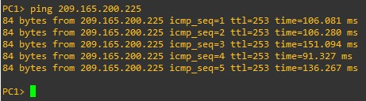

**Step 4: Verify the routing table of R1 and R3.**

Verify the OSPF routing table of R1.

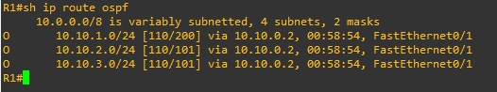

Verify the routing table of R3.

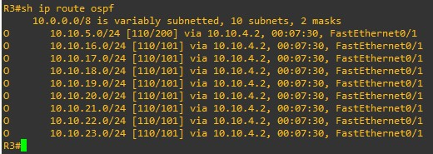

**Step 5: Configure GRE over IPsec using a Crypto Map on R1.**

* **On R1, configure the ISAKMP policy and pre-shared key.**

Like site-to-site VPNs using crypto maps, GRE over IPsec also requires an ISAKMP policy configuration and pre-shared key configured.

In this lab, we will use the following parameters for the ISAKMP policy 10 on R1:

o Encryption: aes 256

o Hash: sha256

o Authentication method: pre-share key

o Diffie-Hellman group: 14

o Lifetime: 3600 seconds (60 minutes / 1 hour)

Configure ISAKMP policy 10 on R1:

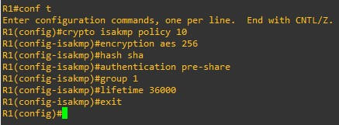

Configure the pre-shared key of cisco123 on R1. This command points to the remote peer R3 G0/0/0 IP address.

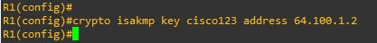

* **On R1, configure the transform set and VPN ACL.**

Create a transform set called GRE-VPN using AES 256 cipher with ESP and the SHA 256 hash function.



Unlike a site-to-site IPsec VPN, the transform must use transport mode. The mode command is used to identify the type of tunnel that will be established. The default is mode tunnel mode. However, GRE over IPsec should be configured using the mode transport command.

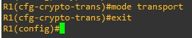

Next, create a named extended ACL called GRE-VPN-ACL that makes the tunnel interface traffic interesting.

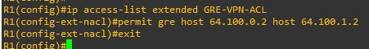

* **On R1, configure the crypto map and apply it to the interface.**

Create a crypto map called GRE-CMAP that associates the new GRE-VPN-ACL, transform set, and peer.

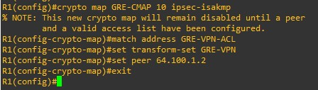

Finally, assign a crypto map called GRE-MAP on G0/0/0

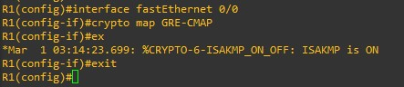

* **On R1, configure the GRE tunnel interface.**

Configure a GRE tunnel interface as shown. To enable GRE on the tunnel interface, the tunnel mode gre ipv4 command is required. However, this command is enabled by default and will therefore not be configured in our example.

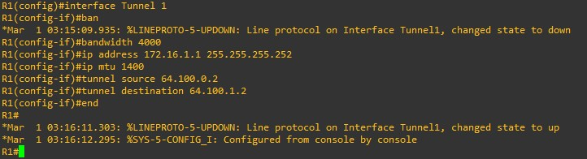

**Step 6: Configure GRE over IPsec using a Tunnel IPsec Profile on R3.**

In this part, we will configure GRE over IPsec using tunnel IPsec profiles on R3.

* **On R3, configure the ISAKMP policy, pre-shared key, and transform set.**

In this step, we will configure the same parameters for the ISAKMP policy 10 that we configured on R1.

Configure ISAKMP policy 10 on R3:

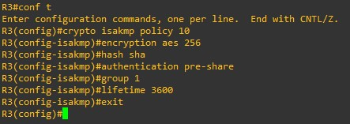

Configure the pre-shared key of cisco123 on R1. This command points to the remote peer R3 G0/0/0 IP address.

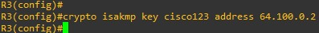

Create a new transform set called GRE-VPN using the same security parameters and transport mode that we configured on R1. Also configure the mode transport command.

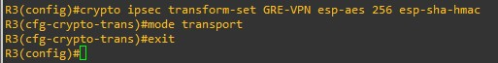

* **On R3, configure the IPsec profile.**

Instead of a crypto map, we will configure an IPsec profile called GRE-PROFILE using the crypto ipsec profile ipsec-profile-name global configuration command.

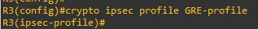

In IPsec profile configuration mode, specify the transform set to be negotiated using the set transform-set transform-set-name command. Multiple transform sets can be specified in order of priority. The fist transform-set-name specified is the highest priority.

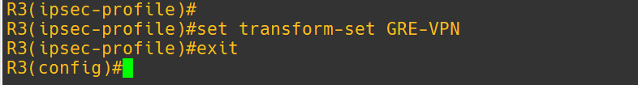

* **On R3, configure the tunnel interface.**

On R3, configure a GRE tunnel interface.

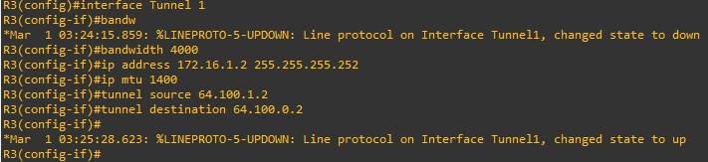

Apply the IPsec profile GRE-PROFILE to the Tunnel 1 interface using the tunnel protection ipsec profile profile-name command.

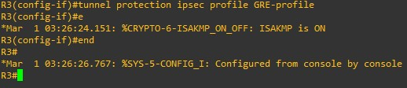

* **On R1 and R3, enable OSPF routing on the tunnel interface.**

Verify that the GRE over IPsec VPN is operational.

On R1, perform an extended ping to the R3 10.10.16.1 interface

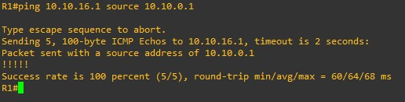

The pings are successful, and it appears that the VPN is operational. On R1, verify the IPsec SA encrypted and decrypted statistics.

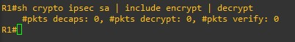

From D1, trace the path taken to the R3 10.10.16.1 interface.

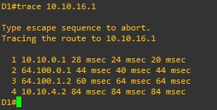

On R1, configure OSPF to advertise the tunnel interfaces.

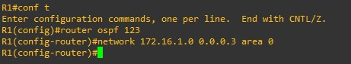

On R3, configure OSPF to advertise the tunnel interfaces.

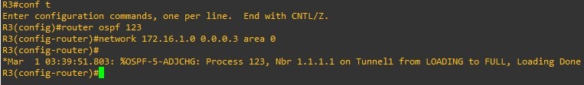

**Step 7:** **Verify the GRE over IPsec Tunnel on R1 and R3**

Now that the GRE over IPsec has been configured, we must verify that the tunnel interfaces are correctly enabled, that the crypto session is active, and then generate traffic to confirm it is traversing securely over the IPsec tunnel.

* **On R1 and R3, verify the tunnel interfaces.**

Use the show interfaces tunnel 1 command to verify the interface settings.

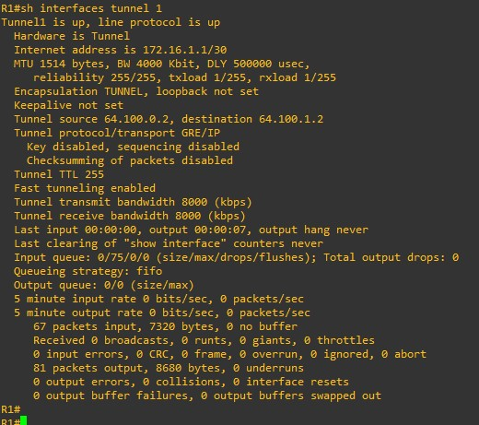

On R3, use the show interfaces tunnel 1 command to verify the interface settings.

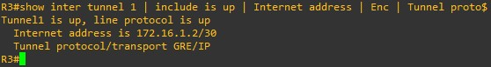

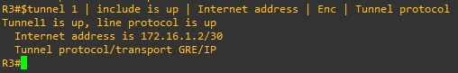

* **On R1 and R3, verify the crypto settings.**

On R1, use the show crypto session command to verify the operation of the VPN tunnel.

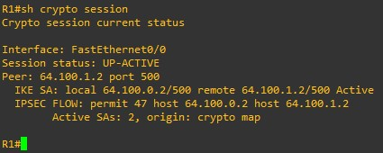

On R3, use the show crypto session command to verify the operation of the VPN tunnel.

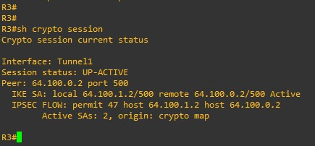

* **On R1 and R3, verify OSPF routing.**

On R1 and R3, verify which interfaces are configured for OSPF using the show ip ospf interface brief command.

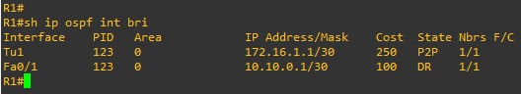

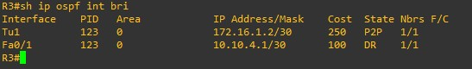

On R1 and R3, verify the OSPF neighbours using the show ip ospf interface brief command.

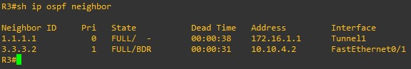

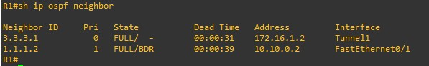

Verify the R1 routing table for OSPF routes.

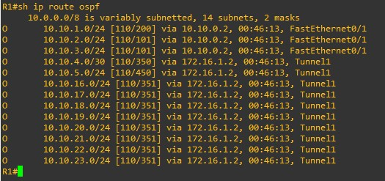

Verify the R3 routing table for OSPF routes.

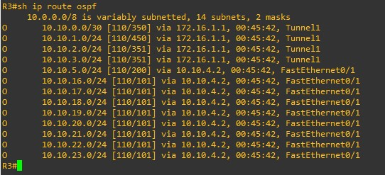

Verify that there is an operational logical point-to-point link between R1 and R3 using the GRE tunnel interface.

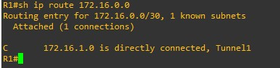

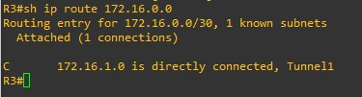

* **Test the GRE over IPsec VPN tunnel.**

From D1, trace the path taken to the R3 10.10.16.1 interface.

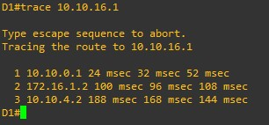

On R1, verify the IPsec SA encrypted and decrypted statistics.

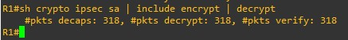

The output verifies that the GRE over IPsec VPN tunnel is properly encrypting traffic between both sites. The packets encrypted include the trace packets along with OSPF packet